**MINISTRY OF EDUCATION AND TRAINING**

**FPT UNIVERSITY**

Capstone Project Document

**Office Task Management**

|  |  |
| --- | --- |
| **Group 3** | |
| **Group member** | Nguyen Cu Dat – SE61010  Lu Cam Toan – SE60633  Le Hai Trieu - SE61146  Tran Thi Kim Anh – SE60909 |
| **Supervisor** | Mr. Lai Duc Hung |
| **Ext. Supervisor** | N/A |
| **Capstone Project code** | OTM |

-Ho Chi Minh City, 13/05/2015-

# Table of Contents

Table of Contents 3

List of Tables 4

List of Figures 5

Definitions, Acronyms, and Abbreviations 6

A. Introduction 7

1. Project Information 7

2. Introduction 7

3. Current Situation 7

4. Problem Definition 7

5. Proposed Solution 7

5.1 Feature functions 7

5.2 Advantage and disadvantage 7

6. Functional Requirement 7

6.1 User Management 7

6.2 Tracking task 7

6.3 Review and approve document 7

6.4 Collaborate in real-time 7

6.5 Statistic 7

7. Role and Responsibility 7

# List of Tables

Table 1: Roles and Responsibility 8

# List of Figures

No table of figures entries found.

# Definitions, Acronyms, and Abbreviations

|  |  |
| --- | --- |
| **Name** | **Definition** |
|  |  |

# Introduction

## Project Information

* Project name: **Office Task Management**
* Project Code: **OTM**
* Product Type: **Website, Mobile app**
* Start Date: **May 13th, 2015**
* End Date: **August 22th, 2015**

## Introduction

Nowadays, business organizations have a very large number of tasks every day, so managers may cause mistakes in tracking work and managing tasks. To solve problems of using handwriting to track tasks and manage works, a solution that will support manager to manage and monitor progress tasks and help members track project’s status in needed.

From actual needs, we give the idea of developing a product that helps manage office tasks for business uses. Besides website version, we will develop one more mobile version. Specifically, this version will run based on Android OS.

With this product, we hope that user will follow up tasks more easily.

## Current Situation

Current systems can support users follow up and manage tasks on website, but don’t have mobile version or vice versa. Besides, current systems have comment function on website, but cannot discuss with real-time collaboration.

All of current systems are web service that allows users create project then add tasks into project simply and freely. This model is not suitable with complex groups like a company.

## Problem Definition

Below are the advantages and disadvantages of current office task management software:

* Advantages:
* Have a nice and simple user-interface, so user can manage tasks more easy.
* Have support review document, download or upload files, and manage groups.
* Disadvantages:
  + - Don’t have support report progress.
    - Lack of productivity assessments.
    - Don’t have discuss function with real-time collaboration on website and mobile.

## Proposed Solution

Our project includes website and mobile app not only let managers track tasks and manage processes, but also help assessing productivity of work and creating convenient communication environment.

### **5.1 Feature functions**

* Assign task
* Document review and approval
* Task review and approval
* Group discussion
* Productivity assessment
* Report

### **5.2 Advantage and disadvantage**

* Advantages:
  + Easy to use
  + Simple interface
  + Easy to divide task
  + Approve document fast and easily
  + Discuss group in real-time
  + Productivity assessment based on effort and difficult-level of task
  + Report progress of work
* Disadvantages:
  + Only for small companies
  + Report feature is simple
  + Business constraint of this system may not be applicable to some others kind of company.

## Functional Requirement

Function requirements of the system are listed as below:

### **6.1 User Management**

* Add, edit, delete account
* Manage user privileges

### 6.2 Tracking task

* Assign task
* Monitor task
* View, update, delete task
* Search task

### 6.3 Review and approve document

* Upload/ Download document
* Approve document

### 6.4 Collaborate in real-time

* Chat group
* See history

### 6.5 Statistic

* Report
* Productivity assessment

## Role and Responsibility

|  |  |  |  |  |
| --- | --- | --- | --- | --- |
| No | Full Name | Role | Position | Contact |
| 1 | Lại Đức Hùng | Project Managers | Instructor | [hungld@fpt.edu.vn](mailto:hungld@fpt.edu.vn) |
| 2 | Nguyễn Cự Đạt | Developer | Leader | [Datncse61010@fpt.edu.vn](mailto:Datncse61010@fpt.edu.vn) |
| 3 | Lư Cẩm Toàn | Developer | Member | [Toanlcse60633@fpt.edu.vn](mailto:Toanlcse60633@fpt.edu.vn) |
| 4 | Lê Hải Triều | Developer | Member | [Trieuthse61146@fpt.edu.vn](mailto:Trieuthse61146@fpt.edu.vn) |
| 5 | Trần Thị Kim Anh | Developer | Member | [Anhttkse60909@fpt.edu.vn](mailto:Anhttkse60909@fpt.edu.vn) |

**Table 1: Roles and Responsibility**

# Software Project Management Plan

## Problem Definition

### 8.1 Name of this Capstone project

* **Office Task Management (OTM)**

### 8.2 Problem Abstract

<Tổng quan về vấn đề đã nêu trong report 1, **tuyệt đối không sao chép** mà diễn giải lại cho phù hợp dưới góc nhìn của quản trị dự án theo khía cạnh đang lên kế hoạch cho giải pháp mà đã đề ra trong phần introduction>

### 8.3 Project Overview

#### Current Situation

<Tình hình hiện tại và các ưu/khuyết điểm của đề tài: có thể là khảo sát thực tế từ người dùng khi lấy yêu cầu, hoặc các thống kê mà nhóm đã nghiên cứu, tìm kiếm trong quá trình nghiên cứu quy trình của hệ thống hiện tại>

#### The proposed system

< Hệ thống mà nhóm đề xuất >

##### Web Site

<Liệt kê tính năng chính theo gom nhóm chức năng/vai trò>

##### Mobile Application

<Liệt kê tính năng chính theo gom nhóm chức năng/vai trò ...

#### Boundaries of the System

<Giới hạn của hệ thống, ngôn ngữ lựa chọn, các thành phần trong sản phẩm cuối cùng>

#### Development Environment

##### Hardware requirements

Mô tả các yêu cầu phần cứng phù hợp cho ứng dụng của nhóm **Ví dụ:**

**For Server**

|  |  |  |
| --- | --- | --- |
| **Windows** | **Minimum Requirements** | **Recommended** |
| **Internet Connection** | Cable, Wi-Fi (4 Mbps) | Cable, Wi-Fi (8 Mbps) |
| **Operating System** | Window Server 2008 | Window Server 2008 |
| **Computer Processor** | Intel® Xeon ® 1.4GHz | Intel® Xeon ® Quad Core  (12M Cache, 2.50 GHz) |
| **Computer Memory** | 1GB RAM | 2GB or more |

##### Software requirements

Mô tả các yêu cầu phần cứng phù hợp cho ứng dụng của nhóm **Ví dụ:**

-Window Server 2008: operating system and platform for development.

-SQL Server 2008 Enterprise R2: used to create and manage the database for system.

- Visual Studio 2012: used to implement website and web service.

- Google Code & TortoiseSVN: used for source control.

- StarUML: used to create models and diagrams.

- Skype: used for communication and meeting.

## Project organization

### 9.1 Software Process Model

<Mô tả về mô hình phát triển mà nhóm lựa chọn, có ảnh hướng tới mục 3 Project management plan>

<Các hình vẽ về mô hình và nội dung mô tả cần phải được reference>

<Giải thích lý do lựa chọn mô hình dựa trên các nội dung liên quan

đến đề tài và những nội dung đã được đề ra trong phần introduction>

### 9.2 Roles and responsibilities

Mô tả vai trò của từng thành viên trong dự án

**Ví dụ**

|  |  |  |  |
| --- | --- | --- | --- |
| **No** | **Full name** | **Role in Group** | **Responsibilities** |
| **1** | Kiều Trọng Khánh | Project manager | • Specify user requirement  • Control the development process  • Give out technique and business analysis  support |
| **2** | Trần Nguyễn Đăng  Khoa | Team Leader, BA, DEV, Tester | • Managing process  • Designing database  • Clarifying requirements  • Prepare documents  • GUI Design  • Create test plan  • Coding  • Testing |

### 9.3 Tools and Techniques

< Các công cụ sử dụng: chú ý ghi gõ phiên bản >

## Project Management Plan

### 10.1 Software development life cycle

Mô tả cụ thể các công việc sẽ làm kèm theo phân bổ tài nguyên và đánh giá rủi ro. Chú ý phải phù hợp với mục 2.1 Software Process Model ở trên>

**Ví dụ**

|  |  |  |  |  |  |
| --- | --- | --- | --- | --- | --- |
| **Phase** | **Description** | **Deliverables** | **Resource needed** | **Dependencies and**  **Constrains** | **Risks** |
| **Requireme nt Analysis** | - Collect requirements  from customer.  -Identify and clarify  requirements  for the system in general. | -Introduction of proposed  system.  -Software requirement  specification.  -Project Task  Plan.  - Prototypes | 20 man- days | N/A | - Missing requirement  - Unclear scope of  project  - Lack of member share  of understand |
| **Design** | - Architecture design for the  system  - Detail design using top-down  break down  - Choose Architecture style | - Software  Design  Document  - Base code structure  - Technology  notes | 20 man- days | Depend on  “Requirement  Analysis” | - Lack of experience.  - Not fulfil  requirement. |
| **....** |  |  |  |  |  |

### 10.2 Phase Detail

Mô tả cụ thể công việc trong các giai đoạn có chỉ định thành viên thực hiện tương ứng nội dung mô tả trong phần

**Ví dụ**

#### 10.2.1 Phase 1: Create the Timetable

|  |  |  |
| --- | --- | --- |
| **Task** | **Description** | **Author** |
| 1. Plan & evaluate priorities | - Get feedback from staff on deliver application in the in the previous step iteration**.**  - Evaluate feedback, function’s priorities and plan for this iteration.  - Identify what function should have implement, update. | CuongLQ |
| 2. Analysis | - Find which systems currently provide similar service, their strengths and weakness.  - Information from FPT University’s staff.  - Identify this function how to implement. | CuongLQ, VuPTT, TrungHT, NguyenHT |
| 3. Design | - Update ER diagram, database.  - Update SRS document, detail design. | CuongLQ, VuPTT, TrungHT, NguyenHT |
| 4. Coding | - Implement, update selected functions in plan & evaluate priorities phase. | CuongLQ, VuPTT, TrungHT, NguyenHT |
| 5. Testing | - Write and do test cases for unit test, integration testing.  - Update testing document. | CuongLQ, VuPTT, TrungHT, NguyenHT |
| 6. Deliver increment | - Deliver this application to FPT’s staff.  - Write installation guide and user manual | CuongLQ, VuPTT, TrungHT, NguyenHT |

### 10.3 All Meeting Minutes

Refer to Meeting Minutes folder

## Coding Convention

Mô tả tổng quan các code convention rule được áp dụng trong dự án được thực hiện, sau đó reference đến nơi tham chiếu. Không được phép reference không vì nếu như thế có thể xem như buộc trong project thực hiện phải áp dụng đúng như là nội dung references qui định

# Software Requirement Specification

## User Requirement Specification

### 12.1 Guest Requirement

Guest is a person who is not able to access the system. Log in is the only function that system provide for Guest. After log in, Guest can use all function of the system.

### 12.2 Staff Requirement

Staff is a person who create and manage timetable. Staff can use these functions:

* Log out.
* Create new semester.
* Import subject list.
* Import student list.
* Create temporary timetable. (Timetable without instructor names).
* View temporary timetable.
* Edit temporary timetable.
* Import instructor list.
* Add course.
* Delete course.
* Check conflict temporary timetable.
* Export temporary timetable.
* Create completed timetable. (Detail timetable for each class)
* View completed timetable.
* Edit completed timetable.
* Check conflict completed timetable.
* Export completed timetable.
* Calculate timekeeping.
* Assign class room.
* Export room usage.
* Import project list.
* Create guide project schedule.
* View suggestion schedule.
* Edit guide project schedule.
* Export guide project schedule.
* Send timekeeping into instructor mail.
* Send timetable into instructor mail.

## System Requirement Specification

### 13.1 External Interface Requirement

#### User Interface

* The interface of application is clear.
* The error, warning dialog should be clear and should detail the steps that user should make at each situation.

#### Hardware Interface

* The system would use the standard hardware and data communications resources of a standard computer.

#### Software Interface

* Java Runtime Environment 8 update 45 (jre-8u45) or above. Download at: <http://www.oracle.com/technetwork/java/javase/downloads/index.html>
* Recommend resolution for using computer is (1280* 720) or above.

#### Communication Protocol

* Application using HTTP for communicating between application and web service.
* Application using SMTP for support send mail.

### 13.2 System Overview Use Case

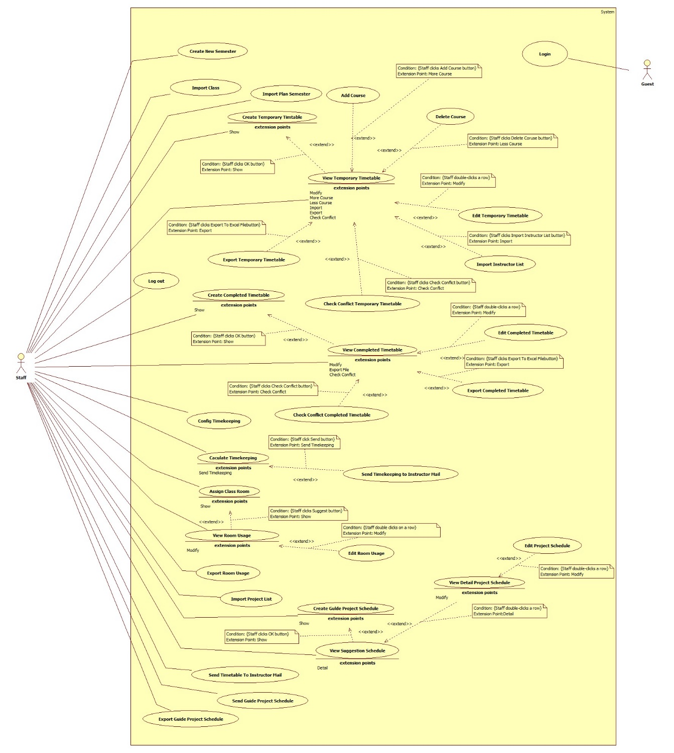

Figure 1: System Overview Use Case

### 13.3 List of Use Case

#### <Guest>Overview Use Case

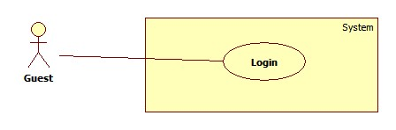

Figure 2: <Guest>Overview Use Case

##### <Guest>Login



Figure 3: <Guest>Login

|  |  |  |  |
| --- | --- | --- | --- |
| **USE CASE –UC001** | | | |
| **Use Case No.** | UC001 | **Use Case Version** | 2.0 |
| **Use Case Name** | Log in | | |
| **Author** | Pham Tran Tuan Vu | | |
| **Date** | 17/01/2015 | **Priority** | Normal |
| **Actor:**   * Guest   **Summary:**   * This use-case allows guest to register in the system.   **Goal:**   * Guest could log into the system to use system’s functions.   **Triggers:**   * Application start.   **Preconditions**:   * Guests have an account to sign in.   **Post Conditions:**   * **Success**: Guest log into the system. * **Fail**: System shows error message.   **Main Success Scenario:**   |  |  |  | | --- | --- | --- | | Step | Actor Action | System Response | | 1 | Run application | System shows login window contains:   * “User Name”: textbox * “Password”: password textbox * “Login”: button * “Close”: button | | 2 | Guest fills username and password |  | | 3 | Guest clicks “Login” button  [Alternative 1] | Guest logs in to system and the system shows the Main Menu window.  [Alternative 2] |   **Alternative Scenario:**   |  |  |  | | --- | --- | --- | | No | Actor Action | System Response | | 1 | Guest clicks “Close” button | Close application. | | 2 | Wrong username or password. | System shows error message “Username or password is wrong, please try again”. |   **Exceptions:** N/A  **Relationships**: N/A  **Business Rules:**   * After login, the system automatically selects the most recent semester added | | | |

Table 1: <Guest>Login

#### <Staff>Overview Use Case

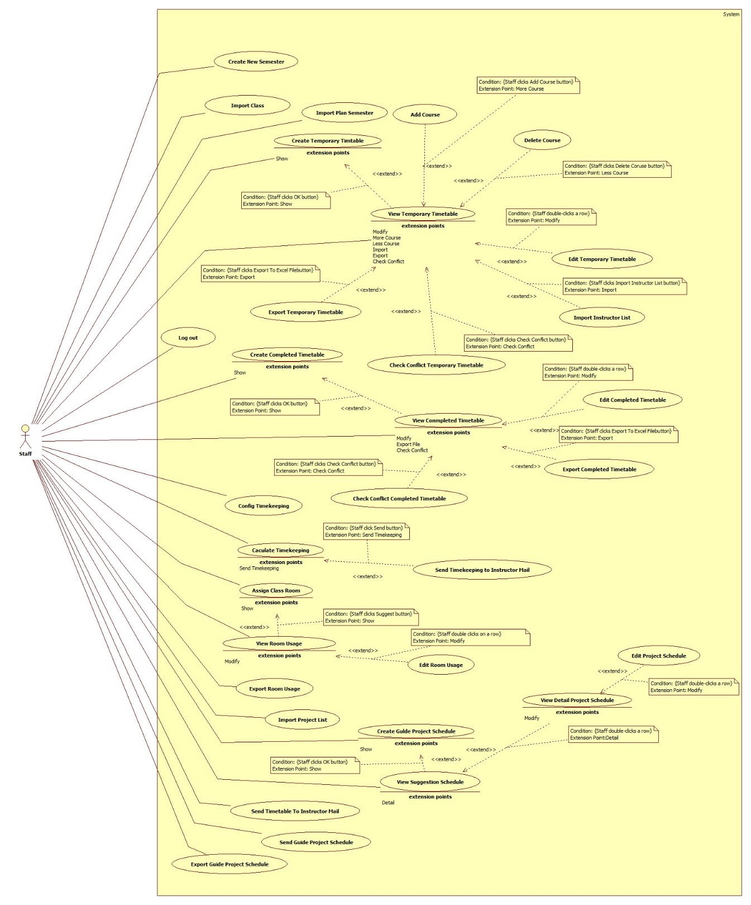

Figure 4: <Staff>Overview Use Case

##### <Manager>Create Project

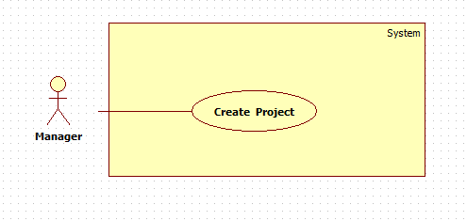

Figure 5: <Manager>Create **Project**

|  |  |  |  |
| --- | --- | --- | --- |
| **USE CASE – UC002** | | | |
| **Use Case No.** | UC002 | **Use Case Version** | 1.0 |
| **Use Case Name** | Create New Project | | |
| **Author** | Trần Thị Kim Anh | | |
| **Date** | 20-05-2015 | **Priority** | Normal |
| **Actor:**   * Manager   **Summary:**   * This use case is about notify manager of create new project for member..   **Goal:**   * New Project is created.   **Triggers:**  Manager chooses “Project” on Menu bar, then choose “Create”.  **Preconditions**:   * Log into the system with Manager role.   **Post Conditions:**   * **Success**: New content of new project are created. * **Fail**: System shows error message.   **Main Success Scenario:**   |  |  |  | | --- | --- | --- | | Step | Actor Action | System Response | | 1 | Manager chooses “Project” on Menu bar, then choose “Create” | System shows new window contains:   * “Project Name”: textbox * “Project Description”: textbox * “Start date”: date picker, require * “End date”: date picker, require * “Assignee”: textbox * “Create”: button * “Cancel”: button | | 2 | Manager inputs requested data |  | | 3 | Manager clicks “Create” button | System closes current window and shows new window contains:   * Information of new project (name, description, time…) * “Create”: button * “Cancel”: button   [Exception 1, 2, 3] |   **Alternative Scenario:**   |  |  |  | | --- | --- | --- | | No | Actor Action | System Response | | 1 | Manager clicks “Cancel” button. | System auto come-back Home page. |   **Exceptions:**   |  |  |  | | --- | --- | --- | | No | Actor Action | System Response | | 1 | Project name is exist. | System shows message “This project name is exist.” | | 2 | Assignee A is busy | System shows message “A is joining another project.” | | 3 | Don’t fill information but click “Create” button. | System shows message “Please fill all Information.” |   **Relationships**: N/A  **Business Rules:** | | | |

Table 2: <Manager>Create New Project

##### <Staff>Import Plan Semester

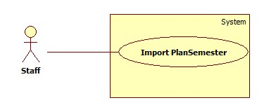

Figure 6: <Staff>Import Plan Semester

|  |  |  |  |
| --- | --- | --- | --- |
| **USE CASE –UC003** | | | |
| **Use Case No.** | UC003 | **Use Case Version** | 2.0 |
| **Use Case Name** | Import Plan Semester | | |
| **Author** | Ho Thien Nguyen | | |
| **Date** | 17/01/2015 | **Priority** | High |
| **Actor:**   * Staff   **Summary:**   * This use case allows Staff to import the plan semester excel file to system.   **Goal:**   * Add list subjects of a semester to system in order to create general timetable.   **Triggers:**   * Staff clicks “Import Plan Semester” button on Plan Semester Tab.   **Preconditions**:   * User has login as Staff role.   **Post Conditions:**   * **Success**: Subject list file is imported successfully. * **Fail**: Show error message.   **Main Success Scenario:**   |  |  |  | | --- | --- | --- | | Step | Actor Action | System Response | | 1 | Staff clicks “Import Plan Semester” button. | Show the file chooser window. | | 2 | Staff chooses the Plan Semester file and clicks “Open” button. [Alternative 1] | Show the table of information in Plan Semester. One row include all information of one subject:   * Subject code * Subject Name (English) * Category * Major * Session * Numbers of week * Slot per day * Require Subject * Connect Subject * Log system if there is any warning or error. * Checkbox if staff wants to import that subject or not.   [Exception 1, 2, 3] | | 3 | Staff clicks “Save” button. [Alternative 2, 3, 4, 5] | System inserts data to system and shows the success message. |   **Alternative Scenario:**   |  |  |  | | --- | --- | --- | | No | Actor Action | System Response | | 1 | Staff clicks “Cancel” button | N/A | | 2 | Staff imports again used file. | Show the confirm message: “This Plan Semester is already exist, do you want to overwrite data?” | | Staff clicks “Yes” button.[Alternative 3] | Overwrite data in system. | | 3 | Staff clicks “No” button. | Close the confirm window | | 4 | Staff imports again used file but choose new subjects. | Show the confirm message: “This Plan Semester is already exist, but subjects is/are not added. Do you want to add it/them?” | | Staff clicks “Yes” button.[Alternative 3] | Add new chosen subjects. | | 5 | Staff doesn’t choose any subject to import. | Show the confirm message: “Please choose at least one subject!” |   **Exceptions:**   |  |  |  | | --- | --- | --- | | No | Actor Action | System Response | | 1 | The format excel is not correct. | Show the error messages depend on number of error. | | 2 | Imported file is not excel file. | Show the error message: “Imported file is not excel file!” | | 3 | Imported file doesn’t exist. | Show the error message: “Imported file doesn’t exist!” |   **Relationships**: N/A  **Business Rules:**   * Excel file should be more than 2003 version and has .xls extension. * Staff can edit information of plan semester by double clicking a row table. * If imported data is wrong or not exist, system will show warning/error in log and highlight data row:   + Yellow color row: Category and major is not exist on database   + Red color row: attributes is null or incorrect format * When overriding data, system will delete related data. * Data can filter by major, class group, subject, warning, error, class group that has more than 6 subjects. * Class group “OJT 2ky” will not imported because it studies the same subject with another class group. * There are 3 cases of saving plan semester:   + Data of this semester is existed: overriding data.   + Data of this semester is existed but imported data is not duplicated: add not-duplicate data.   + Data of this semester is not existed: save new data. * If class group has more than 6 subjects, system will warning and filter imported data by class group which has more than 6 subjects. * Format of plan semester excel file should be:   + FormatCellExtra column includes Deep Major, Week, Slot/day, Category, Connect Plan | | | |

Table 3: <Staff>Import Plan Semester

##### <Staff>Import Class

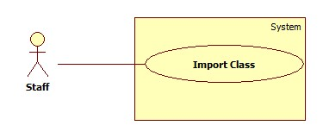

Figure 7: <Staff>Import Class

|  |  |  |  |
| --- | --- | --- | --- |
| **USE CASE –UC004** | | | |
| **Use Case No.** | UC004 | **Use Case Version** | 2.0 |
| **Use Case Name** | Import Class | | |
| **Author** | Ho Thien Nguyen | | |
| **Date** | 17/01/2015 | **Priority** | High |
| **Actor:**   * Staff   **Summary:**   * This use case allows Staff to import class in semester excel file to system.   **Goal:**   * Add classes of a semester to system in order to create general timetable.   **Triggers:**   * Staff clicks “Import Class” button.   **Preconditions:**   * User has login as Staff role   **Post Conditions:**   * Success: Classes is imported successfully. * Fail: Show error message.   **Main Success Scenario:**   |  |  |  | | --- | --- | --- | | Step | Actor Action | System Response | | 1 | Staff clicks “Import Class” button. | Staff clicks “Browse” button | | 2 | Staff chooses the list students file and clicks “Open” button. [Alternative 1] | Show the table of information in Student list. One row include all information of one subject:   * Class Name * Quantity * Class Group * Log system if there is any warning or error. * Checkbox if staff want to import that class or not.   [Exception 1, 2, 3] | | 3 | Staff clicks “Save” button.  [Alternative 2], [Alternative 3] | System inserts data to system and show the success message. |   **Alternative Scenario:**   |  |  |  | | --- | --- | --- | | No | Actor Action | System Response | | 1 | Staff clicks “Cancel” button | N/A | | 2 | Staff imports again used file. | Show the confirm message: “Data is already exist, do you want to overwrite data?” | | Staff clicks “Yes” button.  [Alternative 3] | Overwrite data in system. | | 3 | Staff clicks “No” button. | Close the confirm window |   **Exceptions:**   |  |  |  | | --- | --- | --- | | No | Actor Action | System Response | | 1 | The format excel is not correct. | Show the error messages depend on number of error. | | 2 | Imported file is not Excel file. | Show the error message: “Imported file is not Excel file!” | | 3 | Imported file doesn’t exist. | Show the error message: “Imported file doesn’t exist!” |   **Relationships**: N/A  **Business Rules:**   * Excel file should be more than 2003 version and has .xls extension. * Staff can edit information of class in semester by double click a row table. * If class is not existed in data, system will warn staff by highlight that row. * If quantity of class is less than 14 or more than 30, or class group is missing, system will warning in log and highlight row. * When overriding data, system will delete related data. * Format of excel file should be :      * + Extra Column: ClassGroup | | | |

Table 4: <Staff>Import Class

##### <Staff>Create Temporary Timetable. (Timetable without instructor names)

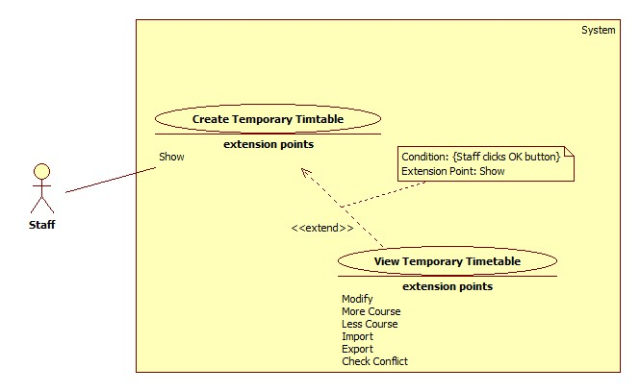

Figure 8: <Staff>Create Temporary Timetable

|  |  |  |  |
| --- | --- | --- | --- |
| **USE CASE – UC005** | | | |
| **Use Case No.** | UC005 | **Use Case Version** | 2.0 |
| **Use Case Name** | Create Temporary Timetable | | |
| **Author** | Pham Tran Tuan Vu | | |
| **Date** | 17/01/2015 | **Priority** | High |
| **Actor:**   * Staff   **Summary:**   * This use-case allows Staff to create temporary timetable for specified classes.   **Goal:**   * Temporary timetable is created.   **Triggers:**   * Staff clicks on “Create Temporary Timetable” button at “Schedule” menu.   **Preconditions**:   * Log into the system with Staff role. * Plan semester and Classes list are imported.   **Post Conditions:**   * **Success**: Temporary timetable is created successfully. * **Fail**: System shows error message.   **Main Success Scenario:**   |  |  |  | | --- | --- | --- | | Step | Actor Action | System Response | | 1 | Staff clicks on “Suggest Temporary Timetable” button. | System shows “Create Temporary Timetable” window that contains:   * A list of classes is assigned in current semester. * Check box beside each class. * “Create”: button. * “Cancel”: button. | | 2 | Staff clicks “Create” button.  [Alternative 1] | System creates Temporary Timetable based on checked classes then show success message to staff.  [Exception 1] |   **Alternative Scenario:**   |  |  |  | | --- | --- | --- | | No | Actor Action | System Response | | 1 | Staff clicks “Cancel” button | Close this window |   **Exceptions:**   |  |  |  | | --- | --- | --- | | No | Actor Action | System Response | | 1 | Have error in process | System shows error message: “Create temporary timetable failed!” |   **Relationships**:   * Extended by View Temporary Timetable (click Show)   **Business Rules:**   * System only shows list of the classes in current semester. * Temporary Timetable is suggested base on the cohesion of Plan Semester and Class List. The suggestion would satisfy following rules:   + The required plans must be learned first.  + If two plans are connecting, they must be learn sequential.  + Week number in a semester in the range of 1 to 16.  + A class is assigned in AM only or PM only. | | | |

Table 5: <Staff>Create Temporary Timetable

##### <Staff>View Temporary Timetable

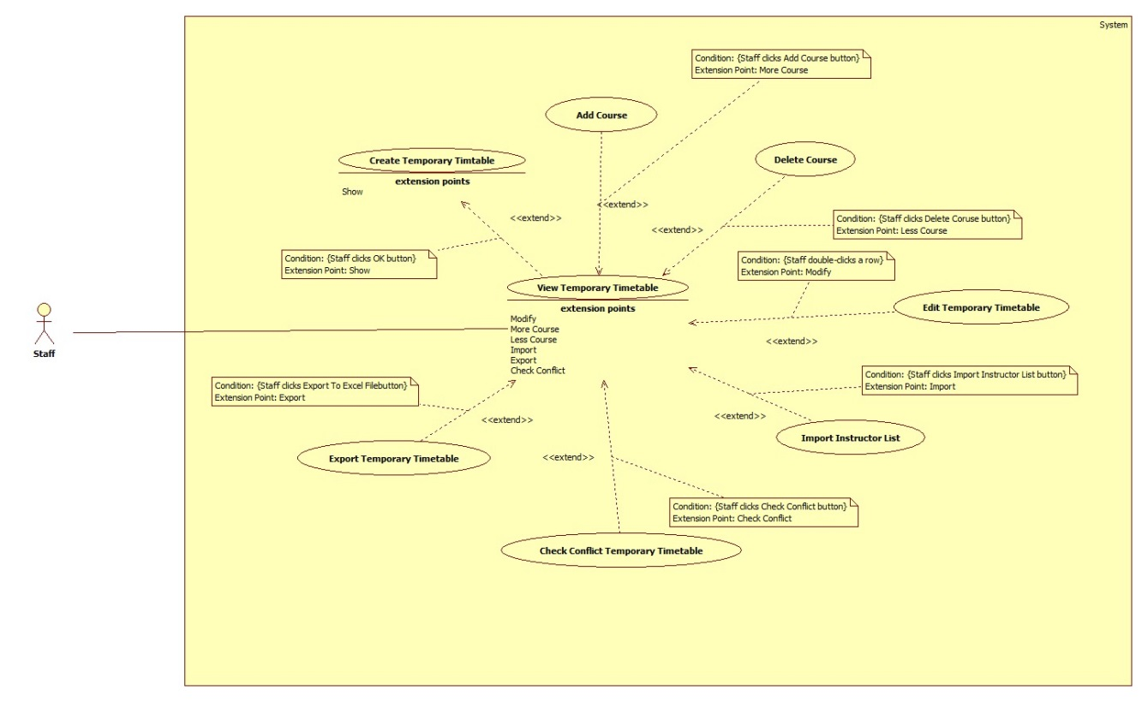

Figure 9: <Staff>View Temporary Timetable

|  |  |  |  |
| --- | --- | --- | --- |
| **USE CASE – UC006** | | | |
| **Use Case No.** | UC006 | **Use Case Version** | 2.0 |
| **Use Case Name** | View Temporary Timetable | | |
| **Author** | Pham Tran Tuan Vu | | |
| **Date** | 17/01/2015 | **Priority** | High |
| **Actor:**   * Staff   **Summary:**   * This use-case allows Staff to view temporary timetable.   **Goal:**   * Temporary timetable is shown as a grid-view.   **Triggers:**   * Staff clicks on “View Temporary Timetable” button at “Schedule” menu.   **Preconditions**:   * Log into system with Staff role * Staff has created temporary timetable.   **Post Conditions:**   * **Success**: Temporary timetable is shown. * **Fail**: System shows error message.   **Main Success Scenario:**   |  |  |  | | --- | --- | --- | | Step | Actor Action | System Response | | 1 | Staff clicks on “View Temporary Timetable” button. | System shows Temporary Timetable in a grid view which contains all information of created timetable include:   * Time that subject will be taught. (AM or PM). * Subject ID. * Subject Name. * Instructor name. * Teaching periods of each subject (displayed by block). * Class is assigned to learn subject in each period. * Quantity of week assigned on each subject. * Slot per day assigned on each subject. * Priority slot assigned on each subject. |   **Alternative Scenario:** N/A  **Exceptions:**   |  |  |  | | --- | --- | --- | | No | Actor Action | System Response | | 1 | Temporary timetable has not created. | System shows error message: “Temporary timetable has not created” |   **Relationships**: Extend Create Temporary Timetable (click Show), extended by Add Course (click Add Course), extended by Delete Course (click Delete Course), extended by Edit Temporary Timetable (double-click a row), extended by Import Instructor (click Import Instructor), extended by Export to Excel (click Export to Excel) and extended by Check Conflict Temporary Timetable (click Check conflict)  **Business Rules:**   * Grid view of Temporary Timetable would only show temporary timetable in a specified semester that has been selecting (in Choose Semester use case). * Grid view of Temporary Timetable is sorted by ClassID in default. * A row in temporary timetable can be locked by click “Lock” button. Locked row cannot be Edit, Delete. * The background color of locked row is Yellow. * User can Edit Temporary Timetable by double-click a row in grid view of Temporary Timetable. | | | |

Table 6: <Staff>View Temporary Timetable

##### <Staff>Edit Temporary Timetable

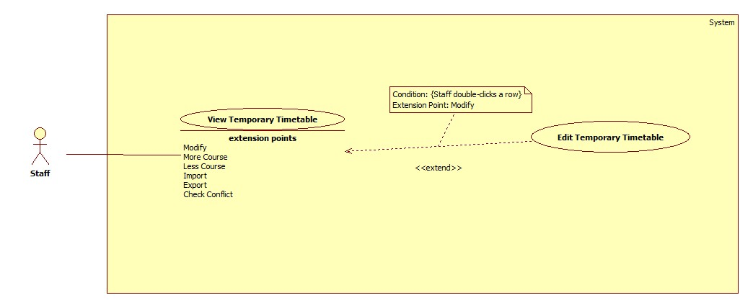

Figure 10: <Staff>Edit Temporary Timetable

|  |  |  |  |
| --- | --- | --- | --- |
| **USE CASE – UC007** | | | |
| **Use Case No.** | UC007 | **Use Case Version** | 2.0 |
| **Use Case Name** | Edit Temporary Timetable | | |
| **Author** | Pham Tran Tuan Vu | | |
| **Date** | 17/01/2015 | **Priority** | Normal |
| **Actor:**   * Staff   **Summary:**   * This use-case allows Staff to edit temporary timetable.   **Goal:**   * Edited data is shown in temporary timetable.   **Triggers:**   * Staff double-clicks on the row that they want to edit.   **Preconditions**:   * Log into system with Staff role. * Staff has created temporary timetable.   **Post Conditions:**   * **Success**: Staff edits temporary timetable successfully. * **Fail**: System shows error message.   **Main Success Scenario:**   |  |  |  | | --- | --- | --- | | Step | Actor Action | System Response | | 1 | Staff double-clicks on a row in timetable. | System shows “Update Temporary Timetable” window that contains all changeable data of this row include:   * Subject name: textbox, un-editable. * Class name: textbox, un-editable. * Time (AM or PM): drop-down list. * Weeks: drop-down list. * Instructor name: drop-down list. * Priority Slots: Check list view. * A “Update” button for staff confirms changes. * A “Cancel” button for staff cancels process. | |  | Staff edits data then clicks on “Save” button. [Alternative 1] | System closes “Update Temporary Timetable” window then shows edited data on temporary timetable.  [Exception 1, 2] |   **Alternative Scenario:**   |  |  |  | | --- | --- | --- | | No | Actor Action | System Response | | 1 | Staff clicks on “Cancel” button. | System closes “Update Temporary Timetable” window then shows temporary timetable with no changed data. |   **Exceptions:**   |  |  |  | | --- | --- | --- | | No | Actor Action | System Response | | 1 | Selected priority slots more than assigned slot of course. | System shows error message: “- Number of selected priority slots is higher than number of assigned slot per day. Please try again!” | | 2 | Selected priority slots is not suitable with selected time of course. | System shows error message:   * If selected time is PM: “- Selected time is PM, so only can select priority slot between 4-8!!!” * If selected time is AM: “- Selected time is AM, so only can select priority slot between 1-3!!!” |   **Relationships**: extend View Temporary Timetable (double-click a row)  **Business Rules:**   * “Update Temporary Timetable” window should contain data of the row staff has clicked. * Weeks (drop-down list) only contain the sets of weeks that staff can change the course into. Example a subject is assigned on 4 weeks, the sets of weeks should be:   + 1,2,3,4 (start at week 1, end at week 4).   + 5,6,7,8.   + 9,10,11,12.   + 13,14,15,16. * Priority Slot (check list view) contains from slot 1 to slot 8. * When change a course to new weeks, if this class has another course at these weeks with same slot, system should swap two course to prevent conflicts. (The second course is called affected course). * If the selected course require other course to be learned first, system should change required course to learn before selected course. * If the selected course is required to learn before other course, system should change the course which require selected course to learn after selected course. * If the selected row is connecting with other course, the other course will be automatically changed. * If system cannot process the changing because some defined constraints, a dialog should be shown for staff confirming. Some constraints prevent the changing:   + The selected course is locked.   + The Affected course is locked.   + The Affected cannot be changed into other weeks.   + The course Affected course require other course or be required by other course. (Not is a constraint if the selected row is required course or be required course). | | | |

Table 7:< Staff>Edit Temporary Timetable

##### <Staff>Import Instructor List

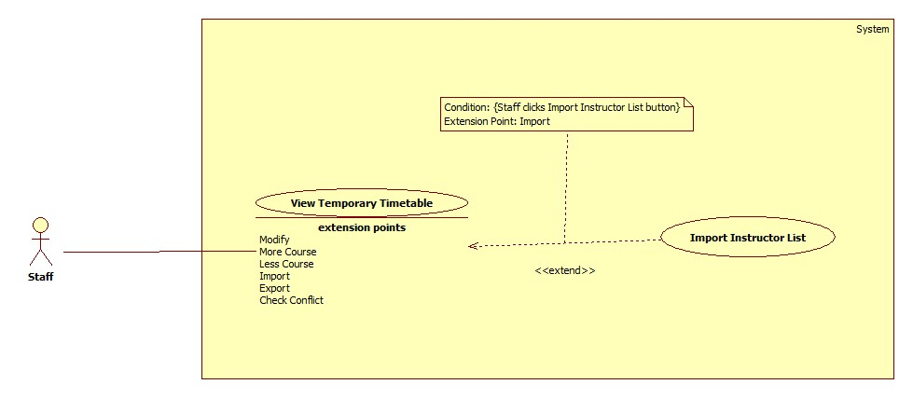

Figure 11: <Staff>Import Instructor List

|  |  |  |  |
| --- | --- | --- | --- |
| **USE CASE – UC008** | | | |
| **Use Case No.** | UC008 | **Use Case Version** | 2.0 |
| **Use Case Name** | Import Instructor List | | |
| **Author** | Pham Tran Tuan Vu | | |
| **Date** | 17/01/2015 | **Priority** | High |
| **Actor:**   * Staff   **Summary:**   * This use-case allows staff to import instructor list.   **Goal:**   * System arranges automatically instructors into timetable.   **Triggers:**   * Staff clicks “Import Instructor List” button at “View Temporary Timetable” window.   **Preconditions**:   * Log into system with Staff role * Staff has created timetable by using subject list and student list.   **Post Conditions:**   * **Success**: Instructors names are arranged into timetable. * **Fail**: System shows error message.   **Main Success Scenario:**   |  |  |  | | --- | --- | --- | | Step | Actor Action | System Response | | 1 | Staff clicks “Import Instructor List” button. | System opens the “Browse File” window. | | 2 | Staff chooses file to import then clicks “OK” button.  [Alternative 1] | System closes the “Browse File” window. System assigns instructors into timetable. |   **Alternative Scenario:**   |  |  |  | | --- | --- | --- | | No | Actor Action | System Response | | 1 | Staff clicks on “Cancel” button. | System closes the “Browse File” window. |   **Exceptions:** N/A  **Relationships**: extend View Temporary Timetable (click Import Instructor button)  **Business Rules:**   * A processing bar would be shown during the import process. * Data about Instructor, Weeks, Time (Am or PM) in Instructor List is given priority if Class and Subject match with Timetable. * If instructors in Instructor List have no course in Timetable, their name will be ignored. * If instructor in Instructor List is not exist, this row is invalid and will be show in Error List Dialog when system finishes importing. | | | |

Table 8: <Staff>Import Instructor List

##### <Staff>Add Course

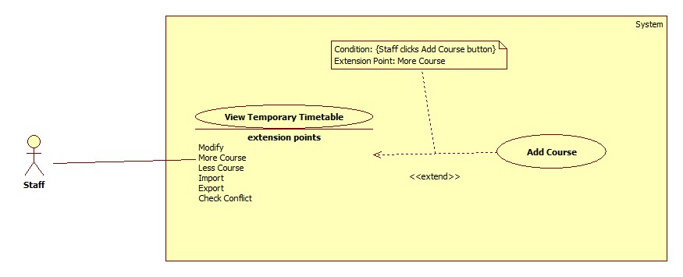

Figure 12: <Staff>Add Course

|  |  |  |  |
| --- | --- | --- | --- |
| **USE CASE – UC009** | | | |
| **Use Case No.** | UC009 | **Use Case Version** | 2.0 |
| **Use Case Name** | Add Course | | |
| **Author** | Pham Tran Tuan Vu | | |
| **Date** | 17/01/2015 | **Priority** | Normal |
| **Actor:**   * Staff   **Summary:**   * This use-case allows staff to add course into temporary timetable.   **Goal:**   * New course is shown in temporary timetable.   **Triggers:**   * Staff clicks on “Add course” button at “View Temporary Timetable” window.   **Preconditions**:   * Log into system with Staff role. * Staff has created temporary timetable.   **Post Conditions:**   * **Success**: New course is added into temporary timetable successfully. * **Fail**: System shows error message.   **Main Success Scenario:**   |  |  |  | | --- | --- | --- | | Step | Actor Action | System Response | | 1 | Staff clicks on “Add Course” button. | System shows “Add Temporary Timetable” window that contains some required input for new course include:   * Subject name: Drop-down list contains subject + week number + slot number of all plans in semester. * Class name: Drop-down list contains all classes in semester. * Time: drop-down list contains AM and PM * Weeks: drop-down list contain week number of semester (1-16 in default) * Priority Slots: Check list view contains slots in a day. (1-8 in default) * An “Add” button for staff confirms create new. * A “Cancel” button for staff cancel process. | | 2 | Staff inputs data then clicks on “Add” button.  [Alternative 1] | System closes “Add Temporary Timetable” window then shows new data on temporary timetable.  [Exception 1] |   **Alternative Scenario:**   |  |  |  | | --- | --- | --- | | No | Actor Action | System Response | | 1 | Staff clicks on “Cancel” button. | System closes “Add Temporary Timetable” window then shows temporary timetable with no changed data. |   **Exceptions:**   |  |  |  | | --- | --- | --- | | No | Actor Action | System Response | | 1 | Selected priority slots more than assigned slot of course. | System shows error message: “- Number of selected priority slots is higher than number of assigned slot per day. Please try again!” |   **Relationships**: extend View Temporary Timetable (click Add Course button)  **Business Rules:**   * If Staff select AM in Time drop-down list, the Priority Slot check list view should only contain value from 1 to 3. * If Staff select PM in Time drop-down list, the Priority Slot check list view should only contain value from 4 to 8. * If inputted information is duplicate with other existed course, system would show a warning dialog: “This class already has this subject! Please try Update or Delete function!” | | | |

Table 9: <Staff>Add Course

##### <Staff>Delete Course

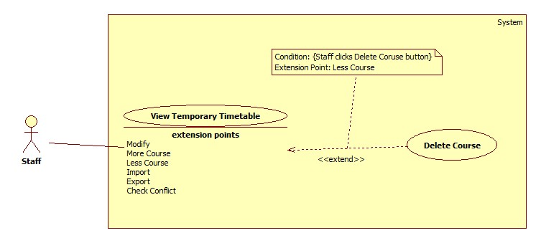

Figure 13: <Staff>Delete Course

|  |  |  |  |
| --- | --- | --- | --- |
| **USE CASE – UC010** | | | |
| **Use Case No.** | UC010 | **Use Case Version** | 2.0 |
| **Use Case Name** | Delete course | | |
| **Author** | Pham Tran Tuan Vu | | |
| **Date** | 17/01/2015 | **Priority** | Normal |
| **Actor:**   * Staff   **Summary:**   * This use-case allows staff can delete the selected course from temporary timetable.   **Goal:**   * Selected course is removed from temporary timetable.   **Triggers:**   * Staff clicks on “Delete Course” button at “View Temporary Timetable” window.   **Preconditions**:   * Log into system with Staff role. * Staff has created temporary timetable.   **Post Conditions:**   * **Success**: New course is added into temporary timetable successfully. * **Fail**: System shows error message.   **Main Success Scenario:**   |  |  |  | | --- | --- | --- | | Step | Actor Action | System Response | | 1 | Staff clicks on “Delete Course” button. | System shows warning message: “Selected timetable will be deleted permanently if you click OK button! This action cannot be recovered. Do you really want to do this?” with:   * OK button for staff confirm deleting * Cancel button for staff denies deleting | | 2 | Staff clicks OK button. [Alternative 1] | System closes the warning window and the selected course would be removed from temporary timetable. |   **Alternative Scenario:**   |  |  |  | | --- | --- | --- | | No | Actor Action | System Response | | 1 | Staff clicks on “Cancel” button. | System closes the warning window then shows temporary timetable with no changed data. |   **Exceptions:** N/A  **Relationships**: extend View Temporary Timetable (click Delete Course button)  **Business Rules:**   * Locked row cannot be deleted. * All involved data which has been created base on selected course would be also removed. | | | |

Table 10: <Staff>Delete Course

##### <Staff>Check Conflict Temporary Timetable

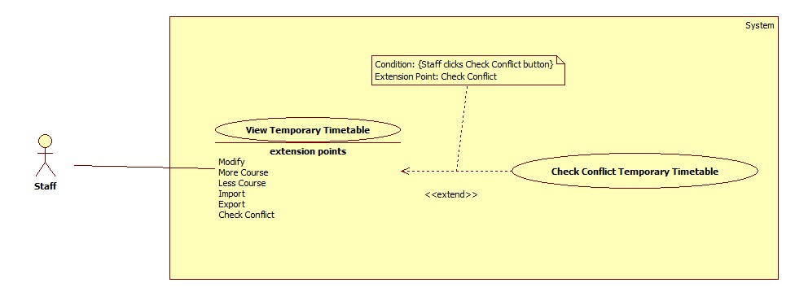

Figure 14: <Staff>Check Conflict Temporary Timetable

|  |  |  |  |
| --- | --- | --- | --- |
| **USE CASE – UC011** | | | |
| **Use Case No.** | UC011 | **Use Case Version** | 2.0 |
| **Use Case Name** | Check Conflict Temporary Timetable | | |
| **Author** | Pham Tran Tuan Vu | | |
| **Date** | 17/01/2015 | **Priority** | High |
| **Actor:**   * Staff   **Summary:**   * This use-case allows staff can check temporary timetable conflict.   **Goal:**   * System notifies to staff of the conflicts in timetable if there are.   **Triggers:**   * Staff clicks “Check Conflict” button at “View Temporary Timetable” window.   **Preconditions**:   * Log into system with Staff role. * Staff has created temporary timetable.   **Post Conditions:**   * **Success**: System notifies information of conflicts to staff. * **Fail**: System shows error message.   **Main Success Scenario:**   |  |  |  | | --- | --- | --- | | Step | Actor Action | System Response | | 1 | Staff clicks on “Check Conflict” button. | System shows conflicts information at a list view below Temporary Timetable grid view. |   **Alternative Scenario:** N/A  **Exceptions:** N/A  **Relationships**: extend View Temporary Timetable (click Check Conflict Button)  **Business Rules:**   * A process bar should be shown during the system is checking conflict. * The conflict at this phase is defined as:   + Instructor has more than three slots at AM or three slots at PM.   + Class has more than three slots at AM or three slots at PM.   + Class has been assigned to learn at both AM and PM.   + Subject has been assigned on weeks after its required subject weeks. * If there is no conflict in timetable, a message is shown “There is no conflict”. | | | |

Table 11: <Staff>Check Conflict Temporary Timetable

##### <Staff>Export Temporary Timetable

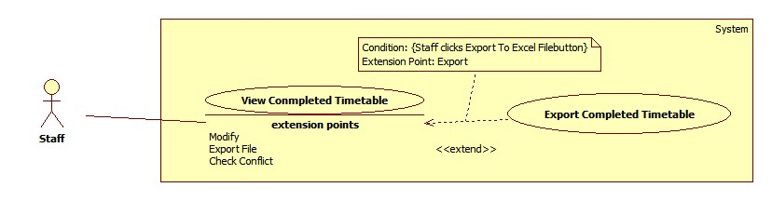

Figure 15: <Staff>Export Temporary Timetable

|  |  |  |  |
| --- | --- | --- | --- |
| **USE CASE – UC012** | | | |
| **Use Case No.** | UC012 | **Use Case Version** | 2.0 |
| **Use Case Name** | Export Temporary Timetable | | |
| **Author** | Lu Quoc Cuong | | |
| **Date** | 17/01/2015 | **Priority** | High |
| **Actor:**   * Staff   **Summary:**   * This use-case allows staff to export temporary timetable.   **Goal:**   * Temporary timetable is exported to determined format file.   **Triggers:**   * Staff clicks on “Export” button at “View Temporary Timetable” window.   **Preconditions**:   * Log into system with Staff role. * Staff has created temporary timetable.   **Post Conditions:**   * **Success**: Temporary timetable is exported. * **Fail**: System shows error message.   **Main Success Scenario:**   |  |  |  | | --- | --- | --- | | Step | Actor Action | System Response | | 1 | Staff clicks on “Export to Excel File” button. | System shows “Export Temporary Timetable” window which contains:   * “Save as”: textbox, required. * “Browse”: button. * “Subject category”: checklist, required. * “Export”: button. * “Close”: button.   [Exception 1] | | 2 | Staff chooses course of subject category want to export in checklist “Subject category”. |  | | 3 | Staff clicks on “Browse” button. | System shows the “Save As” window for staff choose location to save file. | | 4 | Staff chooses location to save file and click “Save” button. | System gets the path to show in “Save as” textbox. | | 5 | Staff clicks on “Browse” button. | System shows the “Save As” window for staff choose location to save file. | | 6 | Staff clicks on “Export” button. [Alternative 1] | System exports excel file at the chosen location and shows confirm message: “Export successfully! Are you open this file?”  Confirm message contain:   * “Yes”: button * “No”: button   [Exception 2] | | 7 | Staff clicks on “Yes” button. [Alternative 2] | System opens the file was exported. |   **Alternative Scenario:**   |  |  |  | | --- | --- | --- | | No | Actor Action | System Response | | 1 | Staff clicks on “Cancel” button. | Close this window | | 2 | Staff clicks on “Cancel” button. | N/A |   **Exceptions:**   |  |  |  | | --- | --- | --- | | No | Actor Action | System Response | | 1 | Complete timetable data is not exits | System shows message “No data to export.” | | 2 | The chosen file is opening | System shows message “Cannot write to this file!” |   **Relationships**: extend View Temporary Timetable (click Export to Excel)  **Business Rules:**   * Default file name is “TemporaryTimetable _yyyyMMddHHmmss” * Default file type is “.xsl” * Default file path is application path. * A processing bar should be shown during exporting process. * Format of Temporary Timetable excel file should be:   Untitled | | | |

Table 12: <Staff>Export Temporary Timetable

##### <Staff>Create Completed Timetable (Detail timetable for each class)

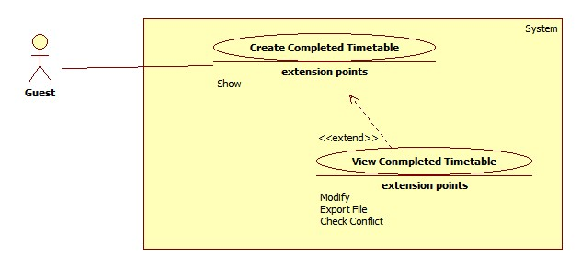

Figure 16: <Staff>Create completed timetable

|  |  |  |  |
| --- | --- | --- | --- |
| **USE CASE – UC013** | | | |
| **Use Case No.** | UC013 | **Use Case Version** | 2.0 |
| **Use Case Name** | Create complete timetable | | |
| **Author** | Lu Quoc Cuong | | |
| **Date** | 17/01/2015 | **Priority** | High |
| **Actor:**   * Staff   **Summary:**   * This use-case allows staff to create complete timetable.   **Goal:**   * System creates automatically complete timetable based on requested data.   **Triggers:**   * Staff clicks “Suggest Timetable” button on “Schedule” menu.   **Preconditions**:   * Log into system with staff role. * Temporary timetable was created.   **Post Conditions:**   * **Success**: The complete timetable was created. System shows successful message. * **Fail**: System shows error message.   **Main Success Scenario:**   |  |  |  | | --- | --- | --- | | Step | Actor Action | System Response | | 1 | Staff clicks “Create timetable” button. | System shows a list contains created temporary timetable data for staff can select the course they want to create complete timetable.  [Exception 1] | | 2 | Staff selects the course they want to create complete timetable and clicks “Suggest” button. | System shows confirm message “Are you sure suggest complete timetable for selected courses?”  Confirm message contain:   * “Yes”: button * “No”: button   [Alternative 1] [Exception 2] | | 3 | Staff clicks “Yes” button.  [Alternative 2] | The complete timetable will be created. System shows message “Complete timetable was created successfully.” |   **Alternative Scenario:**   |  |  |  | | --- | --- | --- | | No | Actor Action | System Response | | 1 | The selected course was created complete timetable | System show confirm message “The selected course was created complete timetable. Wan to override data?”  Confirm message contain:   * “Yes”: button * “No”: button | | Staff clicks “Yes” button.  [Alternative 2] | The complete timetable will be overridden. System shows message “Complete timetable was created successfully.” | | 2 | Staff clicks on “No” button. | N/A |   **Exceptions:**   |  |  |  | | --- | --- | --- | | No | Actor Action | System Response | | 1 | Temporary timetable data is not exits. | System shows message “Complete timetable unable to create because lack of timetable data.” | | 2 | No course was selected | System shows message “Must choice at least 1 course.” |   **Relationships**: extended by View Complete Timetable (click Show)  **Business Rules:**   * If the course has priority slot, it will arrange first. * If the course has not priority slot, system will automatically select relevant slots for them. * System does not automatically suggest slot 7 and slot 8 * System only suggests the date from Monday to Friday | | | |

Table 13: <Staff>Create Completed Timetable

##### <Staff>View Completed Timetable

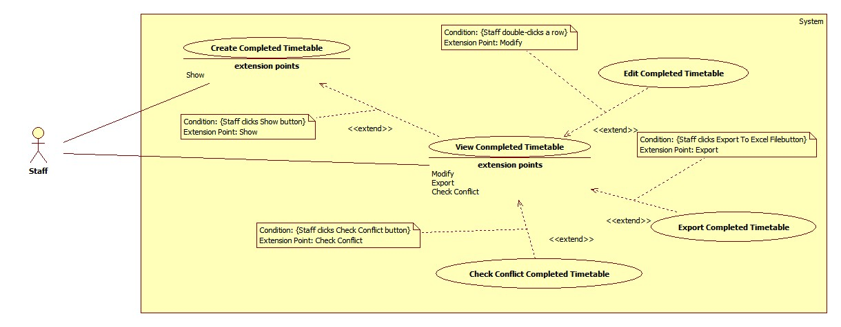

Figure 17: <Staff>View Completed Timetable

|  |  |  |  |
| --- | --- | --- | --- |
| **USE CASE – UC014** | | | |
| **Use Case No.** | UC014 | **Use Case Version** | 2.0 |
| **Use Case Name** | View completed timetable | | |
| **Author** | Lu Quoc Cuong | | |
| **Date** | 17/01/2015 | **Priority** | High |
| **Actor:**   * Staff   **Summary:**   * This use-case allows staff to view complete timetable of specific class.   **Goal:**   * Show selected class will study what subjects, who taught in each specific date and slot.   **Triggers:**   * Staff clicks “Show” button at “View Complete Timetable” window.   **Preconditions**:   * Log into system with staff role. * Complete timetable was created.   **Post Conditions:**   * **Success**: System shows complete timetable of selected class. * **Fail**: System shows error message.   **Main Success Scenario:**   |  |  |  | | --- | --- | --- | | Step | Actor Action | System Response | | 1 | Staff chooses class want to view in “Choose class” dropdown list. |  | | 2 | Staff chooses block want to view in “Choose block” dropdown list. |  | | 3 | Staff clicks “Show” button.  [Alternative 1] | System shows timetable as a grid which  shows the following information:   * “Date”: label * “Day”: label * “Slot”: label * “Subject”: label * “Instructor”: label * “Class”: label |   **Alternative Scenario:**   |  |  |  | | --- | --- | --- | | No | Actor Action | System Response | | 1 | Staff clicks “Advanced” button | Open advanced search window |   **Exceptions:** N/A  **Relationships**: extended by Edit Complete Timetable (double-click a row), extended by Export to excel (click Export to excel), extended by Check Conflict (click Check conflict) and extending Create Complete Timetable (click Show)  **Business Rules:**   * The grid is sorted by “Date”, “Slot” * Staff can edit by double clicking on the row want to edit | | | |

Table 14: <Staff>View Completed Timetable

##### <Staff>Edit Completed Timetable

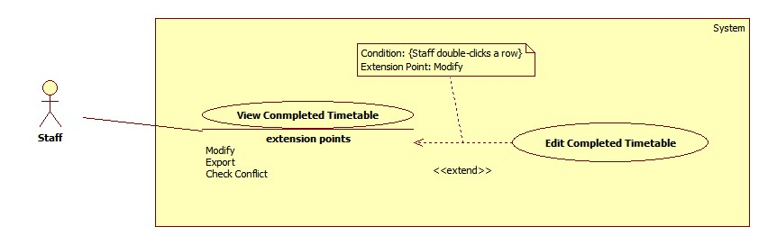

Figure 18: <Staff>Edit Completed Timetable

|  |  |  |  |
| --- | --- | --- | --- |
| **USE CASE – UC015** | | | |
| **Use Case No.** | UC015 | **Use Case Version** | 2.0 |
| **Use Case Name** | Edit Complete Timetable | | |
| **Author** | Lu Quoc Cuong | | |
| **Date** | 17/01/2015 | **Priority** | High |
| **Actor:**   * Staff   **Summary:**   * This use-case allows staff to edit information of a lesson.   **Goal:**   * Change the information of a lesson to suit the actual situation.   **Triggers:**   * Staff double-clicks to the row want to edit in the grid.   **Preconditions**:   * Log into system with staff role. * Complete timetable was shown.   **Post Conditions:**   * **Success**: These changes will be updated into the system. * **Fail**: System shows error message.   **Main Success Scenario:**   |  |  |  | | --- | --- | --- | | Step | Actor Action | System Response | | 1 | Staff double-clicks to the row want to edit in the grid. | System shows new window contains:   * “Subject”: label * “Class”: label * “Date”: date picker, require * “Slot”: dropdown list (Slot 1 -> Slot 8), require * “Instructor”: dropdown list (Load all instructors in system) | | 2 | Staff edits data in window |  | | 3 | Staff clicks “Save” button.  [Alternative 1] | These changes will be updated into the system. [Exception 1] |   **Alternative Scenario:**   |  |  |  | | --- | --- | --- | | No | Actor Action | System Response | | 1 | Staff clicks “Cancel” button. | Close the current window. |   **Exceptions:**   |  |  |  | | --- | --- | --- | | No | Actor Action | System Response | | 1 | The editing has conflict | System shows confirm message “Edited data has conflict. Are you sure update?” | | Staff clicks “OK” button.  [Alternative 1] | These changes will be updated into the system. [Exception 1] |   **Relationships**: extend View Complete Timetable (double-click a row)  **Business Rules:**   * Day is must be in the time of this semester. * Check conflict contain:   + Instructor has lesson in the editing time   + Class has lesson in the editing time | | | |

Table 15: <Staff>Edit Completed Timetable

##### <Staff>Check Conflict Completed Timetable

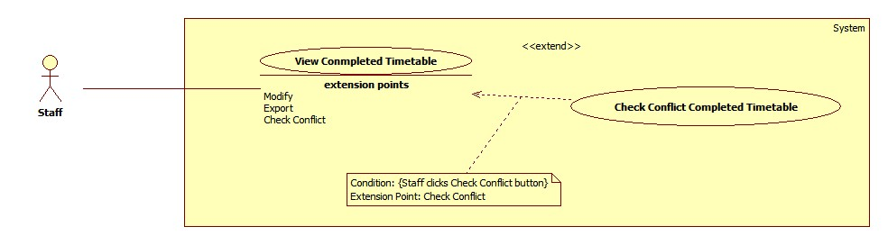

Figure 19: <Staff>Check Conflict Completed Timetable

|  |  |  |  |
| --- | --- | --- | --- |
| **USE CASE – UC016** | | | |
| **Use Case No.** | UC016 | **Use Case Version** | 2.0 |
| **Use Case Name** | Check conflict | | |
| **Author** | Lu Quoc Cuong | | |
| **Date** | 17/01/2015 | **Priority** | High |
| **Actor:**   * Staff   **Summary:**   * This use-case allows staff to check complete timetable conflict.   **Goal:**   * Show all conflict of complete timetable   **Triggers:**   * Staff clicks “Check conflict” button at “View Complete Timetable” window.   **Preconditions**:   * Log into system with staff role. * Complete timetable was created.   **Post Conditions:**   * **Success**: System shows all conflict of complete timetable. * **Fail**: System shows error message.   **Main Success Scenario:**   |  |  |  | | --- | --- | --- | | Step | Actor Action | System Response | | 1 | Staff clicks “Check conflict” button. | System shows all conflict in list view and notifies number of conflict to staff  [Exception 1] |   **Alternative Scenario:** N/A  **Exceptions:**   |  |  |  | | --- | --- | --- | | No | Actor Action | System Response | | 1 | Complete timetable is not exist | System shows message “Complete time table has not been created.” |   **Relationships**: extend View Complete Timetable (click Check Conflict)  **Business Rules:**   * The conflict at this phase is defined as: * Classes have not enough lesson planed. * In the same slot, class which learn more than one lesson. * In the same slot, instructor teaches more than one lesson. * In the same slot, two instructors teach the same class. * If instructor has a lesson, instructor will unable to guile a project in the same time. * The conflict have to informed clearly includes classes, instructor, day and slot. | | | |

Table 16: <Staff>Check Conflict Completed Timetable

##### <Staff>Export Completed Timetable

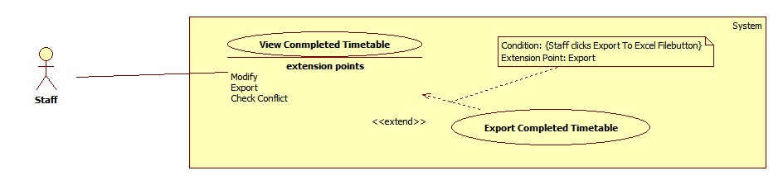

Figure 20: <Staff>Export completed timetable

|  |  |  |  |
| --- | --- | --- | --- |
| **USE CASE – UC017** | | | |
| **Use Case No.** | UC017 | **Use Case Version** | 2.0 |
| **Use Case Name** | Export complete timetable | | |
| **Author** | Lu Quoc Cuong | | |
| **Date** | 17/01/2015 | **Priority** | High |
| **Actor:**   * Staff   **Summary:**   * This use-case allows staff to export complete timetable to excel file.   **Goal:**   * System exports complete timetable to excel file with formatted font and comprehensive presentation   **Triggers:**   * Staff clicks “Export Timetable” button at “Schedule” menu.   **Preconditions**:   * Log into system with staff role. * Timetable was created.   **Post Conditions:**   * **Success**: Excel file was created. System shows successful message. * **Fail**: System shows error message.   **Main Success Scenario:**   |  |  |  | | --- | --- | --- | | Step | Actor Action | System Response | | 1 | Staff clicks “Export to Excel” button at “Schedule” menu. | System shows “Export Complete Timetable” window which contains:   * “Choose block”: dropdown list (Block 1 -> Block 4, All), require * “Save as”: textbox. * “Browse”: button. * “Export”: button. * “Close”: button.   [Exception 1] | | 2 | Staff chooses block want to export in dropdown list “Choose block”. |  | | 3 | Staff clicks on “Browse” button. | System shows the “Save As” window for staff choose location to save file. | | 4 | Staff chooses location to save file and click “Save” button. | System gets the path to show in “Save as” textbox. | | 5 | Staff clicks on “Export” button. [Alternative 1] | System exports excel file at the chosen location and shows confirm message: “Export successfully! Are you open this file?”  Confirm message contain:   * “Yes”: button * “No”: button   [Exception 2] | | 6 | Staff clicks on “Yes” button. [Alternative 2] | System opens the file was exported. |   **Alternative Scenario:**   |  |  |  | | --- | --- | --- | | No | Actor Action | System Response | | 1 | Staff clicks on “Close” button. | System closes “Export Complete Timetable” window. | | 2 | Staff clicks on “Cancel” button. | N/A |   **Exceptions:**   |  |  |  | | --- | --- | --- | | No | Actor Action | System Response | | 1 | Complete timetable data is not exits | System shows message “No data to export.” | | 2 | The chosen file is opening | System shows message “Cannot write to this file!” |   **Relationships**: extend View Complete Timetable (click Export to Excel)  **Business Rules:**   * Default file name is “CompleteTimetable_yyyyMMddHHmmss” * Default file type is “.xsl” * Default file path is application path. * Format of Temporary Timetable excel file should be:   Untitled | | | |

Table 17: <Staff>Export Completed Timetable

##### <Staff>Calculate Timekeeping

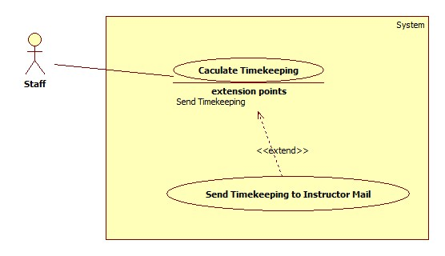

Figure 17: <Staff>Calculate Timekeeping

|  |  |  |  |
| --- | --- | --- | --- |
| **USE CASE –UC018** | | | |
| **Use Case No.** | UC018 | **Use Case Version** | 2.0 |
| **Use Case Name** | Calculate Timekeeping | | |
| **Author** | Ho Thien Nguyen | | |
| **Date** | 17/01/2015 | **Priority** | Normal |
| **Actor:**   * Staff   **Summary:**   * This use case allows Staff to view the teaching time of instructor in a period time.   **Goal:**   * View the information about teaching time of instructor.   **Triggers:**   * Staff clicks “Calculate Timekeeping” button.   **Preconditions**:   * User has login as Staff role.   **Post Conditions:**   * **Success**: Show timekeeping of instructors. * **Fail**: Show error message.   **Main Success Scenario:**   |  |  |  | | --- | --- | --- | | Step | Actor Action | System Response | | 1 | Staff clicks “Manage Timekeeping” button. | View a window shows teaching time of instructors contains:   * Name of instructors: table column * Content: table column * Teaching Time: table column * Unit: table column * Start date: date picker * End date: date picker * “Show” button | | 2 | Staff may choose start date and end date. Staff clicks “Show” Button. | Show timekeeping of instructors from chosen date.  [Exception1] |     **Alternative Scenario: N/A**  **Exceptions:**   |  |  |  | | --- | --- | --- | | No | Actor Action | System Response | | 1 | Data to view the timetable is unable to get. | Show the error message: “View timetable fail!” |   **Relationships**:   * Extended by Send Mail Timekeeping (by click “Send” button)   **Business Rules:**   * Names of instructors are sorted by alphabet. * When start “Calculate Timekeeping”, system will automatically load automatically default start date and end date in configuration file for calculating. * Staff can configure a specific number of period, ex: 28 periods will be count as 30 periods. | | | |

Table 18: <Staff>Calculate Timekeeping

##### <Staff>Assign Class Room

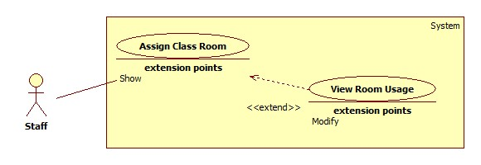

Figure 22: <Staff>Assign Class Room

|  |  |  |  |
| --- | --- | --- | --- |
| **USE CASE –UC019** | | | |
| **Use Case No.** | UC019 | **Use Case Version** | 2.0 |
| **Use Case Name** | Assign Class Room | | |
| **Author** | Ho Thien Nguyen | | |
| **Date** | 17/01/2015 | **Priority** | Normal |
| **Actor:**   * Staff   **Summary:**   * This use case allows Staff to suggest rooms for classes automatically.   **Goal:**   * Room is assigned to class correctly.   **Triggers:**   * Staff clicks “Suggest” button.   **Preconditions**:   * User has login as Staff role.   **Post Conditions:**   * **Success**: Rooms is assigned to classes. * **Fail**: Show error message.   **Main Success Scenario:**   |  |  |  | | --- | --- | --- | | Step | Actor Action | System Response | | 1 | Staff clicks “Suggest” button. | Room is assigned to class correctly and show success dialog.  [Exception 1] |   **Alternative Scenario:** N/A  **Exceptions:**   |  |  |  | | --- | --- | --- | | No | Actor Action | System Response | | 1 | Room is not enough | Show the error message: “Cannot arrange!” |   **Relationships**:   * Extended by View Room Usage (by clicking “Suggest” button)   **Business Rules:**   * Class rooms will be arranged increment. * One room allows two classes for studying, one AM class and one PM class. * Students quantity of class always below or equal room space * Only classes that have temporary timetable are going to be arranged. * If temporary timetable changes time AM/PM of a subject in a class, system will get time AM/PM of first subject in that class to set default time AM/PM for that class. | | | |

Table 17: <Staff>Calculate Timekeeping

##### <Staff>View Room Usage

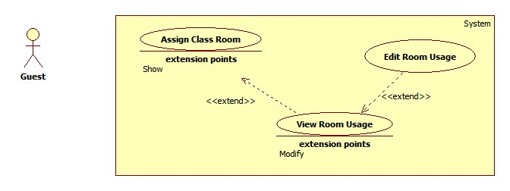

Figure 23: <Staff>View Room Usage

|  |  |  |  |
| --- | --- | --- | --- |
| **USE CASE –UC020** | | | |
| **Use Case No.** | UC020 | **Use Case Version** | 2.0 |
| **Use Case Name** | View Room Usage | | |
| **Author** | Ho Thien Nguyen | | |
| **Date** | 06/04/2015 | **Priority** | Normal |
| **Actor:**   * Staff   **Summary:**   * This use case allows staff to view class and rooms that assigned to classes.   **Goal:**   * Show result after suggest room and able to edit.   **Triggers:**   * Staff clicks “Manage Room Usage” button.   **Preconditions**:   * User has login as Staff role.   **Post Conditions:**   * **Success**: Able to view room usage. * **Fail**: Show error message.   **Main Success Scenario:**   |  |  |  | | --- | --- | --- | | Step | Actor Action | System Response | | 1 | Staff clicks “Manage Room Usage” button. | View a window shows room usage of contains:   * Class: table column * Room: table column * Quantity: table column * Room Space: table column * AM/PM: table column |   **Alternative Scenario:** N/A  **Exceptions:**   |  |  |  | | --- | --- | --- | | No | Actor Action | System Response | | 1 | Data to view the room usage is unable to get. | Show the error message: “View room Usage fail!” |   **Relationships**:   * Extended by Edit Room Usage(by double click on a data row), Extending Assign Class Room   **Business Rules:**   * Staff can add or change room by double clicks on the data row. | | | |

Table 18: <Staff>View Room Usage

##### <Staff>Export Room Usage

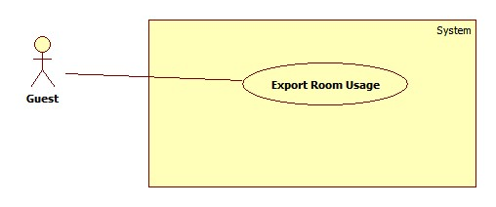

Figure 24: <Staff>Export Room Usage

|  |  |  |  |
| --- | --- | --- | --- |
| **USE CASE –UC021** | | | |
| **Use Case No.** | UC021 | **Use Case Version** | 2.0 |
| **Use Case Name** | Export Room usage | | |
| **Author** | Lu Quoc Cuong | | |
| **Date** | 17/01/2015 | **Priority** | High |
| **Actor:**   * Staff   **Summary:**   * This use-case allows staff to export room usage schedule to excel file.   **Goal:**   * System exports room usage schedule to excel file with formatted font and comprehensive presentation   **Triggers:**   * Staff clicks “Export” button at “Export Room Usage” windows.   **Preconditions**:   * User has login as staff role.   **Post Conditions:**   * **Success**: Excel file was created. System shows successful message. * **Fail**: Show error message.   **Main Success Scenario:**   |  |  |  | | --- | --- | --- | | Step | Actor Action | System Response | | 1 | Staff clicks “Export Room Usage” button at “Room” menu. | System shows “Export Room Usage” window which contains:   * “Save as”: textbox, require. * “Browse”: button. * “From”: Date picker, require. * “To”: Date picker, require. * “Export”: button. * “Close”: button. | | 2 | Staff picks “From” date and “To” date |  | | 3 | Staff clicks on “Browse” button. | System shows the “Save As” window for staff choose location to save file. | | 4 | Staff chooses location to save file and clicks “Save” button. | System gets the path to show in “Save as” textbox. | | 6 | Staff clicks on “Export” button.  [Alternative 1] | System exports excel file at the chosen location and shows confirm message: “Export successfully! Are you open this file?”  Confirm message contain:   * “Yes”: button * “No”: button   [Exception 1] | | 7 | Staff clicks on “Yes” button. [Alternative 1] | System opens the file was exported. |   **Alternative Scenario:**   |  |  |  | | --- | --- | --- | | No | Actor Action | System Response | | 1 | Staff clicks “Cancel” button | Window is closed. |   **Exceptions:**   |  |  |  | | --- | --- | --- | | No | Actor Action | System Response | | 2 | The chosen file is opening | System shows message “Cannot write to this file!” |   **Relationships**: N/A  **Business Rules:**   * Initialization value for the “From” date is nearest Monday. * Initialization value for the “To” date is nearest Saturday. * When “From” date change value, “To” date also change rapidly (“To” date equal “From” date plus 6 days) * Default file name is “RoomUsage_yyyyMMddHHmmss” * Default file type is “.xsl” * Default file path is application path. * Format of Temporary Timetable excel file should be:   **Untitled** | | | |

Table 19: <Staff>Export Room Usage

##### <Staff>Edit Room Usage

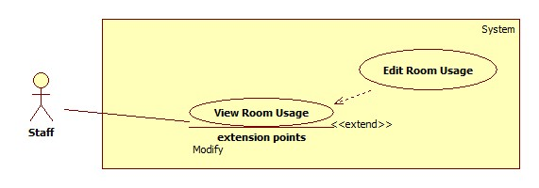

Figure 24: <Staff>Edit Room Usage

|  |  |  |  |
| --- | --- | --- | --- |
| **USE CASE –UC022** | | | |
| **Use Case No.** | UC022 | **Use Case Version** | 2.0 |
| **Use Case Name** | Edit Room Usage | | |
| **Author** | Ho Thien Nguyen | | |
| **Date** | 06/04/2015 | **Priority** | Normal |
| **Actor:**   * Staff   **Summary:**   * This use case allows Staff to edit room for a class.   **Goal:**   * Class can change to study in another room.   **Triggers:**   * Staff double clicks in a row of table.   **Preconditions**:   * User has login as Staff role. * Class has a current room value.   **Post Conditions:**   * **Success**: Class will study in changed room. * **Fail**: Show error message.   **Main Success Scenario:**   |  |  |  | | --- | --- | --- | | Step | Actor Action | System Response | | 1 | Staff double clicks in a row of data table | View a window shows information contains:   * Current information class: label * Current room name-space: label * List of rooms and their space: combo box | | 2 | Staff may select another room for class by combo box. |  | | 3 | Staff clicks “Change” button.  [Alternative 1] | System updates new room for this class  [Exception 1] |   **Alternative Scenario:**   |  |  |  | | --- | --- | --- | | No | Actor Action | System Response | | 1 | Staff clicks “Close” button | Window is closed. |   **Exceptions:**   |  |  |  | | --- | --- | --- | | No | Actor Action | System Response | | 1 | Change room has less seat than class students quantity | Show the error message: “Cannot change this room for class because of less seat.” |   **Relationships**:   * Extending View Room Usage (double clicks a row)   **Business Rules:**   * Class cannot change room itself. * If a class changes another room, but that room has another class is studying, then they will auto swap for each other. | | | |

##### <Staff>Import Project List

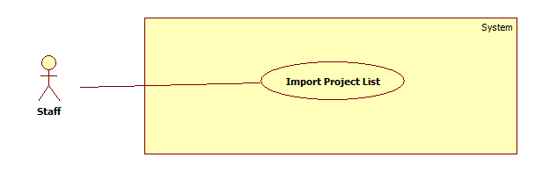

Figure 25: <Staff>Import Project List

|  |  |  |  |
| --- | --- | --- | --- |
| **USE CASE – UC023** | | | |
| **Use Case No.** | UC023 | **Use Case Version** | 2.0 |
| **Use Case Name** | Import Project List Information | | |
| **Author** | Ha Trong Trung | | |
| **Date** | 15/01/2015 | **Priority** | Normal |
| **Actor:**   * Staff   **Summary:**   * This use case allows staff to import data from Excel file to suggest guide project schedule.   **Goal:**   * Import successful excel file to suggest guide project schedule.   **Triggers:**   * Staff clicks “Import Group” from “Initiation” menu.   **Preconditions:**   * Log into system with Staff role.   **Post Conditions:**   * **Success:** Data will be imported to system and the system will show successful message. * **Fail:** The system will show an error message.   **Main Success Scenario:**   |  |  |  | | --- | --- | --- | | Step | Actor Action | System Response | | 1 | From “Timetable Management Support Tools” window, staff clicks “Import Group” icon. | System shows “Open Group Project File” window. | | 2 | Staff specifies the location of the file and clicks “Open”.  [Alternative 1] | Data will be parsed and show on “Import Group Information” window.  [Exception 1] [Exception 2] | | 3 | Staff chooses groups want to import and clicks “Save” button. [Alternative 2] [Alternative 3] [Alternative 5] | Data will be imported into system and show successful message.  [Exception 3][Exception 4] |   **Alternative Scenario:**   |  |  |  | | --- | --- | --- | | No | Actor Action | System Response | | 1 | Staff clicks “Cancel” button. | N/A | | 2 | Staff clicks “Check All” checkbox on top of table. | System will select all groups in table. | | 3 | Step 1: Data import is exist | System shows conform message: “Group type: [name of group type] already exists. Are you sure you want to overwrite it?” [Alternative 1] | | Step 2: Staff clicks “OK” button. [Alternative 3] | Data will be imported into system and show successful message | | 4 | Staff double clicks in a row on table | System shows update window to edit information of group. |   **Exceptions:**   |  |  |  | | --- | --- | --- | | No | Actor Action | System Response | | 1 | Chosen file is not Excel file. (not format *.xls) | Show error message: “Your file is not Excel file, please choose again”. | | 2 | Chosen file is wrong format. | Show error message: “Your file is wrong format, no data is parsed”. | | 3 | Data import is exist conflict. | Show the error message: “Data is exist conflict. Please check again.” | | 4 | No group is selected to import | Show the error message: “Please select groups to import.” |   **Relationships:** N/A  **Business Rules:**   * Excel file must be in 2003 version (xls. extension). * If a row has red color, there are one or more error on that row, system will not allow to import data to system.   + Group name is duplicated   + Name of topic (English) is duplicated.   + Name of topic (Vietnamese) is duplicated.   + Number of days meet instructor per week is empty.   + Instructor have to be ID (eg: KhanhKT)   + Instructor ID is not exist in system. * If a row has yellow color, there are warning on that row, system still allow to import data to system.   + Group type doesn’t exist in system. System will auto add new group type if it is not exist. * Staff can show only Error or Warning by filter on combo box. * If excel file uses Instructor Name instead of Instructor ID, system will compare with Instructor Name in system. If Instructor Name is exist, system will show on table as Instructor ID. * Staff can filter by choose group type in combo box or type on text field to filter Instructor, Topic or Group name. * Staff can double click on row to edit information before import to system.   + Staff can edit Group Name, Topic Name, Group type, and days per week.   + Staff can change only instructor exist in combo box. * When override exist data, system will delete all schedule if have of that groups. * If Instructor is not exist in system, system will show Add button. It allows staff to add new Instructor with ID, Name and Email. * Format of excel file must be either of 2 templates:   + Template 1:      * + Template 2:      * + Extra column includes: “Days per week” at the last column of each sheet. | | | |

Table 19: <Staff>Import Project List Information

##### <Staff>Create Guide Project Schedule

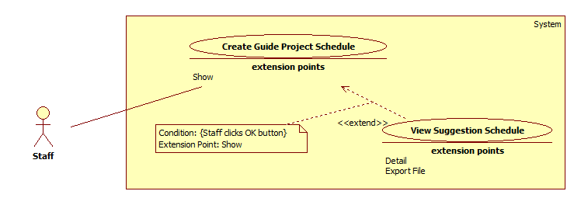

Figure 22: <Staff>Create Guide Project Schedule

|  |  |  |  |
| --- | --- | --- | --- |
| **USE CASE – UC024** | | | |
| **Use Case No.** | UC024 | **Use Case Version** | 2.0 |
| **Use Case Name** | Create guide project schedule | | |
| **Author** | Ha Trong Trung | | |
| **Date** | 15/01/2015 | **Priority** | High |
| **Actor:**   * Staff   **Summary:**   * This user case allows staff to suggest guide project schedule.   **Goal:**   * Suggest guide project schedule with information imported and available.   **Triggers:**   * Staff clicks “Suggest Schedule” from “Schedule” menu.   **Preconditions:**   * Log into system with Staff role. * Groups’ information have to be imported to system.   **Post Conditions:**   * **Success:** Schedule will be created successful and the system will show successful message. * **Fail:** The system will show an error message.   **Main Success Scenario:**   |  |  |  | | --- | --- | --- | | Step | Actor Action | System Response | | 1 | Staff clicks “Suggest Schedule” from “Schedule” menu. | Show “Project Schedule Create” window with the following things:   * “Choose block” dropdown list. * “Choose type” dropdown list. * “Suggest Schedule” button. * “Close” button | | 2 | Staff selects block by choose “Choose block” drop list. |  | | 3 | Staff chooses groups want to suggest and clicks “Suggest Schedule” button.  [Alternative 1] [Alternative 2] [Alternative 5] [Alternative 6] | System suggests a schedule depend on information imported and shows successful message and close “Project Schedule Create” window.  [Exception 1] |   **Alternative Scenario:**   |  |  |  | | --- | --- | --- | | No | Actor Action | System Response | | 1 | Staff clicks “Close” button | Close “Project Schedule Create” window. | | 2 | Step 1: The day staff wants to suggest is before current day. | Show conform window box: “The block you want to create schedule is started, Please choose option to create schedule” | | Step 2: Staff clicks “Create All” button.  [Alternative 3] [Alternative 4] | System continues suggest new schedule and show successful message | | 3 | Staff clicks “Only create new schedule from now” button. | System only suggest schedule from this week to end of block that staff choose and show successful message. | | 4 | Staff clicks “Cancel” button | System show “Project Schedule Create” window | | 5 | Staff clicks “Check All” checkbox on top of table. | System will select all groups in table. | | 6 | Step 1: This block is existed data | Show conform window box: “This semester is exist data of group you want to suggest, Are you sure you want to overwrite it?” | | Step 2: Staff clicks “OK” button. | System continues create new schedule, override into system and show successful message. [Alternative 7] | | 7 | Staff clicks “Cancel” button | N/a |   **Exceptions:**   |  |  |  | | --- | --- | --- | | No | Actor Action | System Response | | 1 | No group is selected | Show error message: “No groups is selected, please choose groups to suggest”. |   **Relationships:** Extended by View Suggestion Schedule (click Show)  **Business Rules:**   * System suggest schedule depend on information imported. * Days per week is the maximum time to meet instructor per week. * If days per week equal 2:   + Limit time to meet instructor: 45 minutes.   + System do not suggest schedule in two consecutive days per week for a group.   + System starts suggest schedule from Tuesday. * If days per week equal 1:   + Limit time to meet instructor: 90 minutes. * Staff can suggest schedule for one or more group by check box on each row. * Staff can filter by choose type in combo box or type on text field to filter Instructor, Topic or Group name. * System will not assign room for group if out of room. * Staff can setting week end in semester. System will not suggest project schedule after week end. (Example: Staff setting week end is 14, a semester has 16 week, system will suggest project schedule from week 1 to week 14). * System will select current block depend on system time. Staff can change another block by click block combo box. | | | |

Table 20: <Staff>Suggest Guide Project Schedule

##### <Staff>View Suggestion Schedule

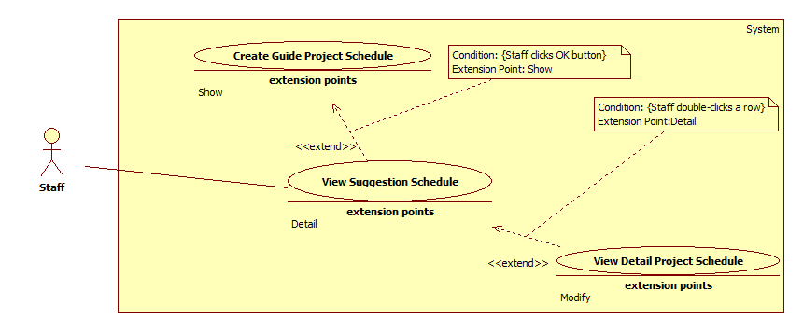

Figure 23: <Staff>View Suggestion Schedule

|  |  |  |  |
| --- | --- | --- | --- |
| **USE CASE – UC025** | | | |
| **Use Case No.** | UC025 | **Use Case Version** | 2.0 |
| **Use Case Name** | View Suggestion Schedule | | |
| **Author** | Ha Trong Trung | | |
| **Date** | 15/01/2015 | **Priority** | High |
| **Actor:**   * Staff   **Summary:**   * This user case allows staff to view guide project schedule.   **Goal:**   * Guide project schedule is shown as a grid-view.   **Triggers:**   * Staff clicks “Manage Schedule” from “Schedule” menu.   **Preconditions:**   * Log into system with Staff role. * Staff has created guide project schedule.   **Post Conditions:**   * **Success:** Guide project schedule is shown. * **Fail:** The system will show an error message.   **Main Success Scenario:**   |  |  |  | | --- | --- | --- | | Step | Actor Action | System Response | | 1 | Select block by choose “Choose block” drop list. |  | | 2 | Staff clicks on “View Schedule” button.  [Alternative 1] [Alternative 3] | System shows guide project schedule in a grid view which contains the following columns information:   * Group name: column * Instructor: column * Week Day: column * From: column * To: column * Time: column * Room: column |   **Alternative Scenario:**   |  |  |  | | --- | --- | --- | | No | Actor Action | System Response | | 1 | Step 1: No data to view schedule | System shows conforming message: “No data in block [block number] semester [semester name], Do you want to create project schedule?” | | Step 2: Staff clicks “OK” button. | System shows “Project Schedule Create” window. [Alternative 2] | | 2 | Staff clicks “Cancel” button | N/A | | 3 | Staff double clicks on a row in table. | System shows detail schedule of that row. |   **Exceptions:** N/A  **Relationships:** extended by View Detail Project Schedule (click on table) and Extending the Create Guide Project Schedule.  **Business Rules:**   * The grid is sorted by “Group” column. * Staff can view detail schedule of each group by double-click on a row. * Week day column show list week days that group meet instructor in week. * Staff can filter by choose group type in combo box or type on text field to filter Instructor, Room, Group Name. * System will select current block depend on system time. Staff can change another block by choose on block combo box. | | | |

Table 21: <Staff>View Suggestion Schedule

##### <Staff>View Detail Project Schedule

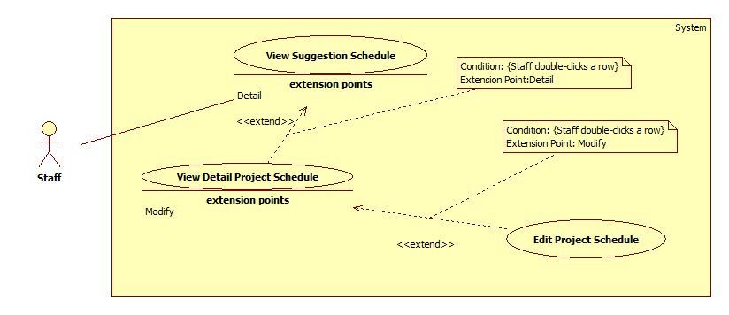

Figure 24: <Staff>View Detail Project Schedule

|  |  |  |  |
| --- | --- | --- | --- |
| **USE CASE – UC026** | | | |
| **Use Case No.** | UC026 | **Use Case Version** | 2.0 |
| **Use Case Name** | View detail project schedule | | |
| **Author** | Ha Trong Trung | | |
| **Date** | 15/01/2015 | **Priority** | Normal |
| **Actor:**   * Staff   **Summary:**   * This user case allows staff to view detail of each group’s schedule project.   **Goal:**   * View detail and update information of group that staff chosen.   **Triggers:**   * Staff double clicks on a row of table in “View Guide project schedule” window.   **Preconditions:**   * Log into system with Staff role.   **Post Conditions:**   * **Success:** System will show detail schedule of a group. * **Fail:** N/A   **Main Success Scenario:**   |  |  |  | | --- | --- | --- | | Step | Actor Action | System Response | | 1 | Staff double clicks on a row of table in “View Guide project schedule” window. | Show “View Detail” window with the following things:   * “Group”: Textbox, read-only. * “Instructor”: Textbox, read-only. * “Change day”: Button. * “Change weekday”: Button. * “Update multiple day”: Button. * “Close”: Button. | | 2 | On “View Detail” window, staff double clicks on a day in table.  [Alternative 1] | The system will show options for staff choose:   * “Change day” button. * “Change week day” button. * “Update multiple day” button. * “Cancel” button. | | 3 | Staff clicks “Change day” button.  [Alternative 2] [Alternative 3] [Alternative 4] | The system will show “Update detail” window. This window allows staff to move day from selected day to new day, edit time, room of new day. |   **Alternative Scenario:**   |  |  |  | | --- | --- | --- | | No | Actor Action | System Response | | 1 | Staff clicks on “Close” button. | System close “Update Information” window. | | 2 | Staff clicks “Change week day” button. | System will show “Update detail” window. This window allows staff to move weekday from selected day to new weekday, edit time, room of new week day. Staff can approve this change for whole block. | | 3 | Staff clicks “Update multiple day” button. | System will show “Update detail” window. This window allows staff to edit time, room of schedule in a period of time. | | 4 | Step 1: Staff edits day before current day | System shows conform dialog “The schedule for the day you selected is started. Are you sure you want to edit this date?” | | Step 2: Staff clicks “OK” button. [Alternative 5] | System show “Update detail” window. | | 5 | Staff clicks on “Cancel” button. | System return “View detail” window. |   **Exceptions:** N/A  **Relationships:** View Guide Project Schedule (double-click a row)  **Business Rules:**   * Staff cannot edit name of group and instructor. | | | |

Table 22: <Staff>View Detail Project Schedule

##### <Staff>Edit project schedule

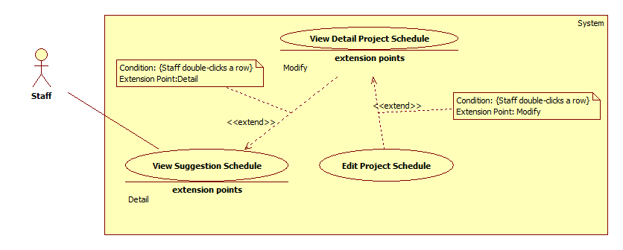

Figure 25: <Staff>Edit Project Schedule

|  |  |  |  |
| --- | --- | --- | --- |
| **USE CASE – UC027** | | | |
| **Use Case No.** | UC027 | **Use Case Version** | 2.0 |
| **Use Case Name** | Edit Temporary Timetable | | |
| **Author** | Ha Trong Trung | | |
| **Date** | 15/01/2015 | **Priority** | Normal |
| **Actor:**   * Staff   **Summary:**   * This use-case is about staff can update detail of project schedule.   **Goal:**   * Edited data is shown on detail project schedule window.   **Triggers:**   * Staff double-clicks on the row that they want to edit.   **Preconditions**:   * Log into system with staff role. * Staff has created project schedule.   **Post Conditions:**   * **Success**: Staff edits detail project schedule successfully. * **Fail**: System shows error message.   **Main Success Scenario:**   |  |  |  | | --- | --- | --- | | Step | Actor Action | System Response | | 1 | Staff double-clicks on a row in “Detail Project Schedule” window. | System shows “Update Schedule” window that contains all changeable data of this row include:   * Group: textbox, un-editable. * Instructor: textbox, un-editable. * Time: drop-down list. * Room: drop-down list. * Old Date: textbox, un-editable. * New Date: date picker. * A “Update” button for staff confirms changes. * A “Close” button for staff cancel process. | | 2 | Staff edits data then clicks on “Update” button. [Alternative 1] | System closes “Update Detail” window then shows edited data on detail project schedule.  [Exception 1] [Exception 2] |   **Alternative Scenario:**   |  |  |  | | --- | --- | --- | | No | Actor Action | System Response | | 1 | Staff clicks on “Close” button. | System closes “Update Detail” window. |   **Exceptions:**   |  |  |  | | --- | --- | --- | | No | Actor Action | System Response | | 1 | Room update is used | System shows error message: “Room [Room Name] in slot [New Slot] at [Date] is used.” | | 2 | Instructor is busy in new slot | System shows error message: “[Instructor name] has class in slot [Slot Name] at [Date].” |   **Relationships**: extend View Detail Project Schedule (double-click a row)  **Business Rules:**   * “Update Detail” window contains data of the row staff has clicked. * Time will show depend on the number days meet instructor per week.   + If days per week is 2: Time will show 45 minutes per period.   + If days per week is 1: Time will show depend on a slot. (90 minutes) * System is not allow to change new date is Sunday. * System is only allow change date in a semester. | | | |

Table 23: <Staff>Edit Project Schedule

##### <Staff>Export guide project schedule

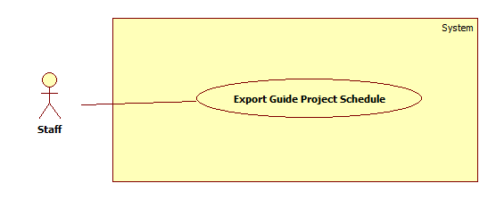

Figure 26: <Staff>Export Guide Project Schedule

|  |  |  |  |
| --- | --- | --- | --- |
| **USE CASE – UC028** | | | |
| **Use Case No.** | UC028 | **Use Case Version** | v2.0 |
| **Use Case Name** | Export guide project schedule to excel file | | |
| **Author** | Ha Trong Trung | | |
| **Date** | 15/01/2015 | **Priority** | Normal |
| **Actor:**   * Staff   **Summary:**   * This user case allows staff to export guide project schedule to excel file.   **Goal:**   * Staff will have an excel file of guide project schedule.   **Triggers:**   * Staff clicks “Export” from “Schedule” menu.   **Preconditions:**   * Log into system with Staff role. * Guide project schedule have to create successful.   **Post Conditions:**   * **Success:** Schedule will be export to excel file successful and notify to staff. * **Fail:** The system will show an error message.   **Main Success Scenario:**   |  |  |  | | --- | --- | --- | | Step | Actor Action | System Response | | 1 | Staff clicks “Export” from “Schedule” menu. | Show “Project Schedule Export” window with the following things:   * “Browse” button. * “Choose block” dropdown list. | | 2 | Staff clicks “Browse” button, choose location and clicks on “Save” button.  [Alternative 1] |  | | 3 | Staff selects block by choosing “Block” drop list and clicking “Export” | System exports excel file at the chosen location and shows conform dialog “Export Excel Successful.”  [Exception 1] | | 4 | Staff clicks “OK” button. | System opens excel file and close “Project Schedule Export” window.  [Alternative 2] |   **Alternative Scenario:**   |  |  |  | | --- | --- | --- | | No | Actor Action | System Response | | 1 | Staff clicks on “Close” button. | N/A | | 2 | Staff clicks “Cancel” button. | N/A |   **Exceptions:**   |  |  |  | | --- | --- | --- | | No | Actor Action | System Response | | 1 | No data in block selected | System shows error message: “No data in this block”. |   **Relationships:** N/A  **Business Rules:**   * Default export file type is “.xsl” * Default file name is “Project_Schedule_ yyyyMMddHHmmss” * Default file path is application path. * Format of project schedule excel file should be: | | | |

Table 24: <Staff>Export Guide Project Schedule

##### <Staff>Send Timekeeping Into Instructor Mail

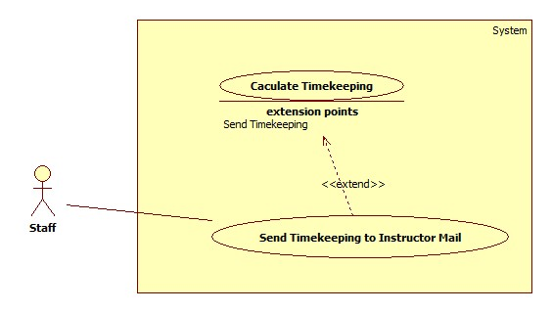

Figure 28: <Staff>Send Timekeeping to Instructor Mail

|  |  |  |  |
| --- | --- | --- | --- |
| **USE CASE –UC029** | | | |
| **Use Case No.** | UC029 | **Use Case Version** | 2.0 |
| **Use Case Name** | Send Timekeeping Mail | | |
| **Author** | Ho Thien Nguyen | | |
| **Date** | 17/01/2015 | **Priority** | Normal |
| **Actor:**   * Staff   **Summary:**   * This use case allows Staff to send the timekeeping to selected instructors.   **Goal:**   * The timekeeping is sent for many instructors in once time.   **Triggers:**   * Staff clicks “Send Mail” button.   **Preconditions**:   * User has login as Staff role * The timekeeping was created.   **Post Conditions:**   * **Success**: The timekeeping is sent successfully. * **Fail**: Show error message.   **Main Success Scenario:**   |  |  |  | | --- | --- | --- | | Step | Actor Action | System Response | | 1 | Staff clicks “Send Mail” button. | Show the send mail window contains:   * List instructor name: list check view * “Check all”: button * “Uncheck all”: button * “Send” button * “Close” button | | 2 | Staff checks to choose instructor.  [Alternative 1], [Alternative 2] |  | | 3 | Staff clicks “Send” button. [Alternative 3] | Timekeeping will send to selected instructors and system shows the success messages.  [Exception 1] |   **Alternative Scenario:**   |  |  |  | | --- | --- | --- | | No | Actor Action | System Response | | 1 | Staff clicks “Check all” button. | Check all list instructors. | | 2 | Staff clicks “Uncheck all” button. | Uncheck all list instructors. | | 3 | Staff clicks “Close” button | Current window is closed. |   **Exceptions:**   |  |  |  | | --- | --- | --- | | No | Actor Action | System Response | | 1 | Send mail is corrupted. | Show the error message: “Send mail fail!” |   **Relationships**: Extending the View Timekeeping (by click “Send Mail”).  **Business Rules:** N/A | | | |

Table 25: <Staff>Send Timekeeping to Instructor Mail

##### <Staff>Send Timetable to Instructor Mail

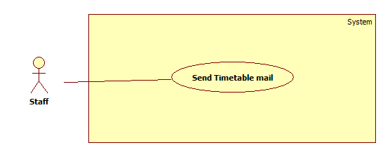

Figure 28: <Staff>Send Timetable to Instructor Mail

|  |  |  |  |
| --- | --- | --- | --- |
| **USE CASE – UC030** | | | |
| **Use Case No.** | UC030 | **Use Case Version** | 2.0 |
| **Use Case Name** | Send/synchronize mail to the instructors’ timetable | | |
| **Author** | Ha Trong Trung | | |
| **Date** | 15/01/2015 | **Priority** | High |
| **Actor:**   * Staff   **Summary:**   * This use case allows staff to send timetable to instructors’ mail.   **Goal:**   * Instructors will be received timetable in a block.   **Triggers:**   * Staff has to click “Send Mail” from “Schedule” menu.   **Preconditions:**   * Log into system with Staff role. * Timetable must be created successful.   **Post Conditions:**   * **Success:** Instructors will be received timetable by mail and show successful message. * **Fail:** The system will show an error message.   **Main Success Scenario:**   |  |  |  | | --- | --- | --- | | Step | Actor Action | System Response | | 1 | Select block by choosing “Block” drop list. |  | | 2 | Click “Show Instructors” button. | System shows list of all names of instructors who have courses in the selected and block. Right screen includes:   * Check boxes to choose instructors * “Check all”: checkbox * “Synchronize to instructor's Google Calendar” checkbox   [Exception 1] | | 3 | Choose Instructor by check checkboxes.  [Alternative 1], [Alternative 2] |  | | 4 | Check “Synchronize to instructor's Google Calendar” checkbox.  [Alternative 3] | The system send timetable to instructor’s mail and synchronize schedule with Google Calendar. | | 5 | Click “Send Mail” button. |  | | 6 |  | Send information about the timetable to instructors’ mail with the defined template.  [Exception 2], [Exception 3] |   **Alternative Scenario:**   |  |  |  | | --- | --- | --- | | No | Actor Action | System Response | | 1 | Staff checks “Check all” check box. | Check all instructors in check boxes list. | | 2 | Staff unchecks “Uncheck all” check box. | Uncheck all instructors in check boxes list. | | 3 | Staff unchecks “Synchronize to instructor's Google Calendar” checkbox | The system only send timetable to instructor’s mail, do not synchronize schedule with Google Calendar. |   **Exceptions:**   |  |  |  | | --- | --- | --- | | No | Actor Action | System Response | | 1 | Empty instructor of selected block. | Show error window box: “Timetable of [block name] do not have any instructor.” | | 2 | No instructor is chosen | Show error window box: “No instructor to send, please check again” |   **Relationships**: N/A  **Business Rules**:   * List all instructors have courses in selected block. * If staff checks “Synchronize to instructor's Google Calendar” checkbox, the system will send request to instructors’ mail to synchronize timetable to instructor’s Google Calendar. * System will select current block depend on system time. Staff can change another block by click block combo box. * Format of email when send mail: | | | |

Table 26: <Staff>Send Timetable to Instructor Mail

##### <Staff>Send Project Schedule to Instructor Mail

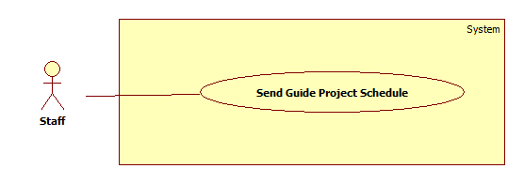

Figure 29: <Staff>Send Project Schedule to Instructor Mail

|  |  |  |  |
| --- | --- | --- | --- |
| **USE CASE – UC031** | | | |
| **Use Case No.** | UC031 | **Use Case Version** | 2.0 |
| **Use Case Name** | Send/synchronize mail to the instructors’ project schedule | | |
| **Author** | Ha Trong Trung | | |
| **Date** | 15/01/2015 | **Priority** | High |
| **Actor:**   * Staff   **Summary:**   * This use case allows staff to send project schedule to instructors’ mail.   **Goal:**   * Instructors will be received project schedule in a block.   **Triggers:**   * Staff has to click “Send Mail” from “Schedule” menu.   **Preconditions:**   * Log into system with Staff role. * Project schedule must be suggested successful.   **Post Conditions:**   * **Success:** Instructors will be received project schedule by mail and show successful message. * **Fail:** The system will show an error message.   **Main Success Scenario:**   |  |  |  | | --- | --- | --- | | Step | Actor Action | System Response | | 1 | Select block by choosing “Block” drop list. |  | | 2 | Click “Show Instructors” button. | System shows list of all names of instructors who have courses in the selected and block. Right screen includes:   * Check boxes to choose instructors * “Check all”: checkbox * “Synchronize to instructor's Google Calendar” checkbox   [Exception 1] | | 3 | Choose Instructor by check checkboxes.  [Alternative 1], [Alternative 2] |  | | 4 | Check “Synchronize to instructor's Google Calendar” checkbox.  [Alternative 3] | The system send project schedule to instructor’s mail and synchronize schedule with Google Calendar. | | 5 | Click “Send Mail” button. |  | | 6 |  | Send information about the project schedule to instructors’ mail with the defined template.  [Exception 2], [Exception 3] |   **Alternative Scenario:**   |  |  |  | | --- | --- | --- | | No | Actor Action | System Response | | 1 | Staff checks “Check all” check box. | Check all instructors in check boxes list. | | 2 | Staff unchecks “Uncheck all” check box. | Uncheck all instructors in check boxes list. | | 3 | Staff unchecks “Synchronize to instructor's Google Calendar” checkbox | The system only send project schedule to instructor’s mail, do not synchronize schedule with Google Calendar. |   **Exceptions:**   |  |  |  | | --- | --- | --- | | No | Actor Action | System Response | | 1 | Empty instructor of selected block. | Show error window box: “Project schedule of [block name] do not have any instructor.” | | 2 | No instructor is chosen | Show error window box: “No instructor to send, please check again” |   **Relationships**: N/A  **Business Rules**:   * List all instructors have courses in selected block. * If staff checks “Synchronize to instructor's Google Calendar” checkbox, the system will send request to instructors’ mail to synchronize project schedule to instructor’s Google Calendar. * System will select current block depend on system time. Staff can change another block by click block combo box. * Format of email when send mail: | | | |

Table 27: <Staff>Send Project Schedule to Instructor Mail

##### <Staff>Logout

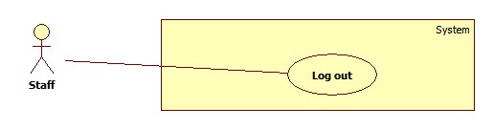

Figure 30: <Staff>Logout

|  |  |  |  |
| --- | --- | --- | --- |
| **USE CASE – UC032** | | | |
| **Use Case No.** | UC032 | **Use Case Version** | 2.0 |
| **Use Case Name** | Log out | | |
| **Author** | Pham Tran Tuan Vu | | |
| **Date** | 17/01/2015 | **Priority** | Normal |
| **Actor:**   * Staff   **Summary:**   * This use-case allows staff to log out system.   **Goal:**   * Staff logs out system and becomes Guest that is not able to use system’s functions.   **Triggers:**   * Staff clicks on “Log out” button.   **Preconditions**:   * Log into system with staff role.   **Post Conditions:**   * **Success**:   + Staff logs out system and becomes Guest.   + System show “Login” windows. * **Fail**: N/A   **Main Success Scenario:**   |  |  |  | | --- | --- | --- | | Step | Actor Action | System Response | | 1 | Staff clicks on “Log out” button. | System shows a message “Do you want to log out?” with “OK” and “Cancel” button. | | 2 | Staff clicks “OK” button. [Alternative 1] | System closes the message.  System shows the “Login” window.  System kills the session of Staff role. |   **Alternative Scenario:**   |  |  |  | | --- | --- | --- | | No | Actor Action | System Response | | 1 | Staff clicks “Cancel” button. | System closes the message. |   **Exceptions:** N/A  **Relationships**: N/A  **Business Rules:** N/A | | | |

Table 28: <Staff>Logout

## Software System Attribute

### 14.1 Usability

#### Graphic User Interface

* Language is used should be English.

#### Usability

* Staff should need less than one training week to interact with system productivity.

#### Installation

* The system is easy to deploy if following the steps in installation guide.

### 14.2 Availability

* System can run without network connection. In case network is not available, user still can use all features except “Send Mail” and “Synchronize”.

### 14.3 Security

* Only user who has account can access into System.
* System always ask for authentication every time user open application.
* System always check authorization before process user’s request.

### 14.4 Maintainability

* Code is easy to maintain and upgrade.

### 14.5 Performance

(All the cases below are tested using 12Mbps Internet Connection Broadband)

* The total time for creating and sending mail for each instructor to SMTP host is less than 15 seconds per mail.
* The speed of synchronize timetable and project guide schedule to Instructor’s Google Calendar is less than 4 seconds per record.
* The speed of suggest temporary timetable is less than 2 second per class.
* The speed of suggest completed timetable is less than 0.5 second per class.

## Conceptual Diagram

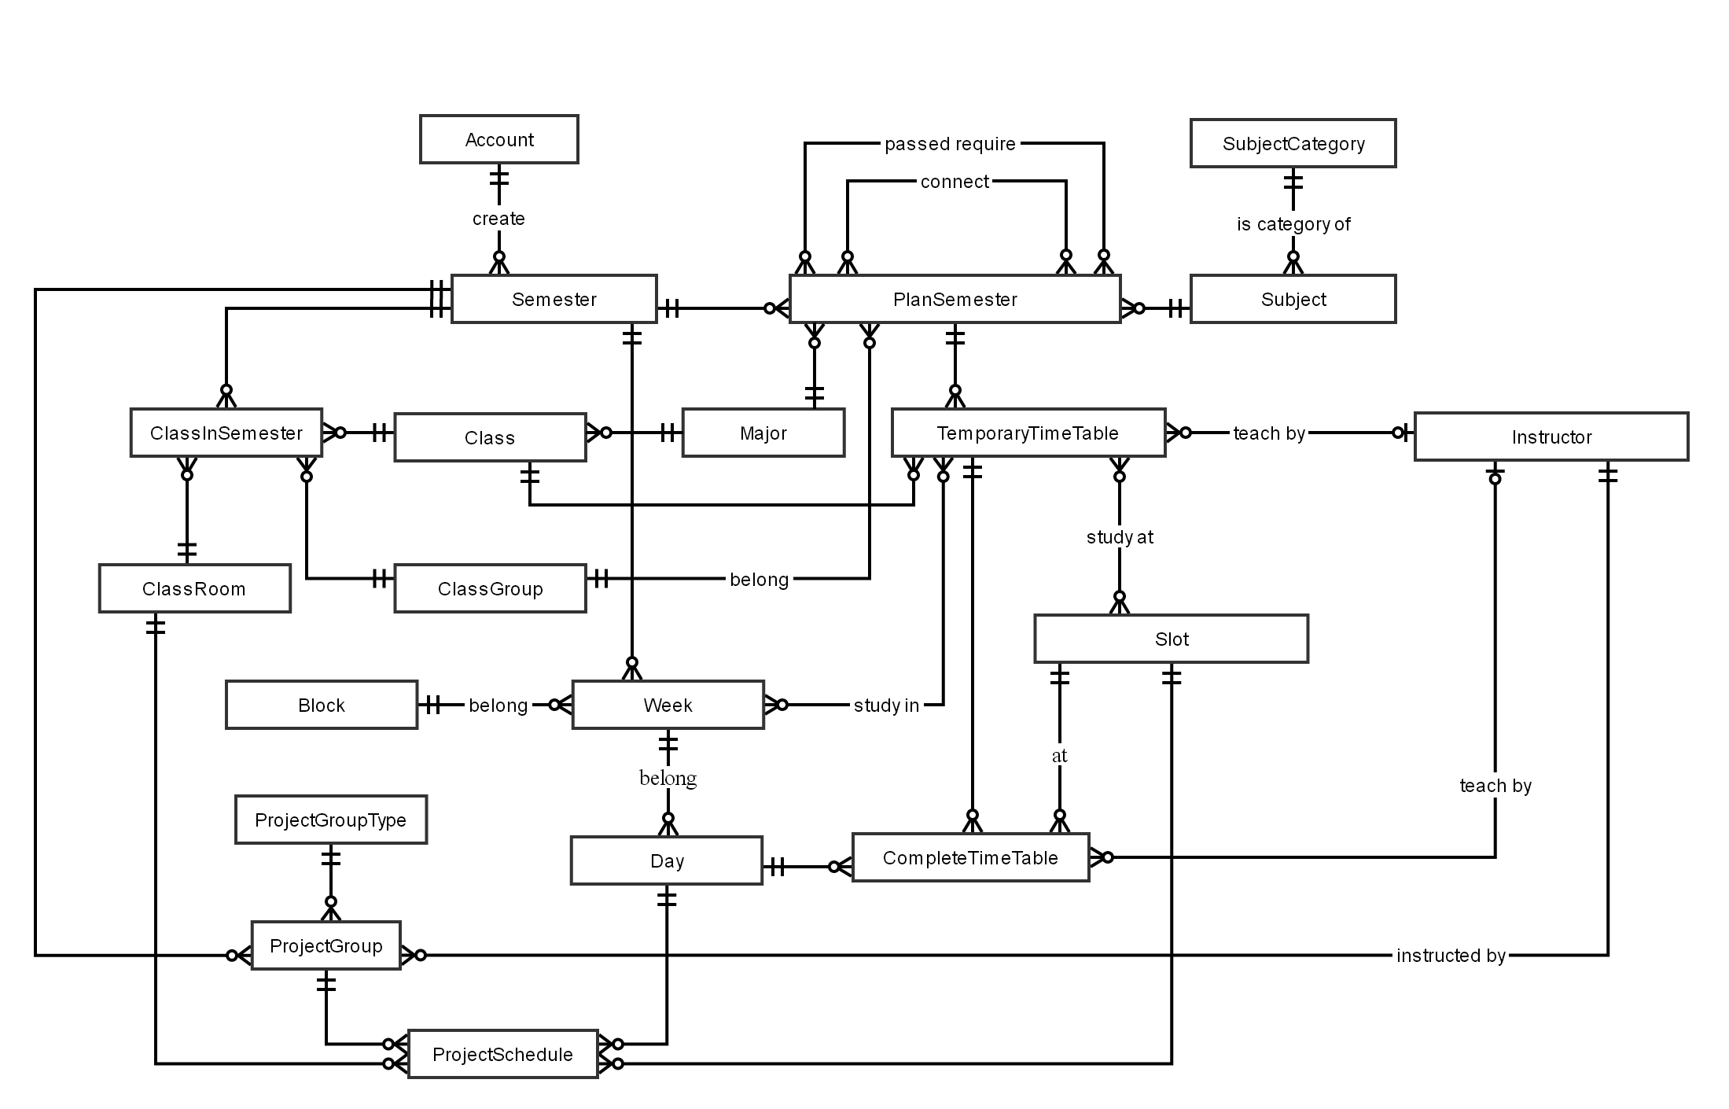

Figure 31: Conceptual Diagram

Data dictionary:

|  |  |
| --- | --- |
| **Entity Name** | **Description** |
| Account | Describe all user of the system. Each user has only one account. |
| Semester | Describe the semesters of FPT University, each semester at FPT University is about 4 months. |
| ClassRoom | Describe the rooms of FPT University which can be used for teaching. |
| Class | Describe the classes in FPT University. Each class is a set of students who have same courses. |
| ClassInSemester | Describe the specific class in a specific semester. |
| ClassGroup | Describe the sets of class in FPT University have the same plan in a semester. |
| Major | Describe the sets of class in FPT University have the same major. |
| Slot | Describe the slot in FPT University. Each slot is 90 minutes. |
| Day | Describe the official day in FPT University’s curriculum. Each day has 8 slots. |
| Week | Describe the week in FPT University’s curriculum. |
| Block | Describe the sets of weeks defined by FPT University. |
| Subject | Describe all available subject in FPT University. |
| SubjectCategory | Describe the sets of Subject. |
| PlanSemester | Describe the specific subjects which are available for each class group in a specific semester. Each semester has many plan semesters. |
| Instructor | Describe all instructors in FPT University. |
| CompletedTimetable | Describe the timetable in FPT University. Each timetable is about a set of answers for these question: which class has which subjects, teaching by who (instructor), at which specific period? |
| TemporaryTimetable | Describe the timetable in a brief description way. |
| ProjectGroup | Describe the set of students who is doing Capstone Project and Graduation Thesis. |
| ProjectGroupType | Describe the type of project group. |
| ProjectSchedule | Describe the time for meeting of project groups with their Instructor. |

Table 29: Data dictionary

Relationship dictionary:

|  |  |
| --- | --- |
| **Relationship** **Name** | **Description** |
| Passed require (between PlanSemester and PlanSemester) | Describe a PlanSemester have to be learned before one or few others PlanSemester. |
| Connect (between PlanSemester and PlanSemester) | Describe a PlanSemester have to be learned right after another PlanSemester (both of them have to learned in the same Semester). |
| Study in (between TemporaryTimetable and Week) | Describe which weeks the Temporary Timetable is assigned in. |
| Study at (between TemporaryTimetable and Slot) | Describe which slots the Temporary Timetable is assigned at. |

# Software Design Description

## Design Overview

* This document describes the technical and user interface design of Timetable Management Support Tools. It includes the architectural design, the detailed design of common functions and business functions.
* The architectural design describes the overall architecture of the system and the architecture of each main component and subsystem.
* The detailed design describes static and dynamic structure for each component and functions. It includes class diagrams, class explanations and sequence diagrams for each use cases.
* The database design describes the relationships between entities and details of each entity.
* Document overview:
* **Section 2:** The overall description of the system architectural design.
* **Section 3:** Component diagrams that describe the connection and integration of the system.
* **Section 4:** Detail design description, which includes class diagram, class explanation, and sequence diagram to describe the application functions.
* **Section 5:** The user interface of application.
* **Section 6:** Database design with entity relationship diagram.
* **Section 7:** The algorithms used for timetable, schedule suggestion.

## 17. System Architectural Design

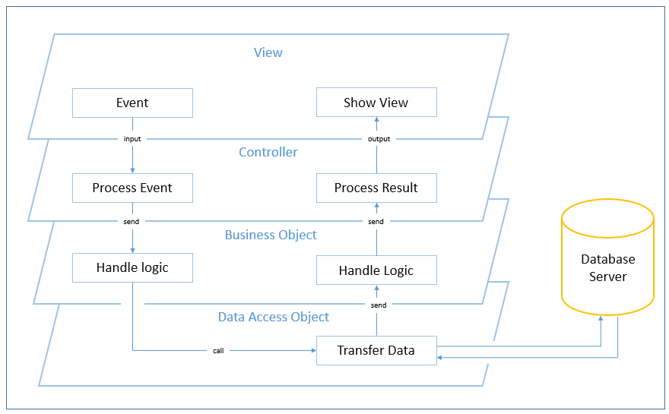

Figure 1: TMST System Architectural

* The System Architectural model of system is Multi Layered Architecture (MLA) model for some reason:

+ TMST is a desktop application which contain many features, so using MLA model could reduce complexity of code, and also reduce code per layer.

+ Requirement is changed and updated frequently, so using MLA model could provide the easy way to test, maintain code and add new functionality or reuse code.

## 18. Component Diagram

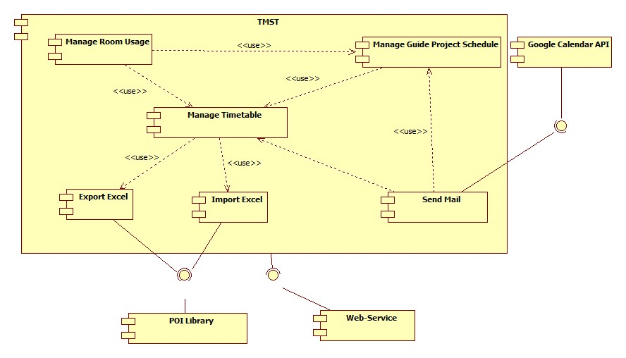

Figure 2: Component Diagram

|  |  |
| --- | --- |
| Component dictionary | |
| Component Name | Description |
| Manage Timetable | Component contains all modules about Suggest, Create, Edit, Check Conflict Temporary Timetable and Completed Timetable. |
| Manage Room Usage | Component contains all modules about Suggest, View, and Edit Room Usage. |
| Manage Guide Project Schedule | Component contains all modules about Suggest, View, and Edit Guide Project Schedule. |
| Export Excel | Component contains module that is used to export Timetable, Manage Guide Project Schedule, and Room Usage to Excel file. |
| Import Excel | Component contains module that is used to import Plan Semester, Class List, Instructor List, and Guide Project List into System. |
| Send Mail | Component contains module that is used to send Timekeeping, Timetable, and Project Schedule to Instructor. |
| POI library | Component contains library that is used for system can import or export excel file. Download at:  <http://poi.apache.org/download.html> |
| Web Service | Component contains module that is used for get access key to system can synchronize Timetable and Guide Project Schedule to Google Calendar. |
| Google Calendar API | Component contains Google Calendar API to help system can synchronize and send mail to Google Calendar. |

Table 1: Component Dictionary

## 19.Detailed Description

### 19.1 Class Diagram

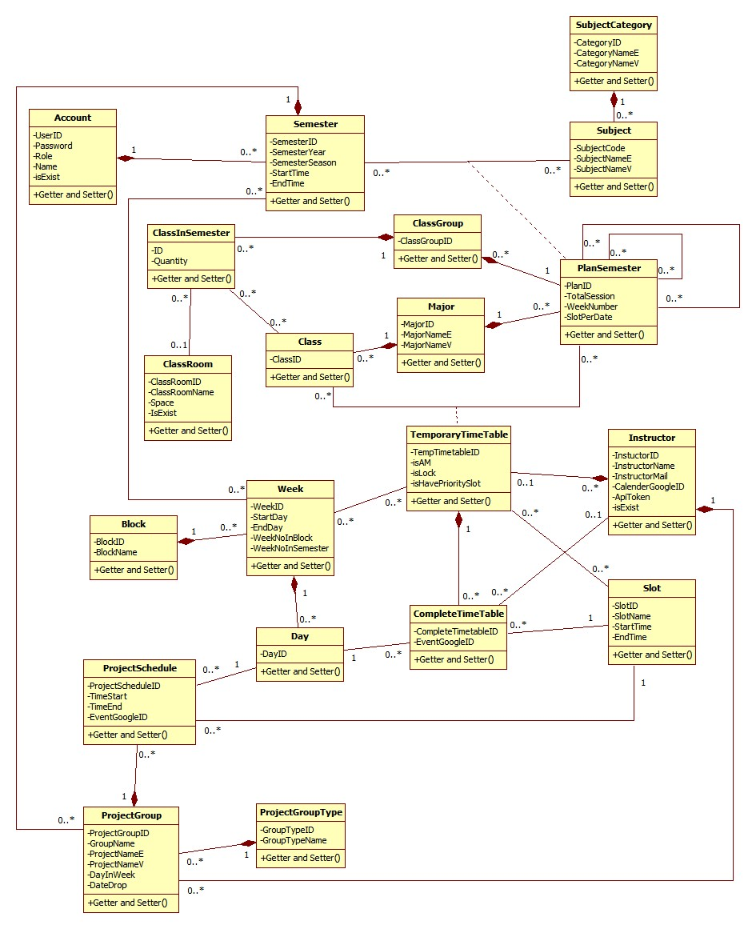

Figure 3: Class Diagram

|  |  |
| --- | --- |
| **Class dictionary** | |
| **Class Name** | **Description** |
| Account | Describe all user of the system. Each user has only one account. |
| Semester | Describe the semesters of FPT University, each semester at FPT University is about 4 months. |
| ClassRoom | Describe the rooms of FPT University which can be used for teaching. |
| Class | Describe the classes in FPT University. Each class is a set of students who have same courses. |
| ClassInSemester | Describe the specific class in a specific semester. |
| ClassGroup | Describe the sets of class in FPT University have the same plan in a semester. |
| Major | Describe the sets of class in FPT University have the same major. |
| Slot | Describe the slot in FPT University. Each slot is 90 minutes. |
| Day | Describe the official day in FPT University’s curriculum. Each day has 8 slots. |
| Week | Describe the week in FPT University’s curriculum. |
| Block | Describe the sets of weeks defined by FPT University. |
| Subject | Describe all available subject in FPT University. |
| SubjectCategory | Describe the sets of Subject. |
| PlanSemester | Describe the specific subjects which are available for each class group in a specific semester. Each semester has many plan semesters. |
| Instructor | Describe all instructors in FPT University. |
| CompletedTimetable | Describe the timetable in FPT University. Each timetable is about a set of answers for these question: which class has which subjects, teaching by who (instructor), at which specific period? |
| TemporaryTimetable | Describe the timetable in a brief description way. |
| ProjectGroup | Describe the set of students who is doing Capstone Project and Graduation Thesis. |
| ProjectGroupType | Describe the type of project group. |
| ProjectSchedule | Describe the time for meeting of project groups with their Instructor. |

Table 2: Class Dictionary

### 19.2 Class Diagram Explanation

#### 19.2.1 Account

Attribute

|  |  |  |  |
| --- | --- | --- | --- |
| **Attribute** | **Type** | **Visibility** | **Description** |
| UserID | String | Private | Unique identifier of an Account |
| Password | String | Private | Password of account user |
| Role | Integer | Private | Role name |
| Name | String | Private | Name of account user |
| isExist | Boolean | Private | Identifier of active account or not |

Method

|  |  |  |  |
| --- | --- | --- | --- |
| **Method** | **Return type** | **Visibility** | **Description** |
| Getter | Attribute type | Public | Get attribute value |
| Setter | Void | Public | Set value of attribute |

#### 19.2.2 Semester

Attribute

|  |  |  |  |
| --- | --- | --- | --- |
| **Attribute** | **Type** | **Visibility** | **Description** |
| SemesterID | Interger | Private | ID of semester |
| SemesterYear | Interger | Private | Year of semester |
| SemesterSeason | String | Private | Season of semester |
| StartTime | Date | Private | Start time of a semester |
| EndTime | Date | Private | End time of a semester |

Method

|  |  |  |  |
| --- | --- | --- | --- |
| **Method** | **Return type** | **Visibility** | **Description** |
| Getter | Attribute type | Public | Get attribute value |
| Setter | Void | Public | Set value of attribute |

#### 19.2.3 SubjectCategory

Attribute

|  |  |  |  |
| --- | --- | --- | --- |
| **Attribute** | **Type** | **Visibility** | **Description** |
| CategoryID | String | Private | ID of category |
| CategoryNameE | String | Private | Category name in English |
| CategoryNameV | String | Private | Category name in Vietnamese |

Method

|  |  |  |  |
| --- | --- | --- | --- |
| **Method** | **Return type** | **Visibility** | **Description** |
| Getter | Attribute type | Public | Get attribute value |
| Setter | Void | Public | Set value of attribute |

#### 19.2.4 Subject

Attribute

|  |  |  |  |
| --- | --- | --- | --- |
| **Attribute** | **Type** | **Visibility** | **Description** |
| SubjectCode | String | Private | ID of subject |
| SubjectNameE | String | Private | Subject name in English |
| SubjectNameV | String | Private | Subject name in Vietnamese |

Method

|  |  |  |  |
| --- | --- | --- | --- |
| **Method** | **Return type** | **Visibility** | **Description** |
| Getter | Attribute type | Public | Get attribute value |
| Setter | Void | Public | Set value of attribute |

#### 19.2.5 PlanSemester

Attribute

|  |  |  |  |
| --- | --- | --- | --- |
| **Attribute** | **Type** | **Visibility** | **Description** |
| PlanID | Integer | Private | ID of a plan semester |
| TotalSession | Integer | Private | Number of session for a plan semester |
| WeekNumber | Integer | Private | Number of week for a plan semester |
| SlotPerDate | Integer | Private | Number of slot for a plan semester |

Method

|  |  |  |  |
| --- | --- | --- | --- |
| **Method** | **Return type** | **Visibility** | **Description** |
| Getter | Attribute type | Public | Get attribute value |
| Setter | Void | Public | Set value of attribute |

#### 19.2.6 Major

Attribute

|  |  |  |  |
| --- | --- | --- | --- |
| **Attribute** | **Type** | **Visibility** | **Description** |
| MajorID | String | Private | ID of major |
| MajorNameE | String | Private | Name of major in English |
| MajorNameV | String | Private | Name of major in VietNam |

Method

|  |  |  |  |
| --- | --- | --- | --- |
| **Method** | **Return type** | **Visibility** | **Description** |
| Getter | Attribute type | Public | Get attribute value |
| Setter | Void | Public | Set value of attribute |

#### 19.2.7 ClassGroup

Attribute

|  |  |  |  |
| --- | --- | --- | --- |
| **Attribute** | **Type** | **Visibility** | **Description** |
| ClassGroupID | Integer | Private | ID of group class |

Method

|  |  |  |  |
| --- | --- | --- | --- |
| **Method** | **Return type** | **Visibility** | **Description** |
| Getter | Attribute type | Public | Get attribute value |
| Setter | Void | Public | Set value of attribute |

#### 19.2.8 Class

Attribute

|  |  |  |  |
| --- | --- | --- | --- |
| **Attribute** | **Type** | **Visibility** | **Description** |
| ClassID | String | Private | ID of class |

Method

|  |  |  |  |
| --- | --- | --- | --- |
| **Method** | **Return type** | **Visibility** | **Description** |
| Getter | Attribute type | Public | Get attribute value |
| Setter | Void | Public | Set value of attribute |

#### 19.2.9 ClassInSemester

Attribute

|  |  |  |  |
| --- | --- | --- | --- |
| **Attribute** | **Type** | **Visibility** | **Description** |
| ID | Integer | Private | ID of a class in semester |
| Quantity | Integer | Private | Number of student of class in semester |

Method

|  |  |  |  |
| --- | --- | --- | --- |
| **Method** | **Return type** | **Visibility** | **Description** |
| Getter | Attribute type | Public | Get attribute value |
| Setter | Void | Public | Set value of attribute |

#### 19.2.10 ClassRoom

Attribute

|  |  |  |  |
| --- | --- | --- | --- |
| **Attribute** | **Type** | **Visibility** | **Description** |
| ClassRoomID | Integer | Private | ID of classroom |
| ClassRoomName | String | Private | Name of classroom |
| Space | Integer | Private | Room space of classroom |
| IsExist | Boolean | Private | Identifier if room is valid to use |

Method

|  |  |  |  |
| --- | --- | --- | --- |
| **Method** | **Return type** | **Visibility** | **Description** |
| Getter | Attribute type | Public | Get attribute value |
| Setter | Void | Public | Set value of attribute |

#### 19.2.11 Temporary Time Table

Attribute

|  |  |  |  |
| --- | --- | --- | --- |
| **Attribute** | **Type** | **Visibility** | **Description** |
| TempTimetableID | Integer | Private | ID of temporary timetable |
| isAM | Boolean | Private | Identifier if timetable is AM or PM |
| isLock | Boolean | Private | Identifier if timetable is lock |
| isHavePrioritySlot | Boolean | Private | Identifier if timetable have priority slot |

Method

|  |  |  |  |
| --- | --- | --- | --- |
| **Method** | **Return type** | **Visibility** | **Description** |
| Getter | Attribute type | Public | Get attribute value |
| Setter | Void | Public | Set value of attribute |

#### 19.2.12 Slot

Attribute

|  |  |  |  |
| --- | --- | --- | --- |
| **Attribute** | **Type** | **Visibility** | **Description** |
| SlotID | Integer | Private | ID of slot |
| SlotName | String | Private | Name of slot |
| StartTime | Time | Private | Start time of slot in a day |
| EndTime | Time | Private | End time of slot in day |

Method

|  |  |  |  |
| --- | --- | --- | --- |
| **Method** | **Return type** | **Visibility** | **Description** |
| Getter | Attribute type | Public | Get attribute value |
| Setter | Void | Public | Set value of attribute |

#### 19.2.13 Instructor

Attribute

|  |  |  |  |
| --- | --- | --- | --- |
| **Attribute** | **Type** | **Visibility** | **Description** |
| InstuctorID | Integer | Private | ID in instructor |
| InstructorName | String | Private | Name of instructor |
| InstructorMail | String | Private | Mail of instructor |
| CalenderGoogleID | String | Private | ID of Google calendar |
| ApiToken | String | Private | Access token to synchronize Google calendar |
| isExist | Boolean | Private | Identifier if instructor is valid to use |

Method

|  |  |  |  |
| --- | --- | --- | --- |
| **Method** | **Return type** | **Visibility** | **Description** |
| Getter | Attribute type | Public | Get attribute value |
| Setter | Void | Public | Set value of attribute |

#### 19.2.14 Block

Attribute

|  |  |  |  |
| --- | --- | --- | --- |
| **Attribute** | **Type** | **Visibility** | **Description** |
| BlockID | Integer | Private | ID of block in semester |
| BlockName | String | Private | Name of block in semester |

Method

|  |  |  |  |
| --- | --- | --- | --- |
| **Method** | **Return type** | **Visibility** | **Description** |
| Getter | Attribute type | Public | Get attribute value |
| Setter | Void | Public | Set value of attribute |

#### 19.2.15 Week

Attribute

|  |  |  |  |
| --- | --- | --- | --- |
| **Attribute** | **Type** | **Visibility** | **Description** |
| WeekID | Integer | Private | Unique identifier of a week |
| StartDay | Date | Private | The start date of this week |
| EndDay | Date | Private | The end date of this week |
| WeekNoInBlock | Integer | Private | Ordinal numbers of week in a block |
| WeekNoInSemester | Integer | Private | Ordinal numbers of week in the semester |

Method

|  |  |  |  |
| --- | --- | --- | --- |
| **Method** | **Return type** | **Visibility** | **Description** |
| Getter | Attribute type | Public | Get attribute value |
| Setter | Void | Public | Set value of attribute |

#### 19.2.16 Day

Attribute

|  |  |  |  |
| --- | --- | --- | --- |
| **Attribute** | **Type** | **Visibility** | **Description** |
| DayID | Date | Private | Unique identifier of a date |

Method

|  |  |  |  |
| --- | --- | --- | --- |
| **Method** | **Return type** | **Visibility** | **Description** |
| Getter | Attribute type | Public | Get attribute value |
| Setter | Void | Public | Set value of attribute |

#### 19.2.17 CompleteTimeTable

Attribute

|  |  |  |  |
| --- | --- | --- | --- |
| **Attribute** | **Type** | **Visibility** | **Description** |
| CompleteTimetableID | Integer | Private | ID of complete timetable |
| EventGoogleID | String | Private | ID of Google Event |

Method

|  |  |  |  |
| --- | --- | --- | --- |
| **Method** | **Return type** | **Visibility** | **Description** |
| Getter | Attribute type | Public | Get attribute value |
| Setter | Void | Public | Set value of attribute |

#### 19.2.18 ProjectGroupType

Attribute

|  |  |  |  |
| --- | --- | --- | --- |
| **Attribute** | **Type** | **Visibility** | **Description** |
| GroupTypeID | Integer | Private | ID of group type |
| GroupTypeName | String | Private | Name of group type |

Method

|  |  |  |  |
| --- | --- | --- | --- |
| **Method** | **Return type** | **Visibility** | **Description** |
| Getter | Attribute type | Public | Get attribute value |
| Setter | Void | Public | Set value of attribute |

#### 19.2.19 ProjectGroup

Attribute

|  |  |  |  |
| --- | --- | --- | --- |
| **Attribute** | **Type** | **Visibility** | **Description** |
| ProjectGroupID | Integer | Private | ID of project group |
| GroupName | String | Private | Topic name of project group |
| ProjectNameE | String | Private | Name project in English |
| ProjectNameV | String | Private | Name project in Vietnamese |
| DayInWeek | Integer | Private | Number of meeting times with instructor in a week |
| DateDrop | Date | Private | Date drop if a group dropped |

Method

|  |  |  |  |
| --- | --- | --- | --- |
| **Method** | **Return type** | **Visibility** | **Description** |
| Getter | Attribute type | Public | Get attribute value |
| Setter | Void | Public | Set value of attribute |

#### 19.2.20 ProjectSchedule

Attribute

|  |  |  |  |
| --- | --- | --- | --- |
| **Attribute** | **Type** | **Visibility** | **Description** |
| ProjectScheduleID | Integer | Private | ID of project schedule |
| TimeStart | Time | Private | Time start of project schedule |
| TimeEnd | Time | Private | Time end of project schedule |
| EventGoogleID | String | Private | ID of Google event |

Method

|  |  |  |  |
| --- | --- | --- | --- |
| **Method** | **Return type** | **Visibility** | **Description** |
| Getter | Attribute type | Public | Get attribute value |
| Setter | Void | Public | Set value of attribute |

### Interaction Diagram

#### 19.3.1 <Staff>Import Plan Semester

**Summary:** This diagram shows how staff import plan semester into system.

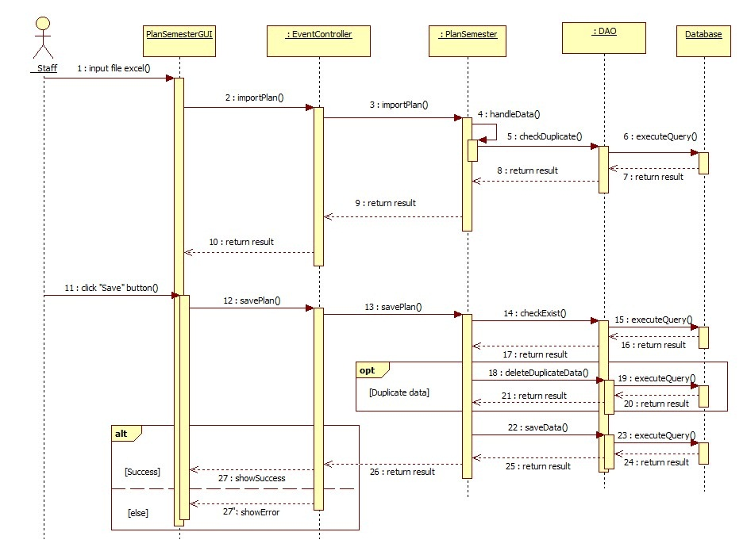

Figure 4: Sequence Diagram <Staff>Import Plan Semester

#### 19.3.2 <Staff>Import Class in Semester

**Summary:** This diagram shows how staff import class into system.

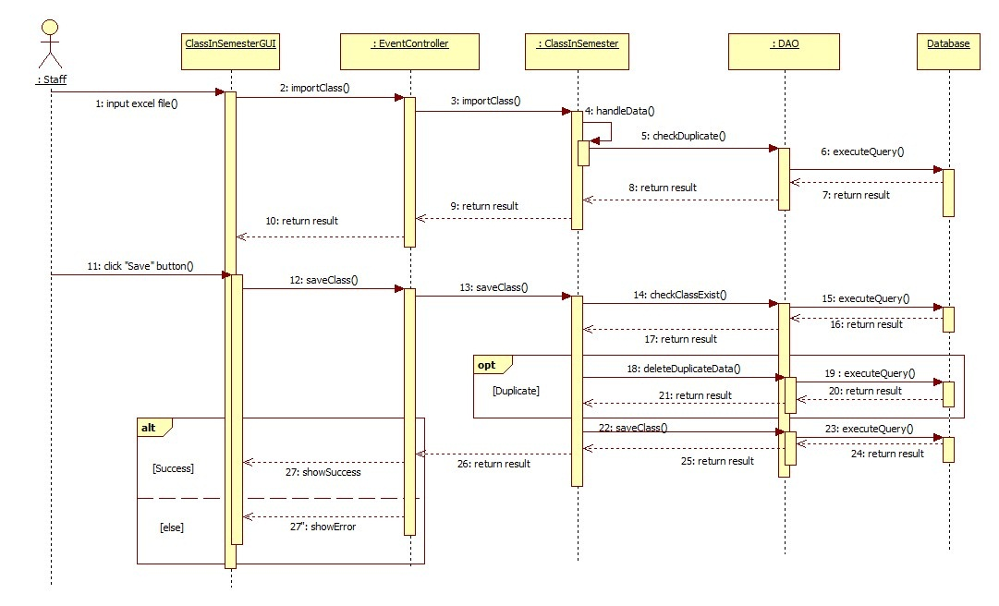

Figure 5: Sequence Diagram <Staff>Import Class in Semester

#### 19.3.3 <Staff>Create Temporary Timetable

**Summary:** This diagram shows how system suggest temporary timetable.

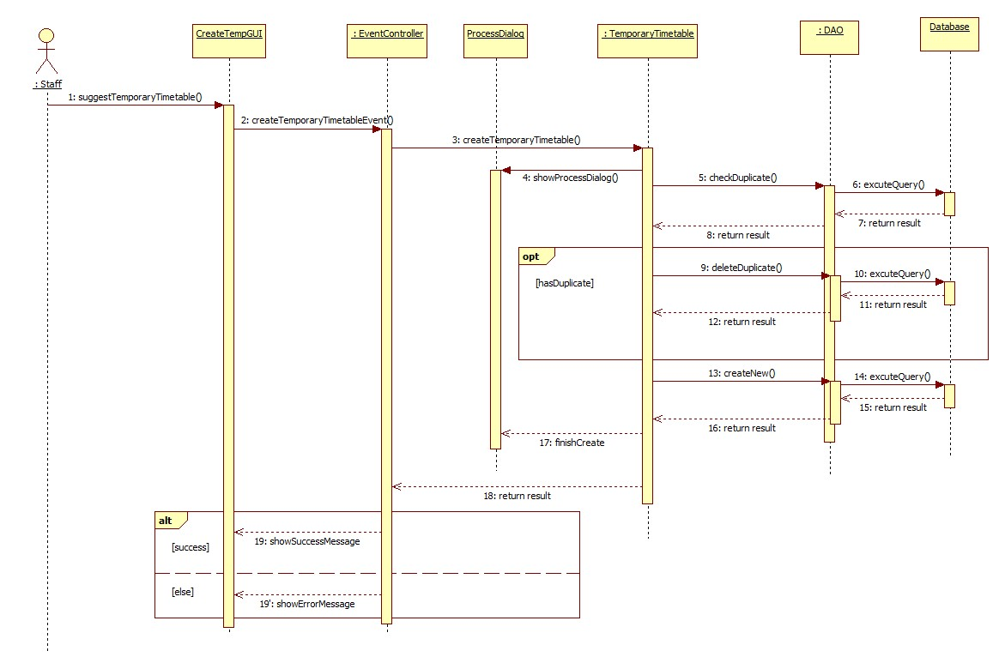

Figure 6: Sequence Diagram <Staff>Create Temporary Timetable

#### 19.3.4 <Staff>View Temporary Timetable

**Summary:** This diagram shows how staff view temporary timetable.

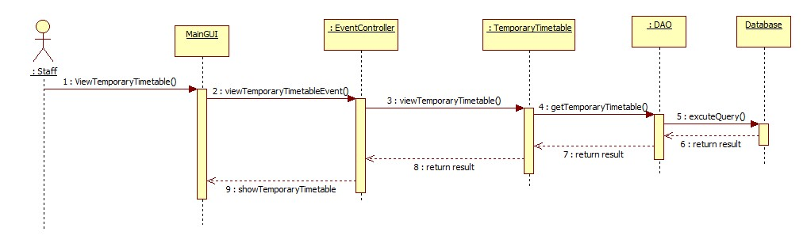

Figure 7: Sequence Diagram <Staff>View Temporary Timetable

#### 19.3.5 <Staff>Edit Temporary Timetable

**Summary:** This diagram shows how staff edit temporary timetable.

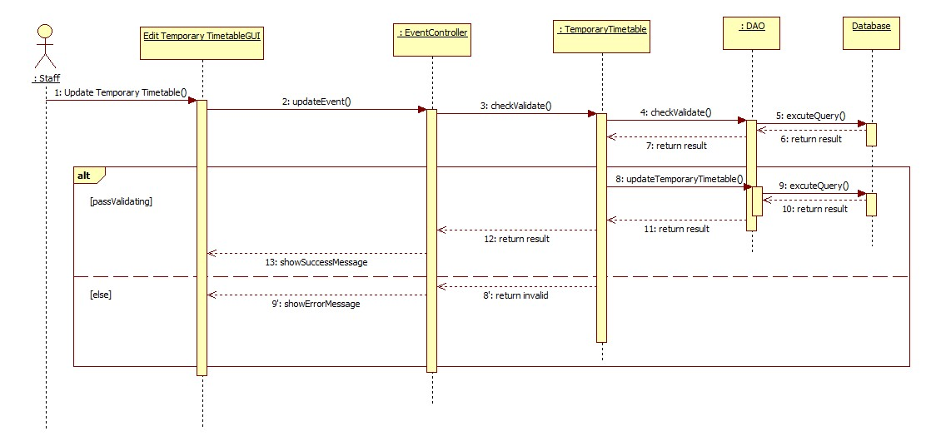

Figure 8: Sequence Diagram <Staff>Edit Temporary Timetable

#### 19.3.6 <Staff>Export Temporary Timetable

**Summary:** This diagram shows how staff export temporary timetable to excel file.

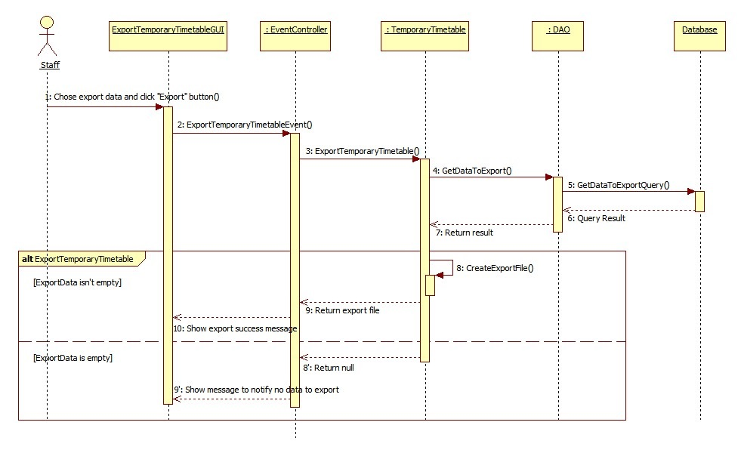

Figure 9: Sequence Diagram<Staff>Export Temporary Timetable

#### 19.3.7 <Staff>Import Instructor List

**Summary:** This diagram shows how staff import instructor list into system.

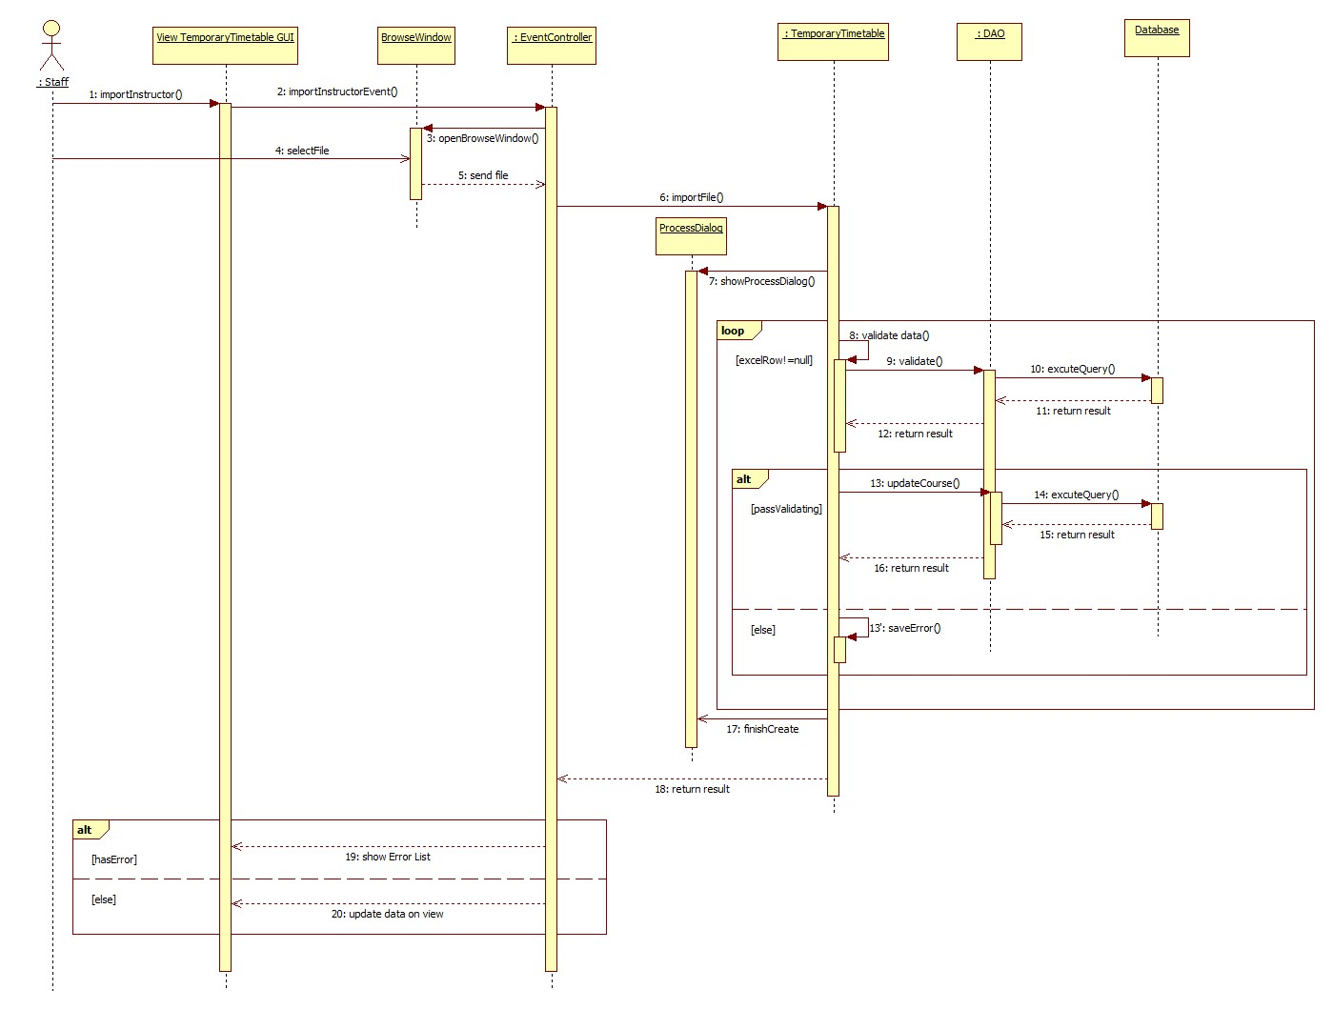

Figure 10: Sequence Diagram <Staff>Import Instructor List

#### 19.3.8 <Staff>Check Conflict (Temporary Timetable)

**Summary:** This diagram shows how staff check conflict of temporary timetable

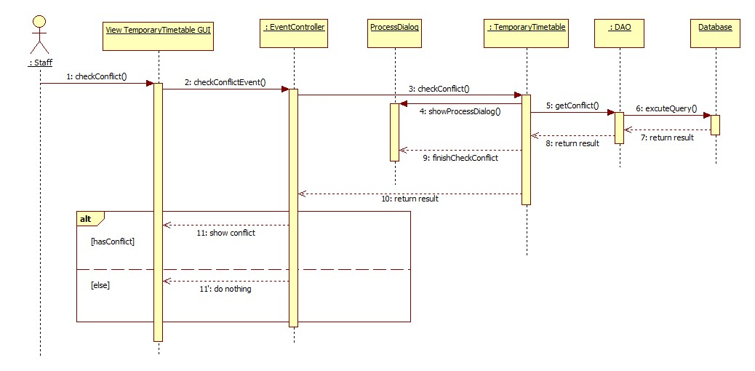

Figure 11: Sequence Diagram <Staff>Check Conflict (Temporary Timetable)

#### 19.3.9 <Staff>Create Complete Timetable

**Summary:** This diagram shows how system suggest complete timetable from temporary timetable data

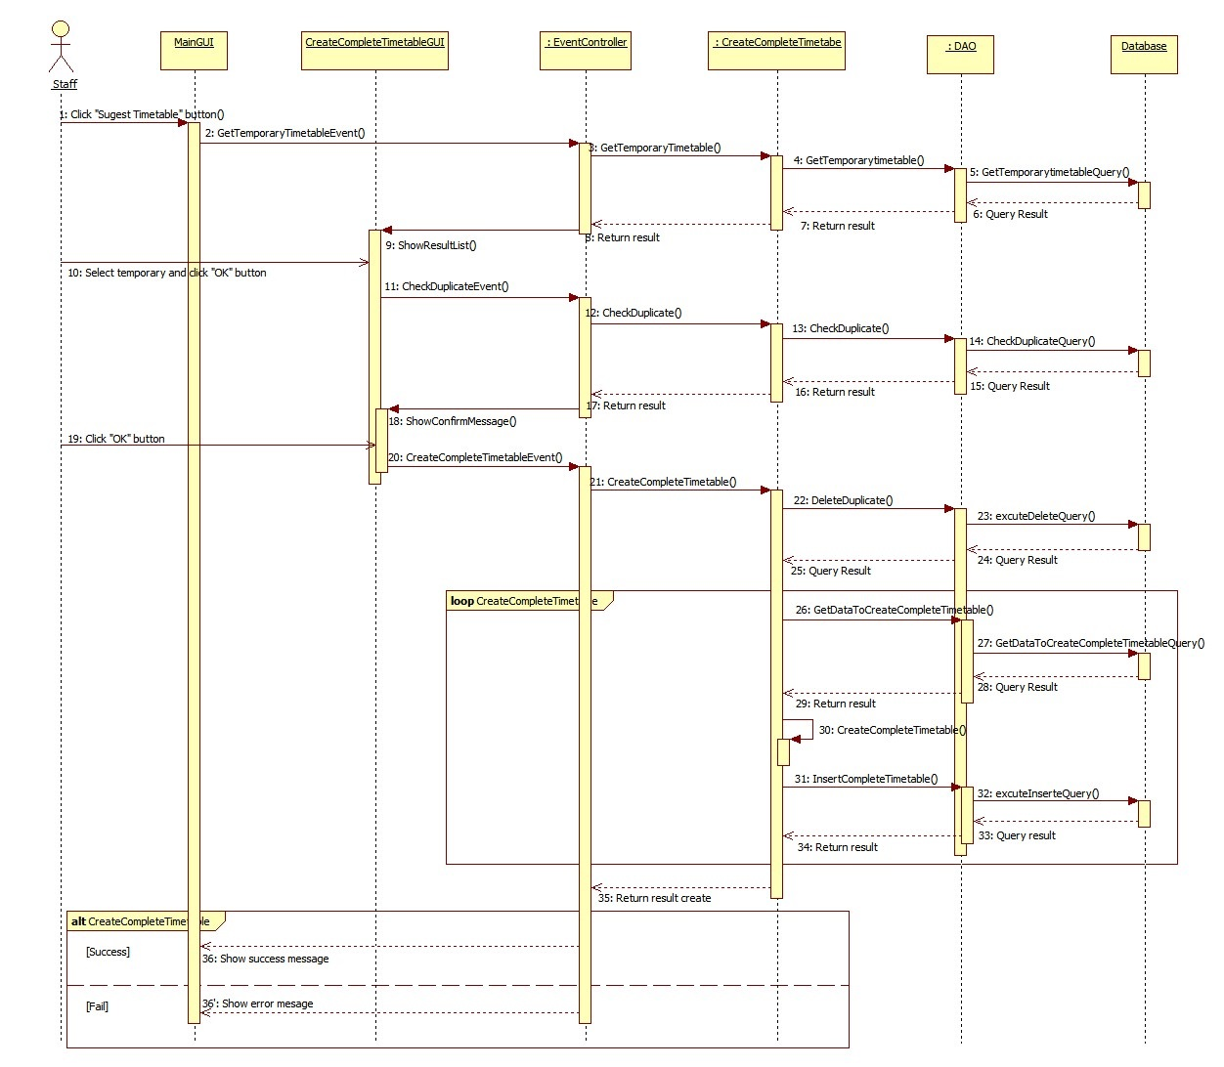

Figure 12: Sequence Diagram <Staff>Create Complete Timetable

#### 19.3.10 <Staff>View Complete Timetable

**Summary:** This diagram shows how staff view complete timetable

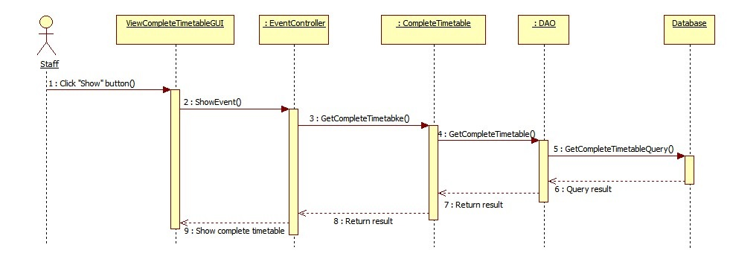

Figure 13: Sequence Diagram <Staff>View Complete Timetable

#### 19.3.11 <Staff>Check Conflict (Complete Timetable)

**Summary:** This diagram shows how staff check conflict of complete timetable

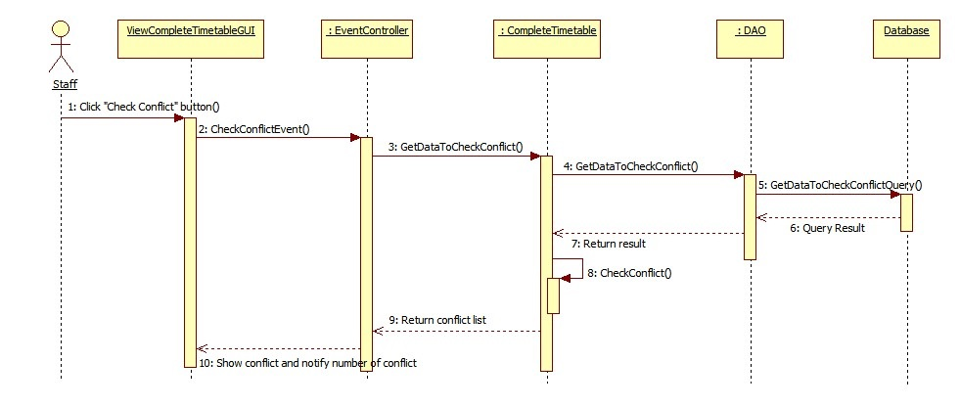

Figure 14: Sequence Diagram <Staff>Check Conflict (Complete Timetable)

#### 19.3.12 <Staff>Export Complete Timetable

**Summary:** This diagram shows how staff export complete timetable to excel file

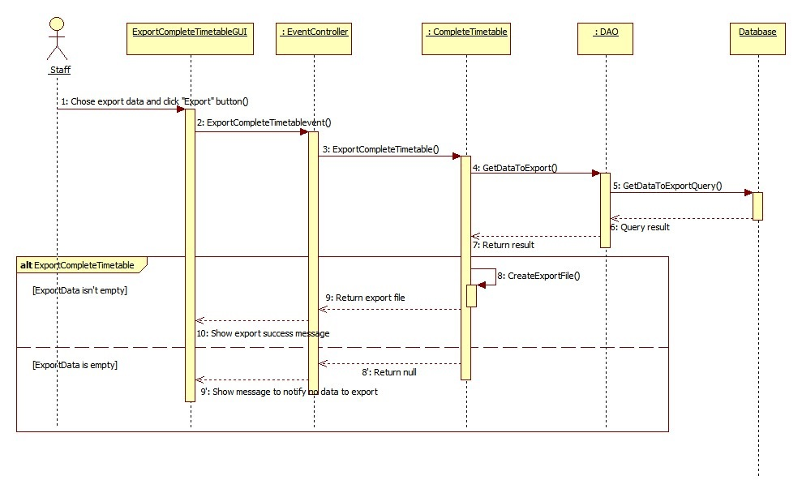

Figure 15: Sequence Diagram <Staff>Export Complete Timetable

#### 19.3.13 <Staff>Edit Complete Timetable

**Summary:** This diagram shows how staff edit complete timetable

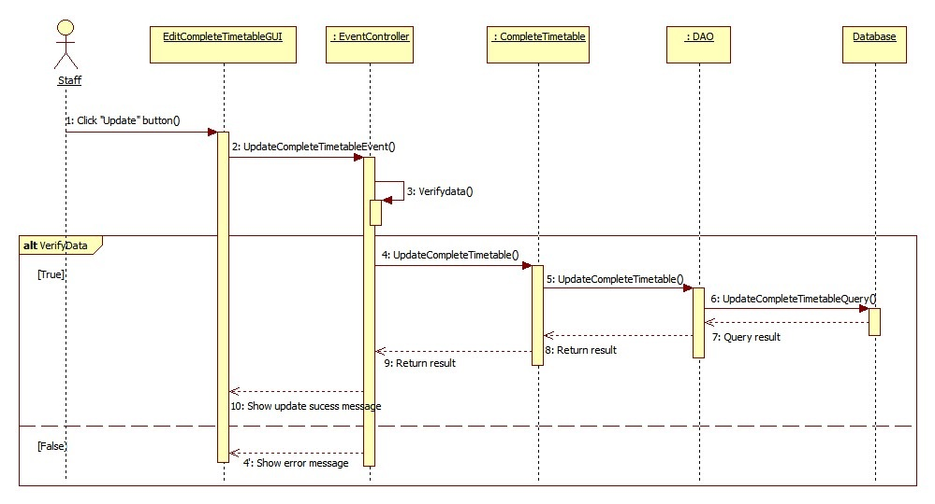

Figure 16: Sequence Diagram <Staff>Edit Complete Timetable

#### 19.3.14 <Staff>Send Mail (Complete Timetable)

**Summary:** This diagram shows how staff send complete timetable to instructor’s mail

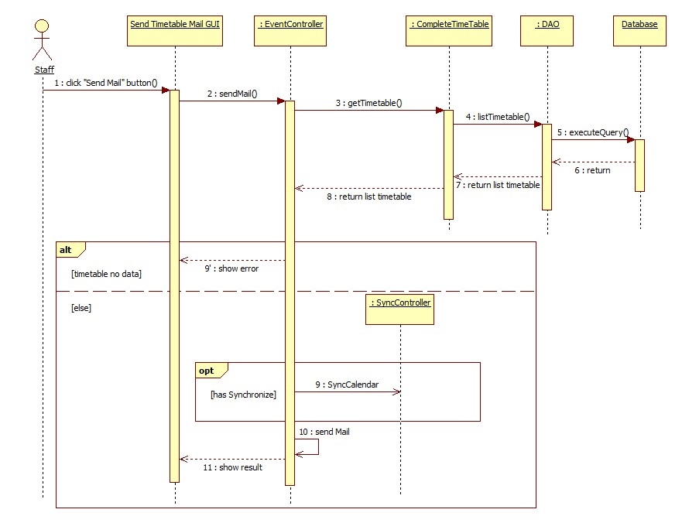

Figure 17: Sequence Diagram <Staff>Send Mail (Complete Timetable)

#### 19.3.15 <Staff>Import Project Group

**Summary:** This diagram shows how staff import project group information into system

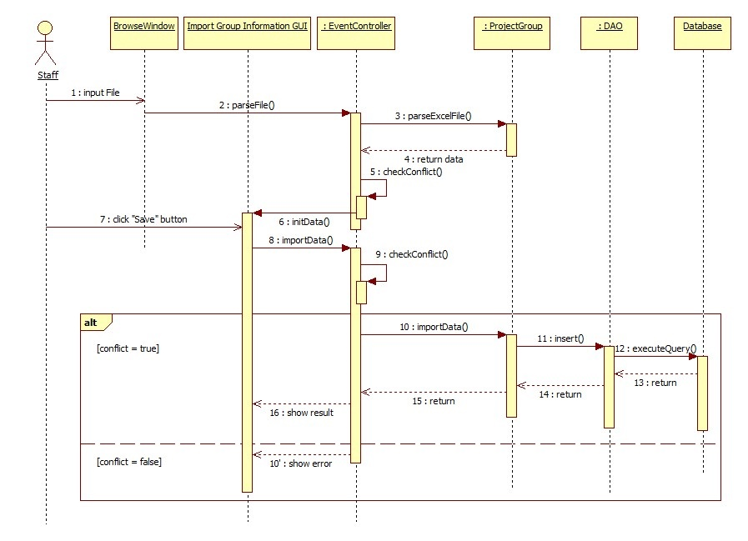

Figure 18: Sequence Diagram <Staff>Import Project Group

#### 19.3.16 <Staff>Create Project Schedule

**Summary:** This diagram shows how staff suggest guild project schedule from complete timetable data

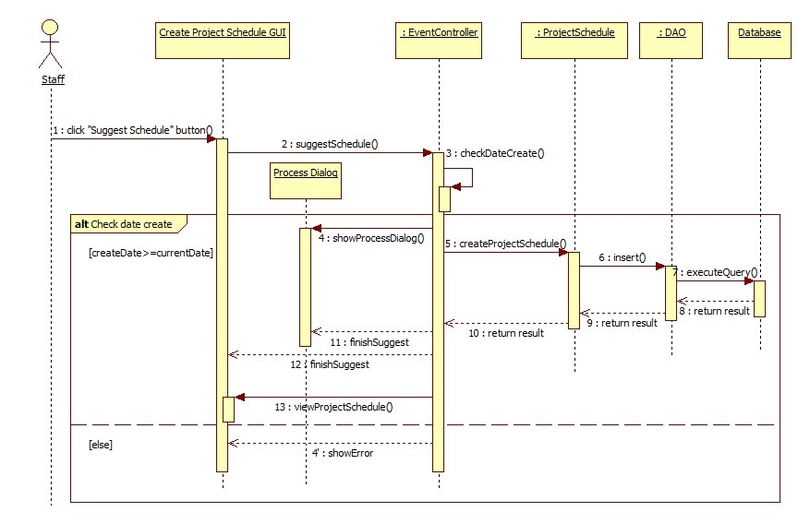

Figure 19: Sequence Diagram <Staff>Create Project Schedule

#### 19.3.17 <Staff>Export Project Schedule

**Summary:** This diagram shows how staff export guild project schedule to excel file

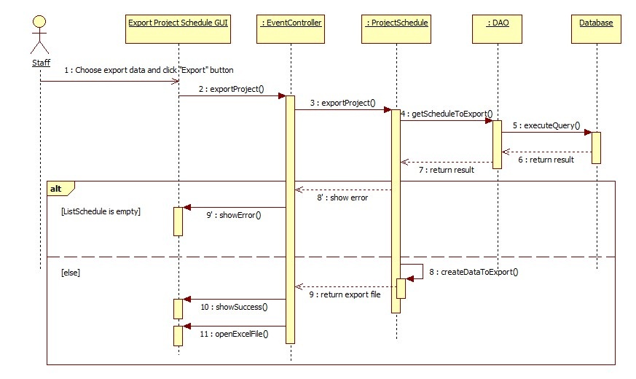

Figure 20: Sequence Diagram <Staff>Export Project Schedule

#### 19.3.18 <Staff>Send Mail (Project Schedule)

**Summary:** This diagram shows how staff send guild project schedule to instructor’s mail

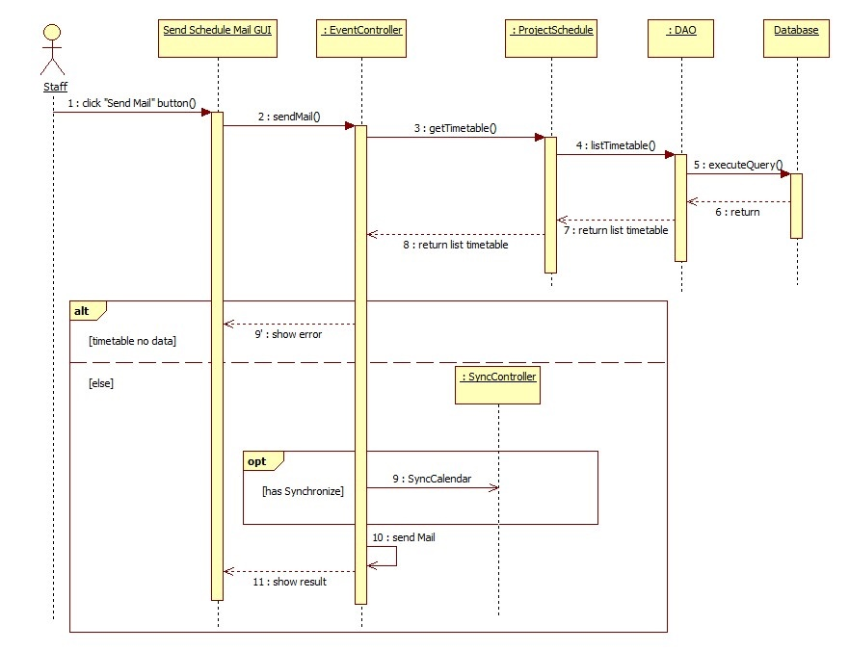

Figure 21: Sequence Diagram <Staff>Send Mail (Project Schedule)

#### 19.3.19 <Staff>Calculate Timekeeping

**Summary:** This diagram shows how staff calculate timekeeping from complete timetable and guide project schedule data

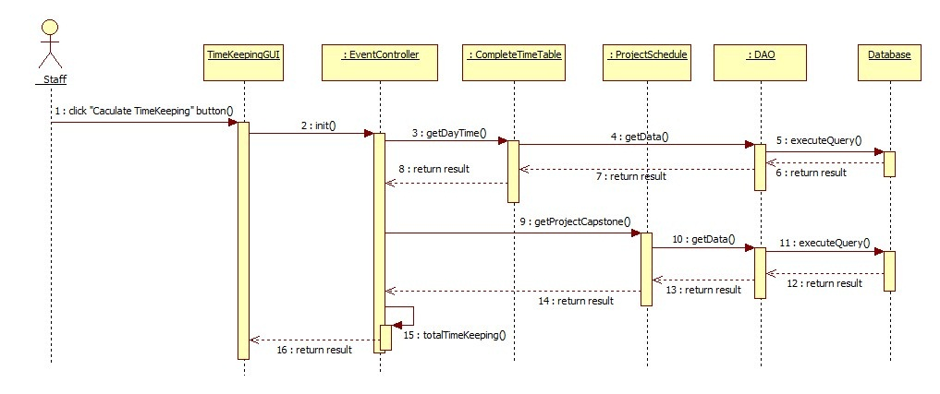

Figure 22: Sequence Diagram <Staff>Calculate Timekeeping

#### 19.3.20 <Staff>Suggest Room

**Summary:** This diagram shows how staff suggest room for classes

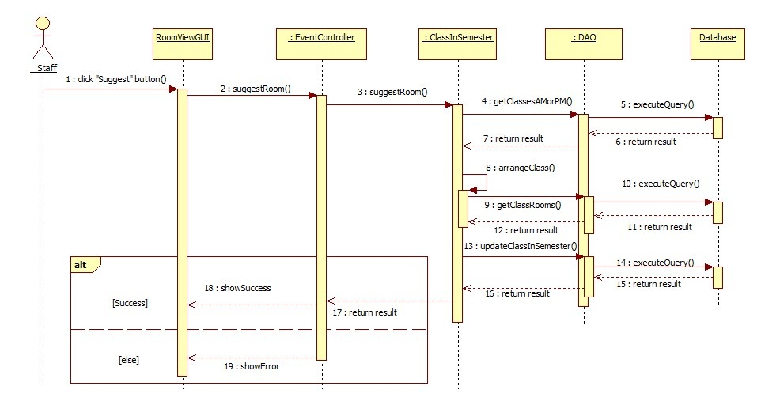

Figure 23: Sequence Diagram <Staff>Suggest Room

#### 19.3.21 <Staff>Export Room Usage Schedule

**Summary:** This diagram shows how staff export room usage schedule to excel file

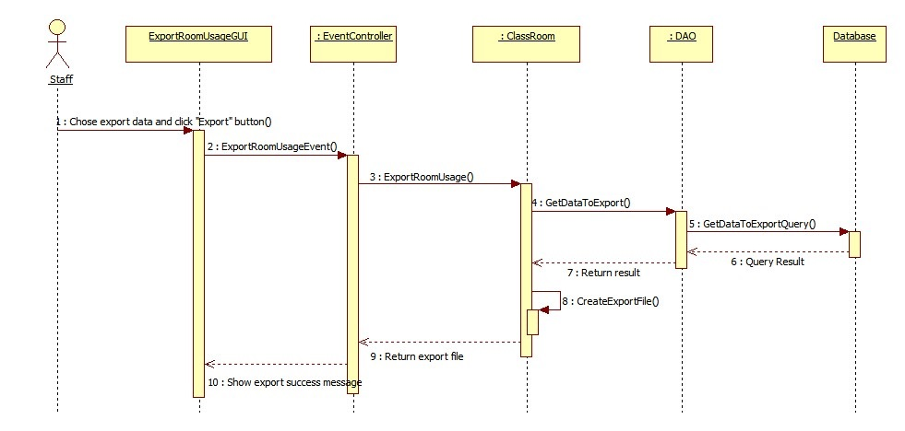

Figure 24: Sequence Diagram <Staff>Export Room Usage Schedule

#### 19.3.22 <Staff>Send Mail (Time Keeping)

**Summary:** This diagram shows how staff send timekeeping to instructor mail 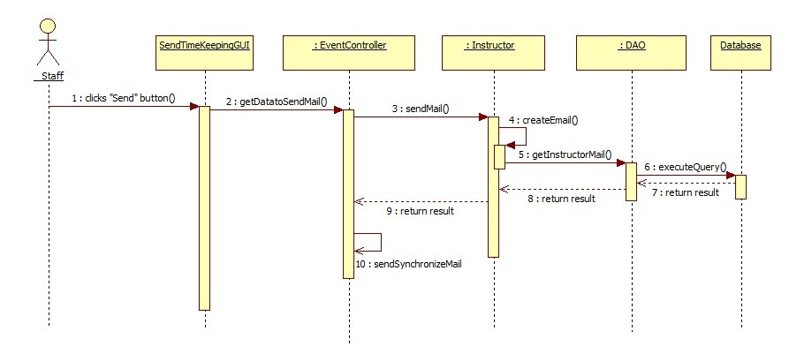

Figure 25: Sequence Diagram <Staff>Send Mail (Time Keeping)

## User Interface Design

### 20.1 Guest Interface Design

#### Login

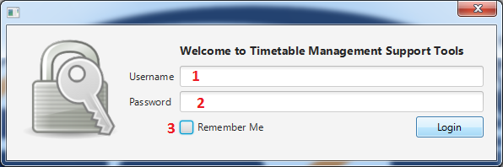

Figure 26: Login

**Fields**

|  |  |  |  |  |  |  |  |
| --- | --- | --- | --- | --- | --- | --- | --- |
| **No** | **Field**  **Name** | **Description** | **Read**  **only** | **Mandatory** | **Control**  **Type** | **Data**  **Type** | **Length** |
| 1 | Username | Fill username | No | Yes | Textbox | String | N/A |
| 2 | Password | Fill password | No | Yes | Password | String | N/A |
| 3 | Remember Me | Choose remember username and password mode | No | No | Checkbox | Boolean | N/A |

**Buttons**

|  |  |  |  |  |
| --- | --- | --- | --- | --- |
| **No** | **Function** | **Description** | **Validation** | **Outcome** |
| 4 | Login | Log-in into the system | N/A | Navigate to main window |

### 20.2 Staff Interface Design

#### Create New Semester

##### Create New Semester Step 1

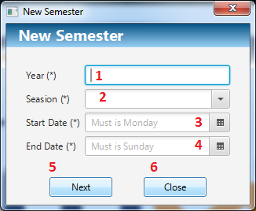

Figure 27: Create New Semester Step 1

**Fields**

|  |  |  |  |  |  |  |  |
| --- | --- | --- | --- | --- | --- | --- | --- |
| No | Field  Name | Description | Read  only | Mandatory | Control  Type | Data  Type | Length |
| 1 | Year | Fill username | No | Yes | Textbox | Integer | 4 |
| 2 | Season | Fill password | No | Yes | Combo box | String | N/A |
| 3 | Start Date | Pick start date | No | Yes | Date Picker | Date | N/A |
| 4 | End Date | Pick end date | No | Yes | Date Picker | Date | N/A |

**Buttons**

|  |  |  |  |  |
| --- | --- | --- | --- | --- |
| **No** | **Function** | **Description** | **Validation** | **Outcome** |
| 5 | Next | Go to next step to create new semester | N/A | Navigate to create new semester step 2 |
| 6 | Close | Click to close window | N/A | Close this window |

##### Create New Semester Step 2

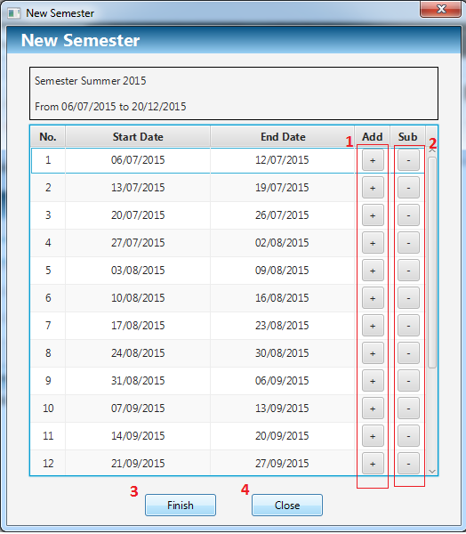

Figure 28: Create New Semester Step 2

**Buttons**

|  |  |  |  |  |
| --- | --- | --- | --- | --- |
| **No** | **Function** | **Description** | **Validation** | **Outcome** |
| 1 | Add | Increase start date and end date of this week as well as the week after it | N/A | Increase start date and end date of this week as well as the week after it |
| 2 | Sub | Decrease start date and end date of this week as well as the week before it | N/A | Decrease start date and end date of this week as well as the week before it |
| 3 | Finish | Add new semester into system | N/A | Create new semester, Choice this and close the window |
| 4 | Close | Click to close window | N/A | Close this window |

#### Chose Semester

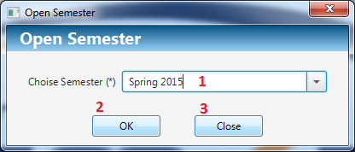

Figure 29: Chose Semester

**Fields**

|  |  |  |  |  |  |  |  |
| --- | --- | --- | --- | --- | --- | --- | --- |
| **No** | **Field**  **Name** | **Description** | **Read**  **only** | **Mandatory** | **Control**  **Type** | **Data**  **Type** | **Length** |
| 1 | Choice Semester | Choose semester want to process | No | Yes | Combo box | String | N/A |

**Buttons**

|  |  |  |  |  |
| --- | --- | --- | --- | --- |
| **No** | **Function** | **Description** | **Validation** | **Outcome** |
| 2 | Open | Open semester to process | N/A | Open this semester to process and close this window |
| 3 | Close | Click to close window | N/A | Close this window |

#### Import Plan Semester

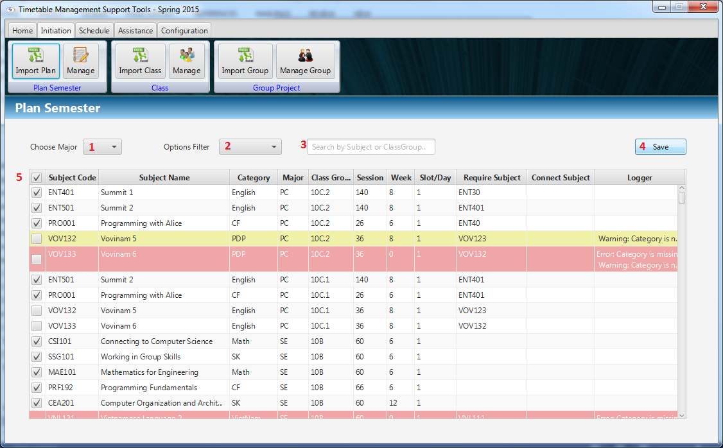

Figure 30: Import Plan Semester

**Fields**

|  |  |  |  |  |  |  |  |
| --- | --- | --- | --- | --- | --- | --- | --- |
| **No** | **Field**  **Name** | **Description** | **Read**  **only** | **Mandatory** | **Control**  **Type** | **Data**  **Type** | **Length** |
| 1 | Major | Filter data by major | No | No | Combo box | String | N/A |
| 2 | Options | Filter data by other options: Warning, Error and Over 6 Subjects | No | No | Combo box | String | N/A |
| 3 | Filter field | Filter data by subject or class group | No | No | Textbox | String | N/A |
| 5 | Check all | Check all row of table | No | No | Checkbox | Boolean | N/A |

**Buttons**

|  |  |  |  |  |
| --- | --- | --- | --- | --- |
| **No** | **Function** | **Description** | **Validation** | **Outcome** |
| 4 | Save | Save selected data from imported data | N/A | Save selected plan into system. |

#### Import Class

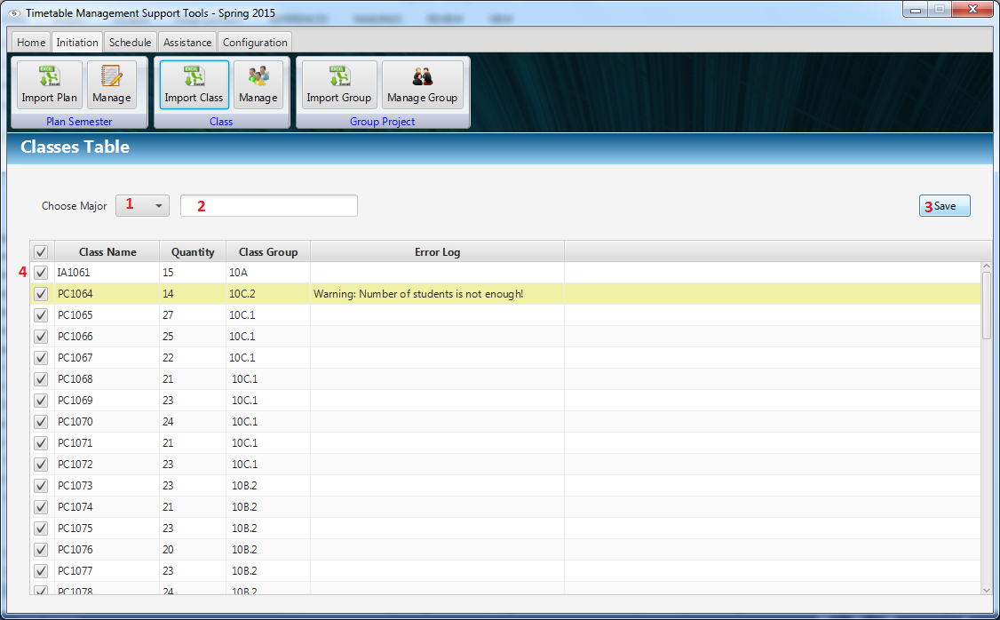

Figure 31: Import Plan Semester

**Fields**

|  |  |  |  |  |  |  |  |
| --- | --- | --- | --- | --- | --- | --- | --- |
| **No** | **Field**  **Name** | **Description** | **Read**  **only** | **Mandatory** | **Control**  **Type** | **Data**  **Type** | **Length** |
| 1 | Major | Filter imported data by major | No | No | Combo box | String | N/A |
| 2 | Filter field | Filter data by class or class group | No | No | Textbox | String | N/A |
| 4 | Check all | Check all row of table | No | No | Checkbox | Boolean | N/A |

**Buttons**

|  |  |  |  |  |
| --- | --- | --- | --- | --- |
| **No** | **Function** | **Description** | **Validation** | **Outcome** |
| 3 | Save | Save selected data from imported data | N/A | Save selected class into system. |

#### Suggest Temporary Timetable

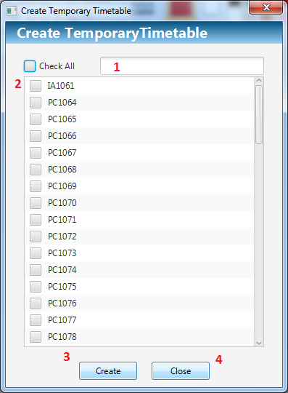

Figure 32: Suggest Temporary Timetable

**Fields**

|  |  |  |  |  |  |  |  |
| --- | --- | --- | --- | --- | --- | --- | --- |
| **No** | **Field**  **Name** | **Description** | **Read**  **only** | **Mandatory** | **Control**  **Type** | **Data**  **Type** | **Length** |
| 1 | Search | Fill search text | No | No | Textbox | String | N/A |
| 2 | Class Check List | Check class for create | No | Yes | Check List View | Boolean | N/A |

**Buttons**

|  |  |  |  |  |
| --- | --- | --- | --- | --- |
| **No** | **Function** | **Description** | **Validation** | **Outcome** |
| 3 | Create | Go to next step to create Temporary Timetable | N/A | Navigate to View Temporary Timetable |
| 4 | Close | Click to close window | N/A | Close this window |

#### Manage Temporary Timetable

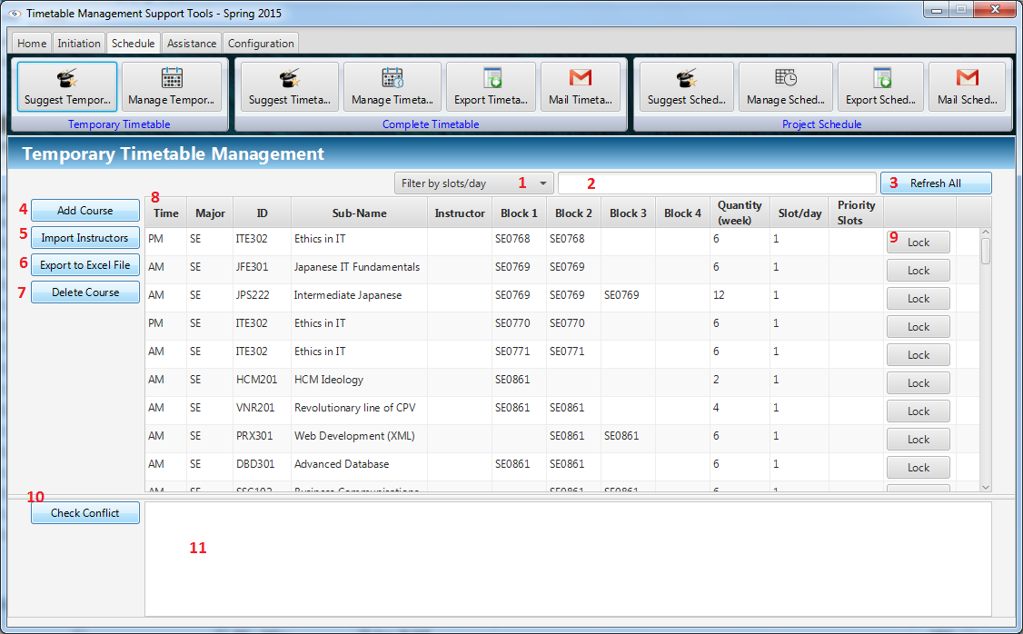

Figure 33: Manage Temporary Timetable

**Fields**

|  |  |  |  |  |  |  |  |
| --- | --- | --- | --- | --- | --- | --- | --- |
| **No** | **Field**  **Name** | **Description** | **Read**  **only** | **Mandatory** | **Control**  **Type** | **Data**  **Type** | **Length** |
| 1 | Filter | Filter data by slot per date. | Yes | No | Combo Box | String | N/A |
| 2 | Search | Fill search text. | No | No | Text Box | String | N/A |
| 8 | View Table | Display temporary timetable. | Yes | Yes | Table View | String, Integer | N/A |
| 11 | Conflict List View | Display conflict | Yes | No | List View | String | N/A |

**Buttons**

|  |  |  |  |  |
| --- | --- | --- | --- | --- |
| **No** | **Function** | **Description** | **Validation** | **Outcome** |
| 3 | Refresh All | Refresh Filter and Search to show all data of temporary timetable. | N/A | Refresh data presenting on Table View. |
| 4 | Add Course | Go to next step to add new course into temporary timetable | N/A | Open to Add New Course window. |
| 5 | Import Instructors | Go to next step to import instructor list. | N/A | Open File Choosers window to import instructors. |
| 6 | Export To Excel File | Go to next step to export temporary timetable to excel file. | N/A | Open to Export Temporary Timetable window. |
| 7 | Delete Course | Go to next step to delete course which is presented by specific selected row in Table View. | N/A | Show confirm message |
| 9 | Lock | Lock the row contains it to prevent double click (Double click to start Edit Course function). | N/A | Lock the container row. |
| 10 | Check Conflict | Check conflict temporary timetable data. | N/A | Show conflicts in Conflict List View |

#### Add course

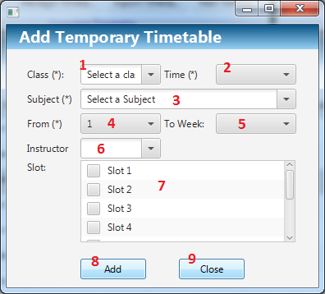

Figure 34: Add course

**Fields**

|  |  |  |  |  |  |  |  |
| --- | --- | --- | --- | --- | --- | --- | --- |
| **No** | **Field**  **Name** | **Description** | **Read**  **only** | **Mandatory** | **Control**  **Type** | **Data**  **Type** | **Length** |
| 1 | Class | Select class to add | No | Yes | Combo Box | String | N/A |
| 2 | Time | Select AM or PM | No | Yes | Combo Box | String | N/A |
| 3 | Subject | Select Subject to add | No | Yes | Combo Box | String | N/A |
| 4 | From Week | Select Start Week | No | Yes | Combo Box | Integer | N/A |
| 5 | End Week | Display End Week associated with selected End Week and Subject | Yes | Yes | Combo Box | Integer | N/A |
| 6 | Instructor | Select Instructor to add | No | No | Combo Box | String | N/A |
| 7 | Slot List View | Check the priority slots if need. | No | No | Check List View | Boolean | N/A |

**Buttons**

|  |  |  |  |  |
| --- | --- | --- | --- | --- |
| **No** | **Function** | **Description** | **Validation** | **Outcome** |
| 8 | Add | Add new course into system | N/A | Add new course into system and close window |
| 9 | Close | Click to close window | N/A | Close this window |

#### Edit Temporary Timetable

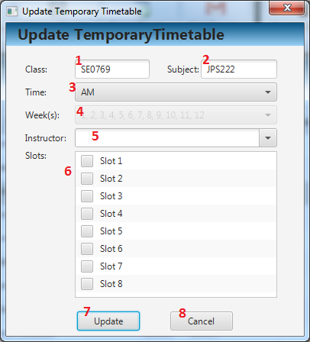

Figure 35: Edit Temporary Timetable

**Fields**

|  |  |  |  |  |  |  |  |
| --- | --- | --- | --- | --- | --- | --- | --- |
| **No** | **Field**  **Name** | **Description** | **Read**  **only** | **Mandatory** | **Control**  **Type** | **Data**  **Type** | **Length** |
| 1 | Class | Select class to edit | No | Yes | Combo Box | String | N/A |
| 2 | Time | Select AM or PM | No | Yes | Combo Box | String | N/A |
| 3 | Subject | Select Subject to edit | No | Yes | Combo Box | String | N/A |
| 4 | From Week | Select assigned weeks | No | Yes | Combo Box | Integer | N/A |
| 5 | Instructor | Select Instructor to edit. | No | No | Combo Box | String | N/A |
| 6 | Slot List View | Check the priority slots if need. | No | No | Check List View | Boolean | N/A |

**Buttons**

|  |  |  |  |  |
| --- | --- | --- | --- | --- |
| **No** | **Function** | **Description** | **Validation** | **Outcome** |
| 7 | Edit | Click to go to next step to edit course | N/A | New course is add to temporary timetable |
| 8 | Cancel | Click to cancel and close window | N/A | Close this window |

#### Export Temporary Timetable

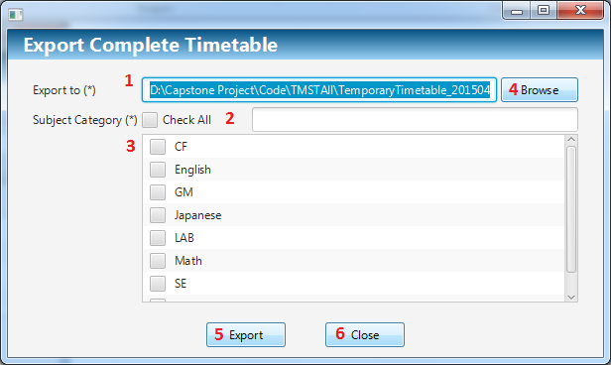

Figure 36: Export Temporary Timetable

**Fields**

|  |  |  |  |  |  |  |  |
| --- | --- | --- | --- | --- | --- | --- | --- |
| **No** | **Field**  **Name** | **Description** | **Read**  **only** | **Mandatory** | **Control**  **Type** | **Data**  **Type** | **Length** |
| 1 | Url Text Box | Display url path | No | Yes | Text Box | String | N/A |
| 2 | Search | Input search text | No | No | Text Box | String | N/A |
| 3 | Category | Seleck Major to export | No | Yes | Check List View | Boolean | N/A |

**Buttons**

|  |  |  |  |  |
| --- | --- | --- | --- | --- |
| **No** | **Function** | **Description** | **Validation** | **Outcome** |
| 4 | Browse | Click to choose URL path | N/A | URL path is show in URL path text box |
| 5 | Export | Click to export to excel file | N/A | Temporary Timetable is export. |
| 6 | Cancel | Click to cancel and close window | N/A | Close this window |

#### Suggest Complete Timetable

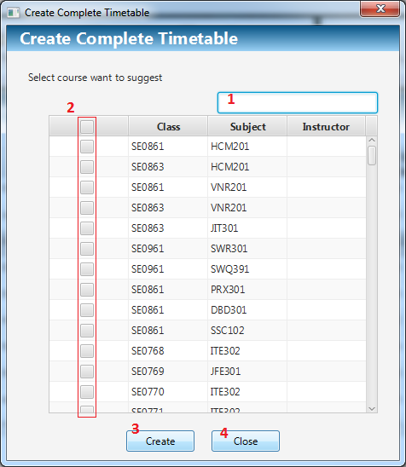

Figure 37: Suggest Complete Timetable

**Fields**

|  |  |  |  |  |  |  |  |
| --- | --- | --- | --- | --- | --- | --- | --- |
| **No** | **Field**  **Name** | **Description** | **Read**  **only** | **Mandatory** | **Control**  **Type** | **Data**  **Type** | **Length** |
| 1 | Filter | Fill filter | No | No | Textbox | String | N/A |
| 2 | N/A | Choice the course want to suggest complete timetable | No | Yes | Checklist View | Boolean | N/A |

**Buttons**

|  |  |  |  |  |
| --- | --- | --- | --- | --- |
| **No** | **Function** | **Description** | **Validation** | **Outcome** |
| 3 | Create | Suggest complete timetable | N/A | Suggest complete timetable for selected course and close window |
| 4 | Close | Click to close window | N/A | Close this window |

#### Manage Complete Timetable

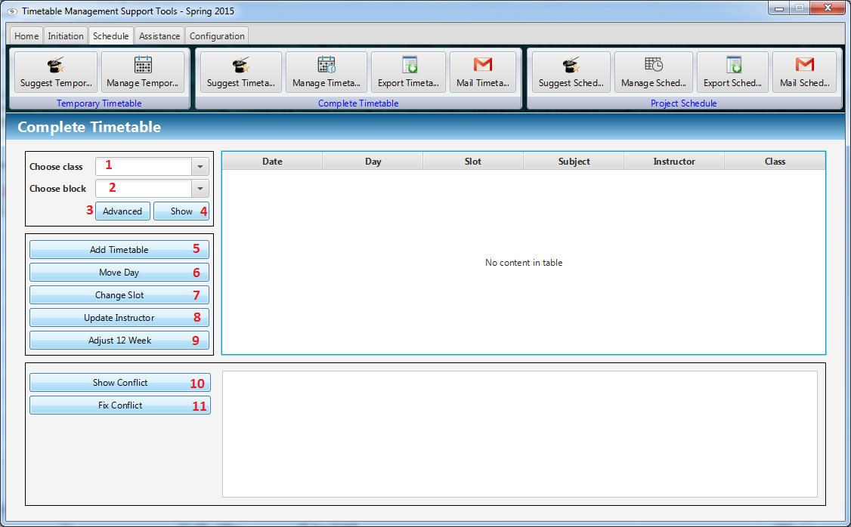

Figure 38: Manage Complete Timetable

**Fields**

|  |  |  |  |  |  |  |  |
| --- | --- | --- | --- | --- | --- | --- | --- |
| **No** | **Field**  **Name** | **Description** | **Read**  **only** | **Mandatory** | **Control**  **Type** | **Data**  **Type** | **Length** |
| 1 | Choose class | Choice the class want to view complete timetable | No | No | Combo box | String | N/A |
| 2 | Choose block | Choice the block want to view complete timetable | No | Yes | Combo box | String | N/A |

**Buttons**

|  |  |  |  |  |
| --- | --- | --- | --- | --- |
| **No** | **Function** | **Description** | **Validation** | **Outcome** |
| 3 | Advanced | Open search advanced window | N/A | Open search advanced window |
| 4 | Show | Show complete timetable in table view | N/A | Show complete timetable in table view |
| 5 | Add timetable | Open add timetable window | N/A | Open add timetable window |
| 6 | Move Day | Open move day window | N/A | Open move day window |
| 7 | Change Slot | Open change slot window | N/A | Open change slot window |
| 8 | Update Instructor | Open update instructor window | N/A | Open update instructor window |
| 9 | Adjust 12 Weeks | Open adjust 12 weeks window | N/A | Open adjust 12 weeks window |
| 10 | Show Conflict | Show conflict in list view | N/A | Show conflict in list view |
| 11 | Fix Conflict | Depending on conflict type, system open window to fix conflict | N/A | Depending on conflict type, system open window to fix conflict |

#### Add Complete Timetable

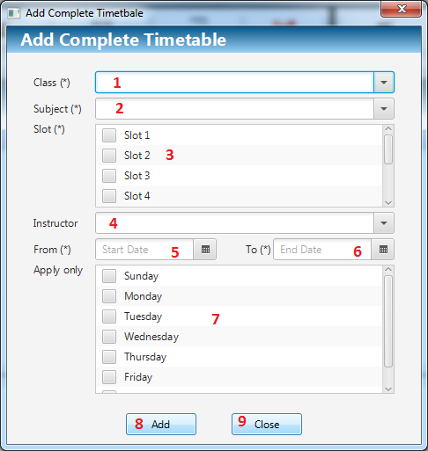

Figure 39: Add Complete Timetable

**Fields**

|  |  |  |  |  |  |  |  |
| --- | --- | --- | --- | --- | --- | --- | --- |
| **No** | **Field**  **Name** | **Description** | **Read**  **only** | **Mandatory** | **Control**  **Type** | **Data**  **Type** | **Length** |
| 1 | Class | Choice the class | No | Yes | Combo box | String | N/A |
| 2 | Subject | Choice the subject | No | Yes | Combo box | String | N/A |
| 3 | Slot | Choice the slot | No | Yes | Checklist View | Boolean | N/A |
| 4 | Instructor | Choice the instructor | No | No | Combo box | String | N/A |
| 5 | Start Date | Pick start date | No | Yes | Date Picker | Date | N/A |
| 6 | End Date | Pick end date | No | Yes | Date Picker | Date | N/A |
| 7 | Apply only | Choice apply only day in week | No | No | Checklist View | String | N/A |

**Buttons**

|  |  |  |  |  |
| --- | --- | --- | --- | --- |
| **No** | **Function** | **Description** | **Validation** | **Outcome** |
| 8 | Add | Add new complete timetable | N/A | Add new complete timetable and close this window |
| 9 | Close | Click to close window | N/A | Close this window |

#### Change Slot

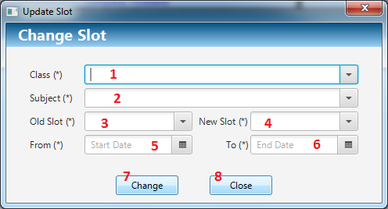

Figure 40: Change Slot

**Fields**

|  |  |  |  |  |  |  |  |
| --- | --- | --- | --- | --- | --- | --- | --- |
| **No** | **Field**  **Name** | **Description** | **Read**  **only** | **Mandatory** | **Control**  **Type** | **Data**  **Type** | **Length** |
| 1 | Class | Choice the class | No | Yes | Combo box | String | N/A |
| 2 | Subject | Choice the subject | No | Yes | Combo box | String | N/A |
| 3 | Old Slot | Choice the old slot | No | Yes | Combo box | Integer | N/A |
| 4 | New Slot | Choice the new slot | No | Yes | Combo box | Integer | N/A |
| 5 | Start Date | Pick start date | No | Yes | Date Picker | Date | N/A |
| 6 | End Date | Pick end date | No | Yes | Date Picker | Date | N/A |

**Buttons**

|  |  |  |  |  |
| --- | --- | --- | --- | --- |
| **No** | **Function** | **Description** | **Validation** | **Outcome** |
| 7 | Change | Change slot of complete timetable from old slot to new slot in start date to end date | N/A | Change slot of complete timetable from old slot to new slot in start date to end date and close this window |
| 8 | Close | Click to close window | N/A | Close this window |

#### Update Instructor

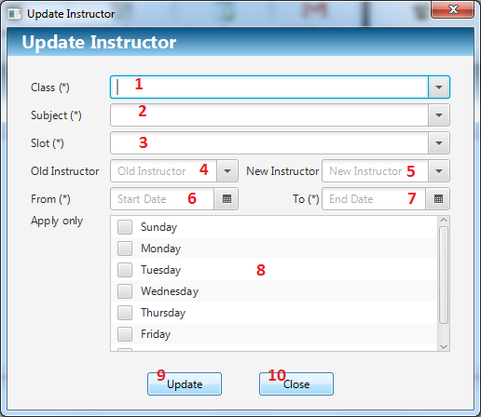

Figure 41: Update Instructor

**Fields**

|  |  |  |  |  |  |  |  |
| --- | --- | --- | --- | --- | --- | --- | --- |
| **No** | **Field**  **Name** | **Description** | **Read**  **only** | **Mandatory** | **Control**  **Type** | **Data**  **Type** | **Length** |
| 1 | Class | Choice the class | No | Yes | Combo box | String | N/A |
| 2 | Subject | Choice the subject | No | Yes | Combo box | String | N/A |
| 3 | Slot | Choice the slot | No | Yes | Combo box | Integer | N/A |
| 4 | Old Instructor | Choice the old instructor | No | No | Combo box | String | N/A |
| 5 | New Instructor | Choice the new instructor | No | No | Combo box | String | N/A |
| 6 | Start Date | Pick start date | No | Yes | Date Picker | Date | N/A |
| 7 | End Date | Pick end date | No | Yes | Date Picker | Date | N/A |
| 8 | Apply only | Choice apply only day in week | No | No | Checklist View | String | N/A |

**Buttons**

|  |  |  |  |  |
| --- | --- | --- | --- | --- |
| **No** | **Function** | **Description** | **Validation** | **Outcome** |
| 9 | Update | Update instructor from old instructor to new instructor | N/A | Update instructor from old instructor to new instructor and close window |
| 10 | Close | Click to close window | N/A | Close this window |

#### Move Date

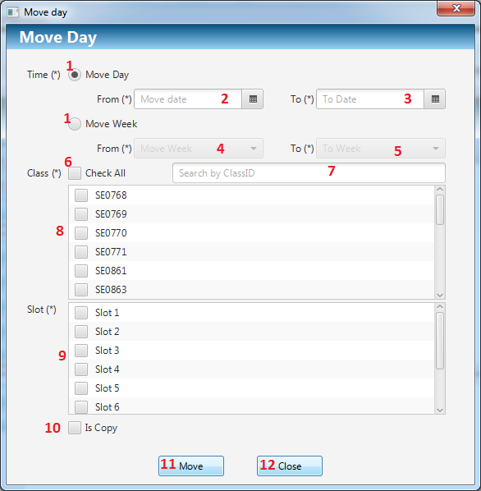

Figure 42: Move Date

**Fields**

|  |  |  |  |  |  |  |  |
| --- | --- | --- | --- | --- | --- | --- | --- |
| **No** | **Field**  **Name** | **Description** | **Read**  **only** | **Mandatory** | **Control**  **Type** | **Data**  **Type** | **Length** |
| 1 | Time | Choice move mode | No | Yes | Radio button | String | N/A |
| 2 | Start Date | Pick start date | No | Yes | Date Picker | Date | N/A |
| 3 | End Date | Pick end date | No | Yes | Date Picker | Date | N/A |
| 4 | Start Week | Choice start week | No | Yes | Combo box | Integer | N/A |
| 5 | End Week | Choice end week | No | Yes | Combo box | Integer | N/A |
| 6 | Check All | Check all/Uncheck all class | No | No | Date Picker | Date | N/A |
| 7 | Filter | Fill filter to filter data | No | No | Textbox | String | N/A |
| 8 | Class | Choice class | No | Yes | Checklist View | Boolean | N/A |
| 9 | Slot | Choice slot | No | Yes | Checklist View | Boolean | N/A |
| 10 | Is copy | Choice is copy mode | No | No | Checkbox | Boolean | N/A |

**Buttons**

|  |  |  |  |  |
| --- | --- | --- | --- | --- |
| **No** | **Function** | **Description** | **Validation** | **Outcome** |
| 11 | Move | Move complete timetable from start date to end date as well as start week to end week | N/A | Move complete timetable and close this window |
| 12 | Close | Click to close window | N/A | Close this window |

#### Delete Complete Timetable

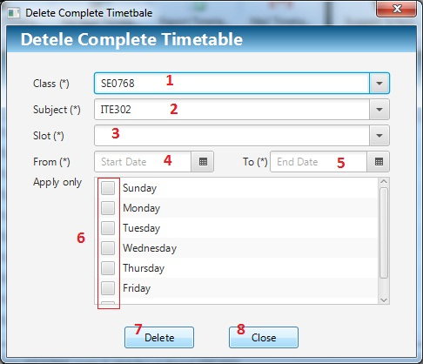

Figure 43: Delete Complete Timetable

**Fields**

|  |  |  |  |  |  |  |  |
| --- | --- | --- | --- | --- | --- | --- | --- |
| **No** | **Field**  **Name** | **Description** | **Read**  **only** | **Mandatory** | **Control**  **Type** | **Data**  **Type** | **Length** |
| 1 | Class | Choice the class | No | Yes | Combo box | String | N/A |
| 2 | Subject | Choice the subject | No | Yes | Combo box | String | N/A |
| 3 | Slot | Choice the slot | No | Yes | Combo box | Integer | N/A |
| 4 | Start Date | Pick start date | No | Yes | Date Picker | Date | N/A |
| 5 | End Date | Pick end date | No | Yes | Date Picker | Date | N/A |
| 6 | Apply only | Choice apply only day in week | No | No | Checklist View | String | N/A |

**Buttons**

|  |  |  |  |  |
| --- | --- | --- | --- | --- |
| No | Function | Description | Validation | Outcome |
| 7 | Delete | Delete complete timetable which satisfy conditions | N/A | Delete complete timetable which satisfy conditions and close window |
| 8 | Close | Click to close window | N/A | Close this window |

#### Adjust 12 Weeks

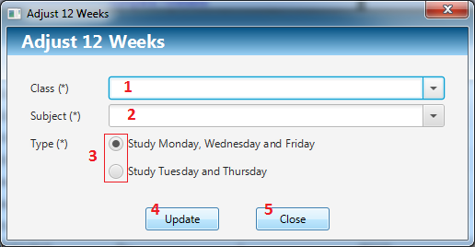

Figure 44: Adjust 12 Weeks

**Fields**

|  |  |  |  |  |  |  |  |
| --- | --- | --- | --- | --- | --- | --- | --- |
| **8** | **Close** | **Click to close window** | **N/A** | **Close this window** | **8** | **Close** | **Click to close window** |
| 1 | Class | Choice the class | No | Yes | Combo box | String | N/A |
| 2 | Subject | Choice the subject | No | Yes | Combo box | String | N/A |
| 3 | Type | Choice adjust type | No | Yes | Radio button | Integer | N/A |

**Buttons**

|  |  |  |  |  |
| --- | --- | --- | --- | --- |
| **No** | **Function** | **Description** | **Validation** | **Outcome** |
| 4 | Update | Adjust complete timetable for subject 12 weeks | N/A | Adjust complete timetable and close window |
| 5 | Close | Click to close window | N/A | Close this window |

#### Export Complete Timetable

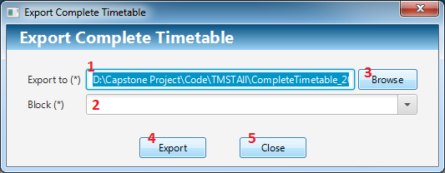

Figure 45: Export Complete Timetable

**Fields**

|  |  |  |  |  |  |  |  |
| --- | --- | --- | --- | --- | --- | --- | --- |
| **No** | **Field**  **Name** | **Description** | **Read**  **only** | **Mandatory** | **Control**  **Type** | **Data**  **Type** | **Length** |
| 1 | Export to | File path | Yes | Yes | Textbox | String | N/A |
| 2 | Block | Choice the block | No | Yes | Combo box | Integer | N/A |

**Buttons**

|  |  |  |  |  |
| --- | --- | --- | --- | --- |
| **No** | **Function** | **Description** | **Validation** | **Outcome** |
| 3 | Browse | Open file chooser window | N/A | Open file chooser window |
| 4 | Export | Export complete timetable to file path | N/A | Export complete timetable and close window |
| 5 | Close | Click to close window | N/A | Close this window |

#### Send Mail (Complete Timetable)

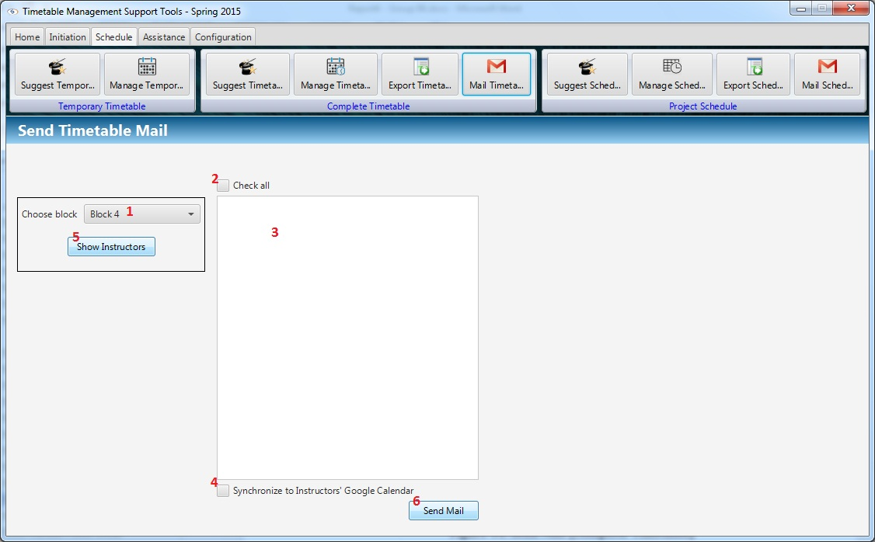

Figure 46: Send Mail (Complete Timetable)

**Fields**

|  |  |  |  |  |  |  |  |
| --- | --- | --- | --- | --- | --- | --- | --- |
| **No** | **Field**  **Name** | **Description** | **Read**  **only** | **Mandatory** | **Control**  **Type** | **Data**  **Type** | **Length** |
| 1 | Block | Choice the block | No | Yes | Combo box | String | N/A |
| 2 | Check all | Check all instructor in list view | No | No | Check box | Boolean | N/A |
| 3 | List Instructors | View instructors in a block | No | No | Checklist View | String | N/A |
| 4 | Synchronize | Synchronize timetable with Google Calendar | No | No | Check box | Boolean | N/A |

**Buttons**

|  |  |  |  |  |
| --- | --- | --- | --- | --- |
| No | Function | Description | Validation | Outcome |
| 5 | Show Instructors | Show instructors have class in block. | N/A | Show instructors have class in block and checked |
| 6 | Send Mail | Send timetable to instructor’s mail. | N/A | Send timetable to instructor’s mail. Synchronize with Google Calendar if Synchronize check box is selected. |

#### Import Project Group

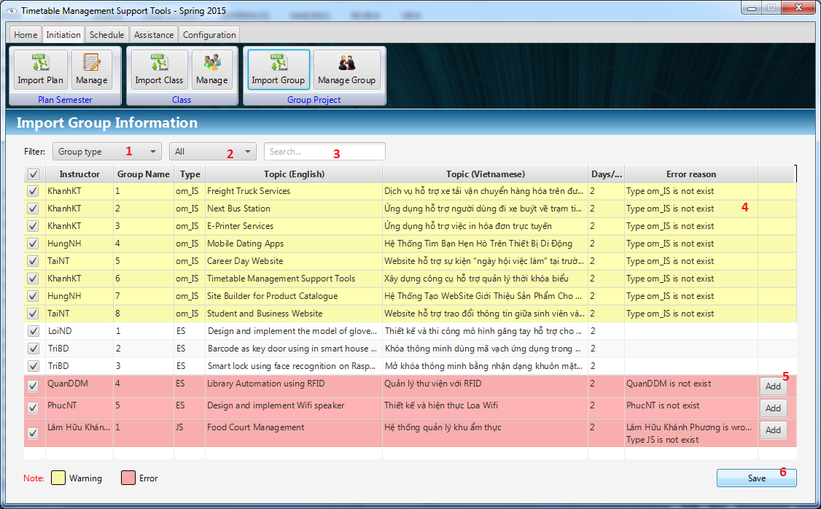

Figure 47: Import Project Group

**Fields**

|  |  |  |  |  |  |  |  |
| --- | --- | --- | --- | --- | --- | --- | --- |
| **No** | **Field**  **Name** | **Description** | **Read**  **only** | **Mandatory** | **Control**  **Type** | **Data**  **Type** | **Length** |
| 1 | Group Type | Filter by group type | No | No | Combo box | String | N/A |
| 2 | Error | Filter by error row or warning row | No | No | Combo box | String | N/A |
| 3 | Search | Filter by input text | No | No | Text Field | String | N/A |
| 4 | View data | Display parsed data from excel. | Yes | No | Table View | String | N/A |

**Buttons**

|  |  |  |  |  |
| --- | --- | --- | --- | --- |
| No | Function | Description | Validation | Outcome |
| 5 | Add instructor | Add information of an instructor. | N/A | Add information of an instructor if this instructor is not exist in system |
| 6 | Save | Save data from table view to system. | N/A | Save data from table view to system. |

#### Manage Project Group

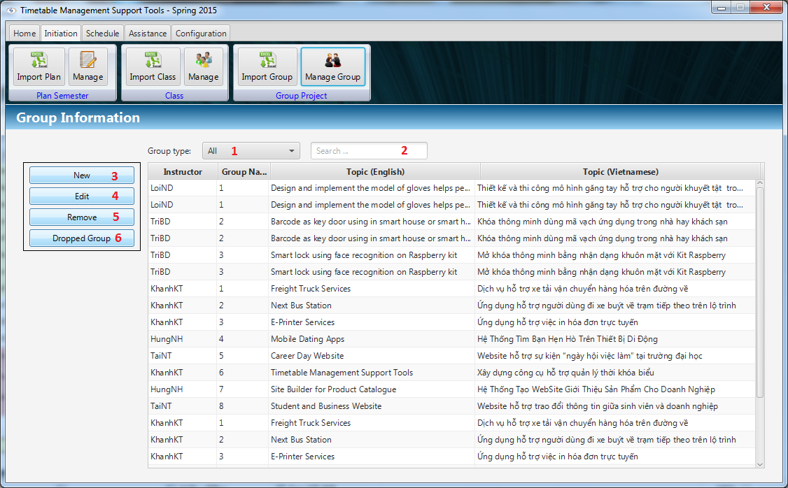

Figure 48: Manage Project Group

**Fields**

|  |  |  |  |  |  |  |  |
| --- | --- | --- | --- | --- | --- | --- | --- |
| **No** | **Field**  **Name** | **Description** | **Read**  **only** | **Mandatory** | **Control**  **Type** | **Data**  **Type** | **Length** |
| 1 | Group Type | Filter by group type | No | No | Combo box | String | N/A |
| 2 | Search | Filter by input text | No | No | Text Field | String | N/A |
| 3 | View data | Display information of each group on table view | Yes | No | Table View | String | N/A |

**Buttons**

|  |  |  |  |  |
| --- | --- | --- | --- | --- |
| No | Function | Description | Validation | Outcome |
| 4 | New | Add new group | N/A | Add new group to system and show on table view. |
| 5 | Edit | Update new information of selected group. | N/A | Update new information of selected group. |
| 6 | Remove | Remove selected group on table view. | N/A | Remove selected group on table view. |
| 7 | Dropped Group | Set date drop for group has been dropped. | N/A | Set date drop for group has been dropped and remove schedules after date drop. |

#### Suggest Project Schedule

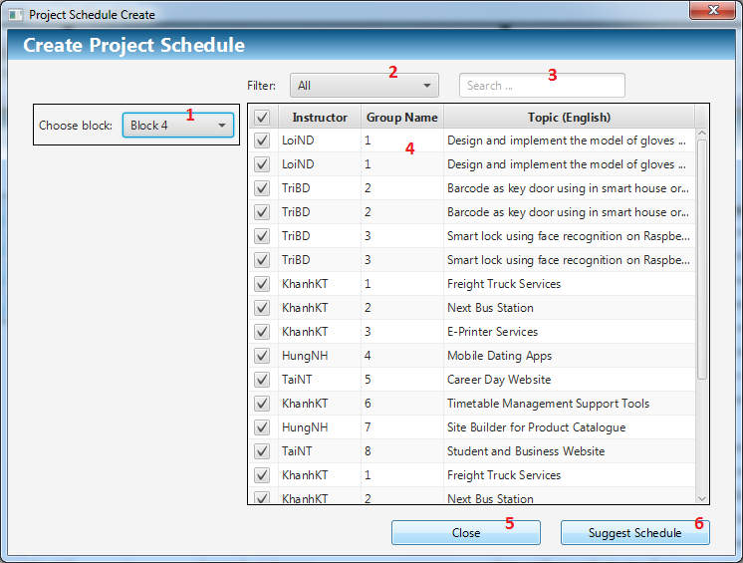

Figure 49: Suggest Project Schedule

**Fields**

|  |  |  |  |  |  |  |  |
| --- | --- | --- | --- | --- | --- | --- | --- |
| **No** | **Field**  **Name** | **Description** | **Read**  **only** | **Mandatory** | **Control**  **Type** | **Data**  **Type** | **Length** |
| 1 | Block | Choice the block | No | Yes | Combo box | String | N/A |
| 2 | Group Type | Filter by group type | No | No | Combo box | String | N/A |
| 3 | Search | Filter by input text | No | No | Text Field | String | N/A |
| 4 | View data | Display list groups of that semester with checkbox. | Yes | Yes | Table View | String | N/A |

**Buttons**

|  |  |  |  |  |
| --- | --- | --- | --- | --- |
| No | Function | Description | Validation | Outcome |
| 5 | Close | Click to close window | N/A | Close this window. |
| 6 | Suggest Schedule | Suggest schedule. | N/A | Suggest schedule for selected groups and close window. |

#### Manage Project Schedule

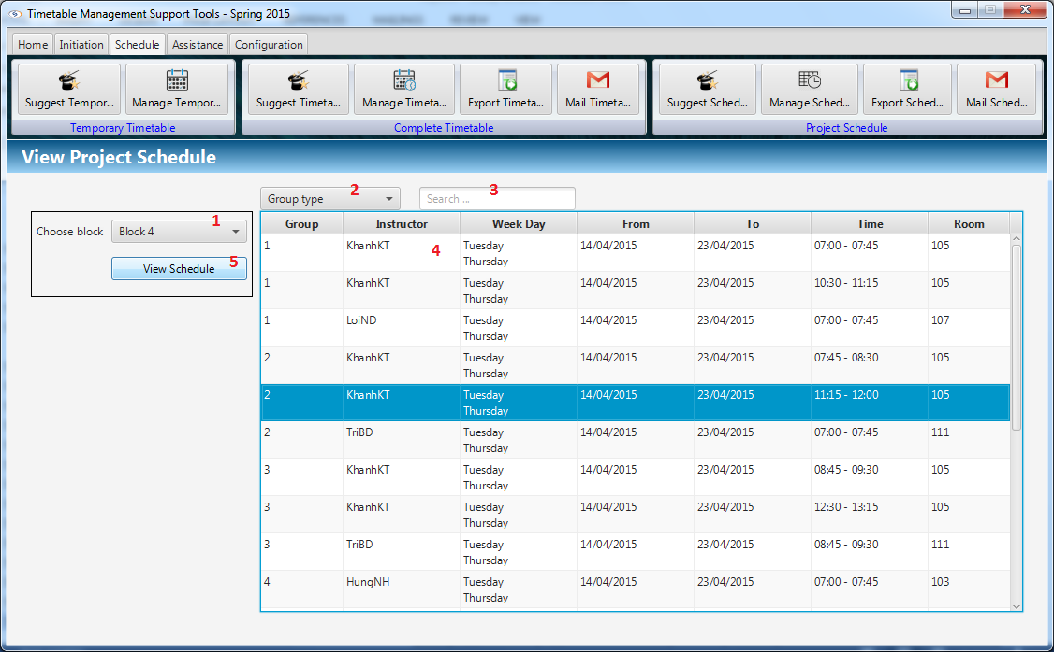

Figure 50: Manage Project Schedule

**Fields**

|  |  |  |  |  |  |  |  |
| --- | --- | --- | --- | --- | --- | --- | --- |
| **No** | **Field**  **Name** | **Description** | **Read**  **only** | **Mandatory** | **Control**  **Type** | **Data**  **Type** | **Length** |
| 1 | Block | Choice the block | No | Yes | Combo box | String | N/A |
| 2 | Group Type | Filter by group type | No | No | Combo box | String | N/A |
| 3 | Search | Filter by input text | No | No | Text Field | String | N/A |
| 4 | View data | Display schedule of each group. | Yes | No | Table View | String | N/A |

**Buttons**

|  |  |  |  |  |
| --- | --- | --- | --- | --- |
| No | Function | Description | Validation | Outcome |
| 5 | View Schedule | Show project schedule on table view. | N/A | Show project schedule on table view. |

#### Send mail (Project Schedule)

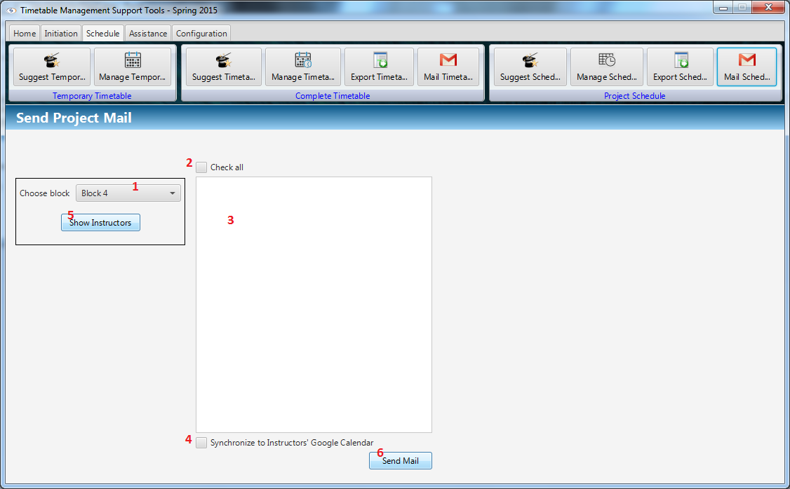

Figure 51: Send mail (Project Schedule)

**Fields**

|  |  |  |  |  |  |  |  |
| --- | --- | --- | --- | --- | --- | --- | --- |
| **No** | **Field**  **Name** | **Description** | **Read**  **only** | **Mandatory** | **Control**  **Type** | **Data**  **Type** | **Length** |
| 1 | Block | Choice the block | No | Yes | Combo box | String | N/A |
| 2 | Check all | Check all instructor in list view | No | No | Check box | Boolean | N/A |
| 3 | List Instructors | View instructors in a block | No | No | Checklist View | String | N/A |
| 4 | Synchronize | Synchronize schedule with Google Calendar | No | No | Check box | Boolean | N/A |

**Buttons**

|  |  |  |  |  |
| --- | --- | --- | --- | --- |
| No | Function | Description | Validation | Outcome |
| 5 | Show Instructors | Show instructors have class in block. | N/A | Show instructors have class in block and checked |
| 6 | Send Mail | Send timetable to instructor’s mail. | N/A | Send schedule to instructor’s mail. Synchronize with Google Calendar if Synchronize check box is selected. |

#### Export Project Schedule

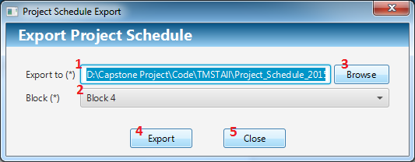

Figure 52: Export Project Schedule

**Fields**

|  |  |  |  |  |  |  |  |
| --- | --- | --- | --- | --- | --- | --- | --- |
| **No** | **Field**  **Name** | **Description** | **Read**  **only** | **Mandatory** | **Control**  **Type** | **Data**  **Type** | **Length** |
| 1 | File Path | View location of file to export | Yes | Yes | Text Field | String | N/A |
| 2 | Block | Choice the block | No | Yes | Combo box | String | N/A |

**Buttons**

|  |  |  |  |  |
| --- | --- | --- | --- | --- |
| No | Function | Description | Validation | Outcome |
| 3 | Browse | Open save dialog to choose location to save file. | N/A | Open save dialog to choose location to save file. View file path on text field File Path. |
| 4 | Export | Export data to excel file. | N/A | Export data to excel file on file path. |
| 5 | Close | Click to close window | N/A | Close this window. |

#### Calculate Timekeeping

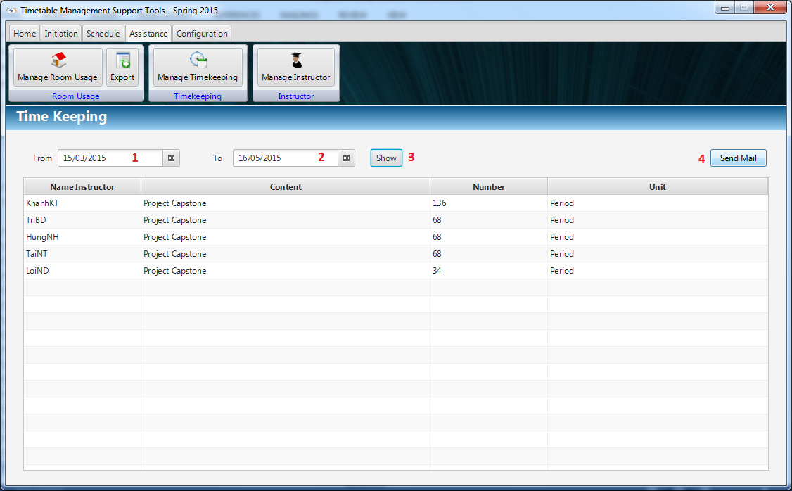

Figure 53: Calculate Timekeeping

**Fields**

|  |  |  |  |  |  |  |  |
| --- | --- | --- | --- | --- | --- | --- | --- |
| **No** | **Field**  **Name** | **Description** | **Read**  **only** | **Mandatory** | **Control**  **Type** | **Data**  **Type** | **Length** |
| 1 | From Date | Start time of timekeeping for calculating. | No | Yes | Date Picker | Date | N/A |
| 2 | To Date | End time of timekeeping for calculating. | No | Yes | Date Picker | Date | N/A |

**Buttons**

|  |  |  |  |  |
| --- | --- | --- | --- | --- |
| **No** | **Function** | **Description** | **Validation** | **Outcome** |
| 3 | Show | Calculate the timekeeping with values from date pickers. | N/A | Data will be shown in table |
| 4 | Send Mail | Send timekeeping mail to instructors | N/A | Navigate to Send Mail Dialog |

#### Send Timekeeping

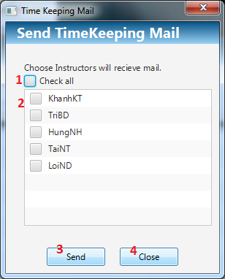

Figure 54: Send Timekeeping

**Fields**

|  |  |  |  |  |  |  |  |
| --- | --- | --- | --- | --- | --- | --- | --- |
| **No** | **Field**  **Name** | **Description** | **Read**  **only** | **Mandatory** | **Control**  **Type** | **Data**  **Type** | **Length** |
| 1 | Check all | Select all instructor | No | Yes | Checkbox | Boolean | N/A |
| 2 | Instructor | Select who will received timekeeping mail | No | Yes | Checklist View | Boolean | N/A |

**Buttons**

|  |  |  |  |  |
| --- | --- | --- | --- | --- |
| **No** | **Function** | **Description** | **Validation** | **Outcome** |
| 3 | Send | Send timekeeping mail to instructors | N/A | Windows will be closed |
| 4 | Close | Close the windows | N/A | Windows will be closed |

#### View Room Usage

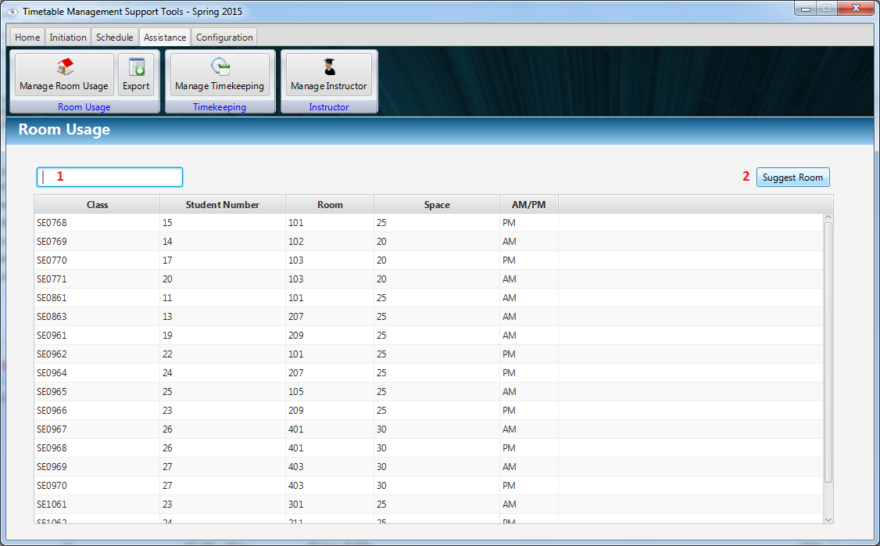

Figure 55: View Room Usage

**Fields**

|  |  |  |  |  |  |  |  |
| --- | --- | --- | --- | --- | --- | --- | --- |
| **No** | **Field**  **Name** | **Description** | **Read**  **only** | **Mandatory** | **Control**  **Type** | **Data**  **Type** | **Length** |
| 1 | Filter field | Filter data by rooms or classes | No | No | Textbox | String | N/A |

**Buttons**

|  |  |  |  |  |
| --- | --- | --- | --- | --- |
| **No** | **Function** | **Description** | **Validation** | **Outcome** |
| 2 | Suggest Room | Suggest rooms for user | N/A | Result of suggestion was shown |

#### Export Room Usage

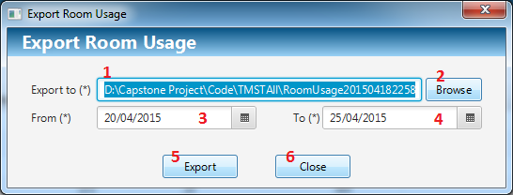

Figure 56: Export Room Usage

**Fields**

|  |  |  |  |  |  |  |  |
| --- | --- | --- | --- | --- | --- | --- | --- |
| **No** | **Field**  **Name** | **Description** | **Read**  **only** | **Mandatory** | **Control**  **Type** | **Data**  **Type** | **Length** |
| 1 | Export to | Location to export room usage excel file | Yes | Yes | Textbox | String | N/A |
| 3 | From Date | Start time of room usage for export. | No | Yes | Date Picker | Date | N/A |
| 4 | To Date | End time of room usage for export. | No | Yes | Date Picker | Date | N/A |

**Buttons**

|  |  |  |  |  |
| --- | --- | --- | --- | --- |
| **No** | **Function** | **Description** | **Validation** | **Outcome** |
| 2 | Browse | Suggest rooms for user | N/A | Open file chooser window |
| 5 | Export | Export excel file | N/A | Export file to specific location |
| 6 | Close | Close the windows | N/A | Windows will be closed |

## Database Design

### 21.1. Logical Diagram

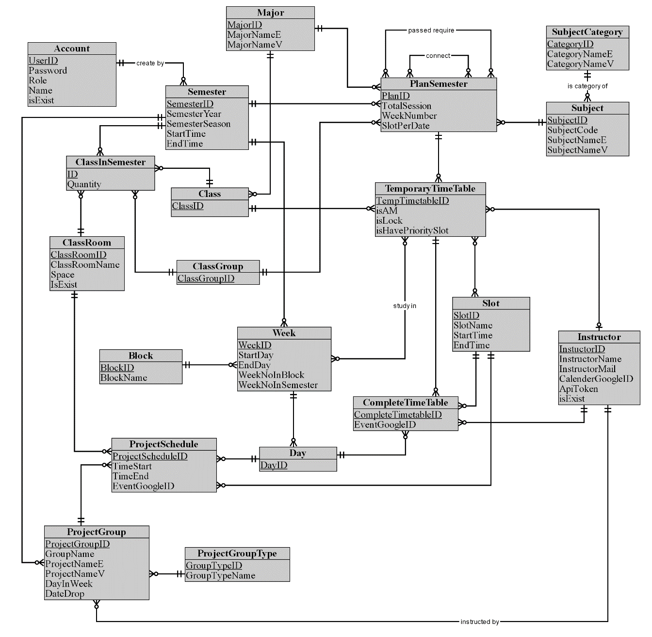

Figure 57: Logical Diagram

### 21.2. Data Dictionary

|  |  |
| --- | --- |
| **Entity dictionary** | |
| **Entity Name** | **Description** |
| Account | Describe all user of the system. Each user has only one account. |
| Semester | Describe the semesters of FPT University, each semester at FPT University is about 4 months. |
| ClassRoom | Describe the rooms of FPT University which can be used for teaching. |
| Class | Describe the classes in FPT University. Each class is a set of students who have same courses. |
| ClassInSemester | Describe the specific class in a specific semester. |
| ClassGroup | Describe the sets of class in FPT University have the same plan in a semester. |
| Major | Describe the sets of class in FPT University have the same major. |
| Slot | Describe the slot in FPT University. Each slot is 90 minutes. |
| Day | Describe the official day in FPT University’s curriculum. Each day has 8 slots. |
| Week | Describe the week in FPT University’s curriculum. |
| Block | Describe the sets of weeks defined by FPT University. |
| Subject | Describe all available subject in FPT University. |
| SubjectCategory | Describe the sets of Subject. |
| PlanSemester | Describe the specific subjects which are available for each class group in a specific semester. Each semester has many plan semesters. |
| Instructor | Describe all instructors in FPT University. |
| CompletedTimetable | Describe the timetable in FPT University. Each timetable is about a set of answers for these question: which class has which subjects, teaching by who (instructor), at which specific period? |
| TemporaryTimetable | Describe the timetable in a brief description way. |
| ProjectGroup | Describe the set of students who is doing Capstone Project and Graduation Thesis. |
| ProjectGroupType | Describe the type of project group. |
| ProjectSchedule | Describe the time for meeting of project groups with their Instructor. |

Table 3: Entity Data Dictionary

|  |  |  |  |  |
| --- | --- | --- | --- | --- |
| **Entity name** | **Attributes** | **Description** | **Domain** | **Null** |
| Account | UserID {PK} | Account username | String, length: 50 | No |
| Password | Account password | String, length: 50 | No |
| Role | Unique identifier of a role (1: Admin, 2: Staff) | Integer | No |
| Name | Account username | Unicode String, length: 50 | No |
| isExist | Account status | Boolean | No |
| Semester | SemesterID {PK} | Unique identifier of a semester, auto increment | Integer | No |
| SemesterYear | Semester Year | Integer | No |
| SemesterSeason | Semester Season (Spring, Summer, Fall) | String, length: 30 | No |
| StartTime | The start date of semester | Date | No |
| EndTime | The end date of semester | Date | No |
| SubjectCategory | CategoryID {PK} | Unique identifier of a subject category | String, length: 10 | No |
| CategoryNameE | Subject category in English | String, length: 50 | No |
| CategoryNameV | Subject category in Vietnamese | Unicode String, length: 50 | No |
| Subject | SubjectCode {PK} | Unique identifier of a subject | String, length: 50 | No |
| SubjectNameE | Subject in Vietnamese | String, length: 100 | No |
| SubjectNameV | Subject in Vietnamese | Unicode String, length: 100 | No |
| PlanSemester | PlanID {PK} | Unique identifier of a plan, auto  increment | Integer | No |
| TotalSession | Total session of this plan | Integer | No |
| WeekNumber | Week number of plan in semester | Integer | No |
| SlotPerDate | Number of slot per date of plan | Integer | No |
| Major | MajorID {PK} | Unique identifier of a major, auto  increment | Unicode String, length: 10 | No |
| MajorNameE | Major in English | String, length: 100 | No |
| MajorNameV | Major in Vietnamese | Unicode String, length: 100 | No |
| ClassGroup | ClassGroupID {PK} | Unique identifier of a class group | String, length: 20 | No |
| Class | ClassID {PK} | Name of class, unique identifier | String, length: 10 | No |
| ClassInSemester | ID {PK} | Unique identifier, auto  increment | Integer | No |
| Quantity | Number of student of class in this semester | Integer | No |
| ClassRoom | ClassRoomID {PK} | Unique identifier of a classroom, auto  increment | Integer | No |
| ClassRoomName | Name of classroom | Unicode String, length: 30 | No |
| Space | Room space | Integer | No |
| IsExist | Classroom status | Boolean | No |
| TemporaryTimeTable | TempTimetableID {PK} | Unique identifier of a course, auto  Increment | Integer | No |
| isAM | Identity the course study in AM or PM | Boolean | No |
| isLock | Identity if the course is locked. If the course is lock, no action affect it. | Boolean | No |
| isHavePrioritySlot | Identity if the course have priority slot. | Boolean | No |
| Slot | SlotID {PK} | Unique identifier of a slot | Integer | No |
| SlotName | Slot name | String, length: 10 | No |
| StartTime | Start time of the slot | Time, length: 7 | No |
| EndTime | End time of the slot | Time, length: 7 | No |
| Instructor | InstuctorID {PK} | Unique identifier of an instructor | String, length: 30 | No |
| InstructorName | Name of instructor | Unicode String, length: 50 | No |
| InstructorMail | Mail of instructor | String, length: 100 | No |
| CalenderGoogleID | Calendar ID in Google calendar | String, length: 100 | Yes |
| ApiToken | Access token to synchronize Google calendar | String, length: 100 | Yes |
| isExist | Instructor status | Boolean | No |
| Block | BlockID {PK} | Unique identifier of a block | Integer | No |
| BlockName | Block name | String, length: 10 | No |
| Week | WeekID {PK} | Unique identifier of a week, auto  increment | Integer | No |
| StartDay | The start date of this week | Date | No |
| EndDay | The end date of this week | Date | No |
| WeekNoInBlock | Ordinal numbers of week in a block | Integer | No |
| WeekNoInSemester | Ordinal numbers of week in the semester | Integer | No |
| Day | DayID {PK} | Unique identifier of a date | Date | No |
| CompleteTimeTable | CompleteTimetableID {PK} | Unique identifier of a complete timetable, auto  increment | Integer | No |
| EventGoogleID | The Google event ID in Google calendar | String, length: 100 | Yes |
| ProjectGroupType | GroupTypeID {PK} | Unique identifier of a project group type | String, length: 5 | No |
| GroupTypeName | Group type name | String, length: 30 | No |
| ProjectGroup | ProjectGroupID {PK} | Unique identifier of a group, auto  increment | Integer | No |
| GroupName | Name of group | Unicode String, length: 30 | No |
| ProjectNameE | Project topic in English | String, length: 200 | No |
| ProjectNameV | Project topic in Vietnamese | Unicode String, length: 200 | No |
| DayInWeek | Number of date per week which instructor has meeting with students | Integer | No |
| DateDrop | The drop date of the group | Date | Yes |
| ProjectSchedule | ProjectScheduleID {PK} | Unique identifier of a projects schedule, auto  increment | Integer | No |
| TimeStart | The start time of meeting | Time, length: 7 | No |
| TimeEnd | The end time of meeting | Time, length: 7 | No |
| EventGoogleID | The Google event ID in Google calendar | String, length: 100 | Yes |

Table 4: Detail Data Dictionary

## Algorithms

### 22.1. Suggest Temporary Timetable

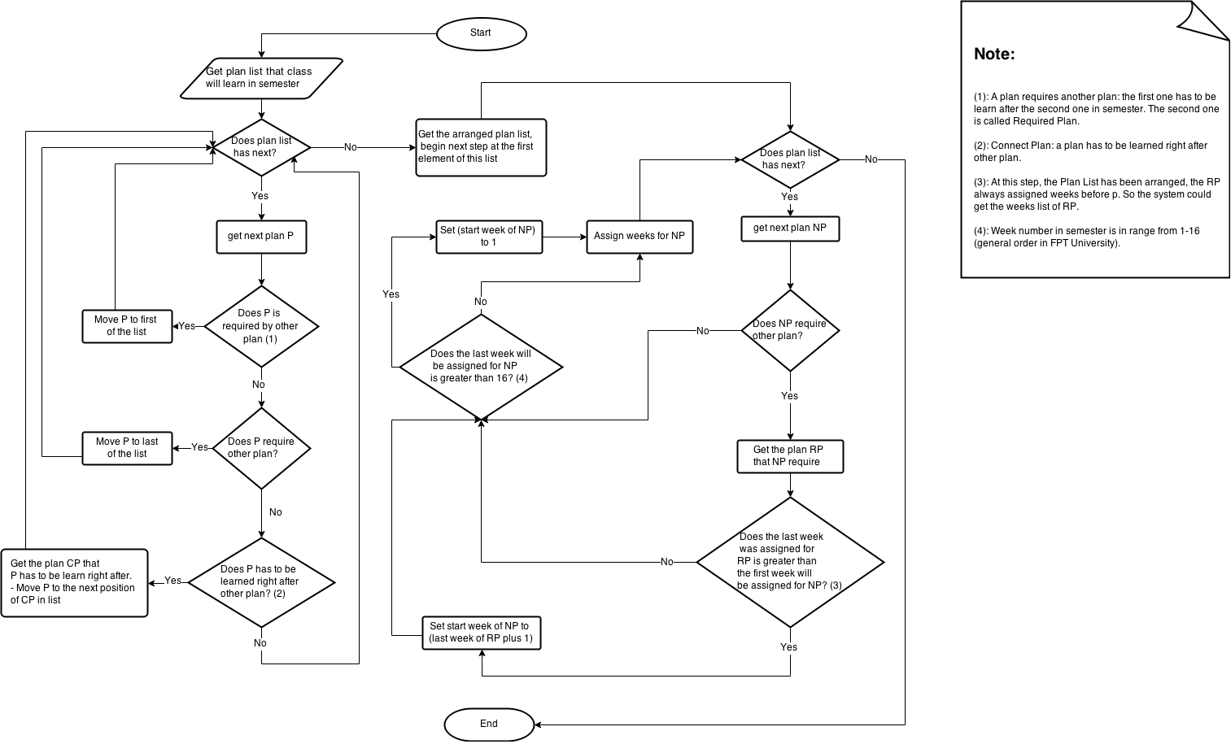

Figure 58: Suggest Temporary Timetable

### 22.2. Suggest Complete Timetable

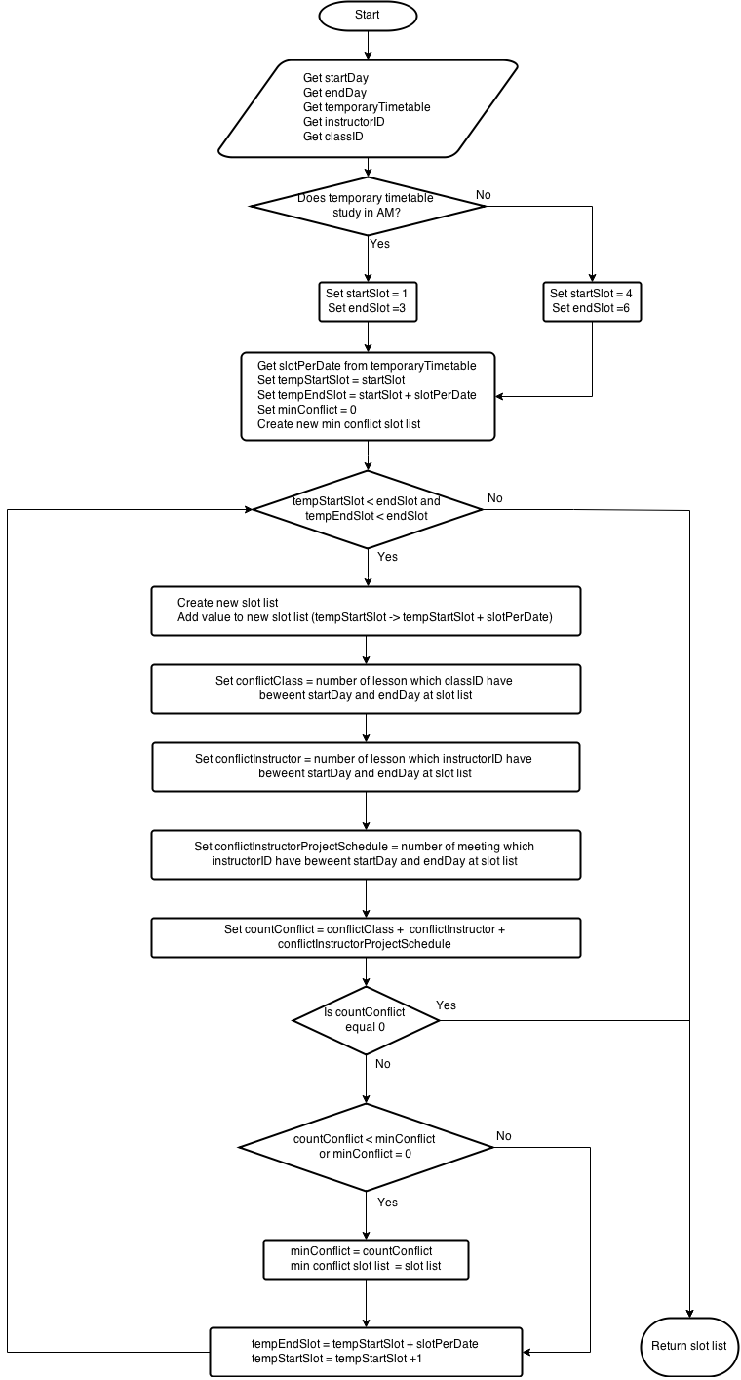

Figure 59: Suggest Complete Timetable

### 22.3. Choose Slot

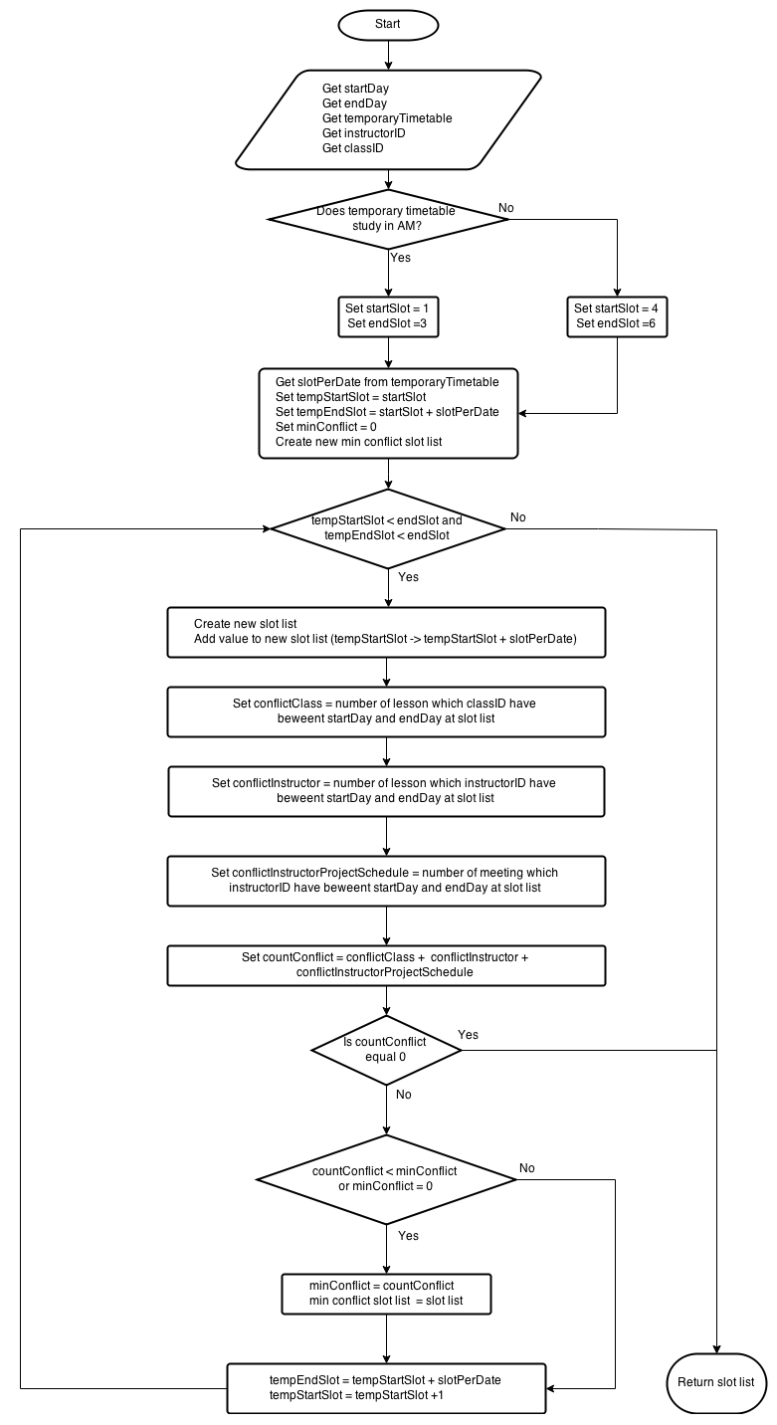

Figure 60: Choose Slot

### 22.4. Suggest Room

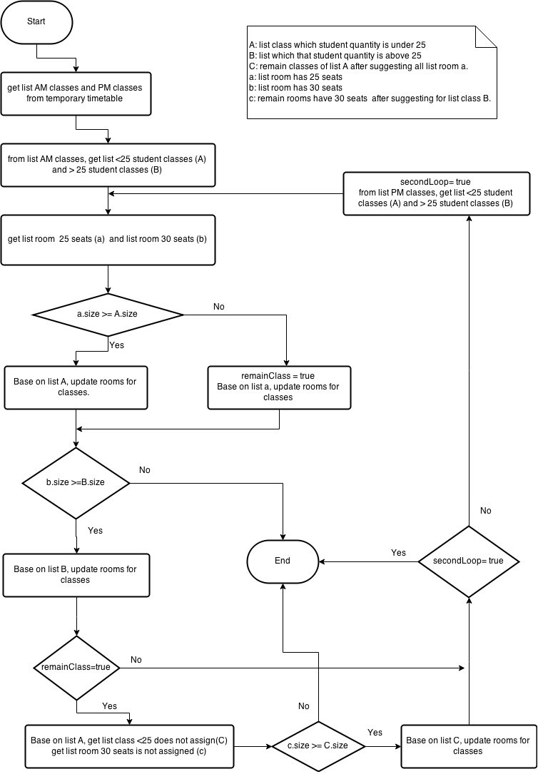

Figure 61: Suggest Room

### 22.5. Suggest Guide Project Schedule

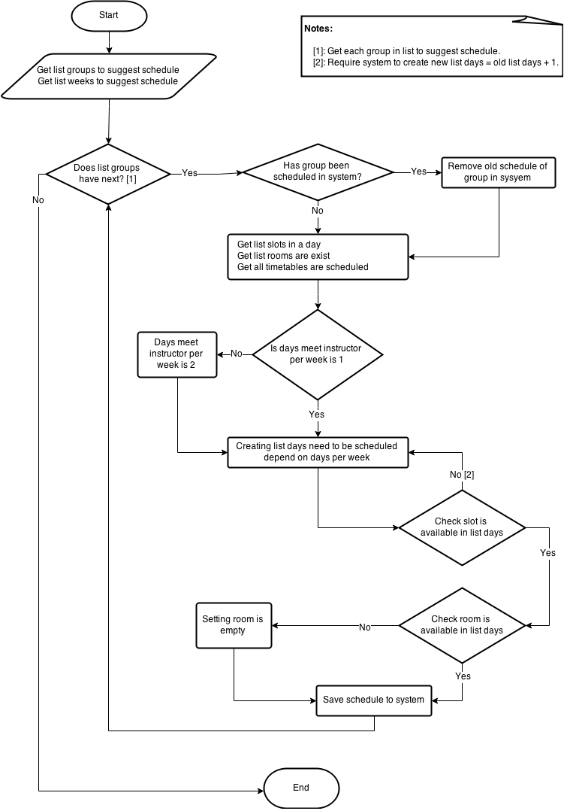

Figure 62: Suggest Guide Project Schedule

# System Implementation & Test

## Introduction

### 23.1. Overview

This section provides in detail all necessary information about test plans, test cases, test result, test environments, pass/fail criteria and risks estimations as well as a checklist to cover all possible cases of this project.

### 23.2. Test Approach

* Goal: To test the whole system based on the core workflow.
* Method: System Testing, Black – box Testing.

## Database Relationship Diagram

### 24.1 Physical Diagram

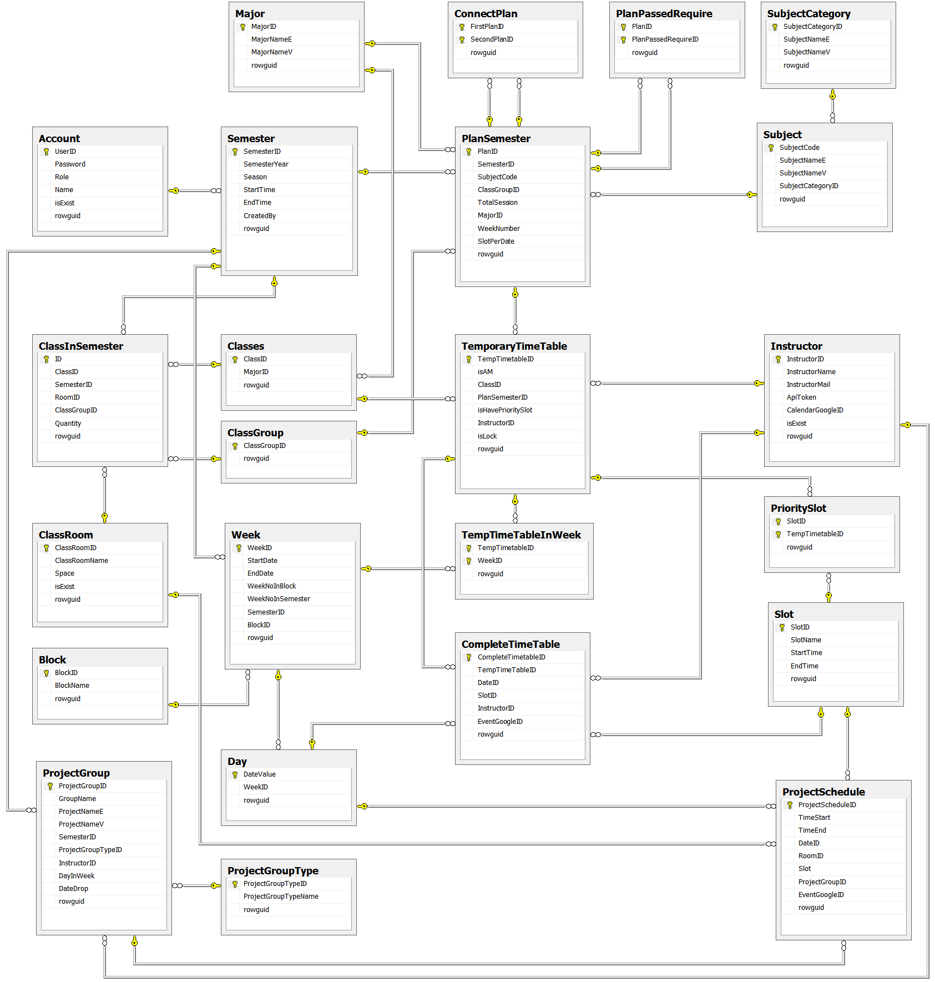

Figure 1: Database Relationship Diagram

### Data Dictionary

#### 24.2.1 Data Dictionary

|  |  |
| --- | --- |
| **Entity Name** | **Description** |
| Account | Describe all users of the system. Each user has only one account. |
| Semester | Describe the semester of FPT University, each semester in FPT University is about 4 months. |
| ClassRoom | Describe the room of FPT University which can be used for teaching. |
| Class | Describe the class in FPT University. Each class is a set of students who have same courses. |
| ClassInSemester | Describe a specific class in a specific semester. |
| ClassGroup | Describe a set of classes in FPT University have the same plan in a semester. |
| Major | Describe a set of classes in FPT University have the same major. |
| Slot | Describe a slot in FPT University. Each slot is 90 minutes. |
| Day | Describe the official day in FPT University’s curriculum. Each day has 8 slots. |
| Week | Describe the week in FPT University’s curriculum. |
| Block | Describe the sets of weeks defined by FPT University. |
| Subject | Describe all available subject in FPT University. |
| SubjectCategory | Describe a set of Subjects. |
| PlanSemester | Describe specific subjects which are available for each class group in a specific semester. Each semester has many plan semesters. |
| PlanPassedRequire | Describe a PlanSemester have to be learned before one or other PlanSemesters. |
| ConnectPlan | Describe a PlanSemester have to be learned right after another PlanSemester (both of them have to learn in the same Semester). |
| Instructor | Describe all instructors in FPT University. |
| CompleteTimetable | Describe the timetable in FPT University. Each timetable is about a set of answers for these questions: which class has which subjects, teaching by who (instructor), at which specific period? |
| TemporaryTimetable | Describe the timetable in a brief description way. |
| TempTimeTableInWeek | Describe which weeks the Temporary Timetable is assigned in. |
| PrioritySlot | Describe which slots the Temporary Timetable is assigned at. |
| ProjectGroup | Describe a set of students who is doing Capstone Project and Graduation Thesis. |
| ProjectGroupType | Describe the type of project group. |
| ProjectSchedule | Describe the time for meeting of project groups with their Instructor. |

Table 1: Data Dictionary

#### Attribute Data Dictionary

|  |  |  |  |  |
| --- | --- | --- | --- | --- |
| **Table name** | **Attributes** | **Description** | **Domain** | **Null** |
| Account | UserID {PK} | Account username | varchar(50) | No |
| Password | Account password | varchar(50) | No |
| Role | Unique identifier of a role (1: Admin, 2: Staff) | int | No |
| Name | Account username | nvarchar(50) | No |
| isExist | Account status | bit | No |
| rowguid | Row ID, this attribute uses for synchronizing data between local and server | uniqueidentifier | No |
| Semester | SemesterID {PK} | Unique identifier of a semester, auto increment | int | No |
| SemesterYear | Semester Year | int | No |
| SemesterSeason | Semester Season (Spring, Summer, Fall) | varchar(30) | No |
| StartTime | The start date of semester | date | No |
| EndTime | The end date of semester | date | No |
| CreatedBy {FK} | Identity who creates a semester | varchar(50) |  |
| rowguid | Row ID, this attribute uses for synchronizing data between local and server | uniqueidentifier | No |
| SubjectCategory | CategoryID {PK} | Unique identifier of a subject category | varchar(10) | No |
| CategoryNameE | Subject category in English | varchar(50) | No |
| CategoryNameV | Subject category in Vietnamese | nvarchar(50) | No |
| rowguid | Row ID, this attribute uses for synchronizing data between local and server | uniqueidentifier | No |
| Subject | SubjectCode {PK} | Unique identifier of a subject | varchar(50) | No |
| SubjectNameE | Subject Name in Vietnamese | varchar(100) | No |
| SubjectNameV | Subject Name in Vietnamese | nvarchar(100) | No |
| SubjectCategoryID {FK} | Category of subject. | varchar(10) |  |
| rowguid | Row ID, this attribute uses for synchronizing data between local and server | uniqueidentifier | No |
| PlanSemester | PlanID {PK} | Unique identifier of a plan, auto  increment | int | No |
| TotalSession | Total session of a plan | int | No |
| WeekNumber | Week number of plan in semester | int | No |
| SlotPerDate | Number of slot per date of plan | int | No |
| SubjectCode {FK} | Identity a plan study what subject | varchar(50) | No |
| SemesterID {FK} | Identity a plan belong what semester | int | No |
| ClassGroupID {FK} | Identity a plan belong belong what class group | varchar(20) | No |
| MajorID {FK} | Identity a plan belong belong what major | nvarchar(10) | No |
| rowguid | Row ID, this attribute uses for synchronizing data between local and server | uniqueidentifier | No |
| PlanPassedRequire | PlanID {PK} | Identity what plan have to be learned before other plan. | int | No |
| PlanPassedRequireID {PK} | Identity what plan have to be learned after other plan. | int | No |
| rowguid | Row ID, this attribute uses for synchronizing data between local and server | int | No |
| ConnectPlan | FirstPlanID {PK} | Identity what plan have to be learned right before other plan. | int | No |
| SecondPlanID {PK} | Identity what plan have to be learned right after other plan. | int | No |
| rowguid | Row ID, this attribute uses for synchronizing data between local and server | int | No |
| Major | MajorID {PK} | Unique identifier of a major, auto increment | nvarchar(10) | No |
| MajorNameE | Major in English | varchar(100) | No |
| MajorNameV | Major in Vietnamese | nvarchar(100) | No |
| rowguid | Row ID, this attribute uses for synchronizing data between local and server | uniqueidentifier | No |
| ClassGroup | ClassGroupID {PK} | Unique identifier of a class group | varchar(20) | No |
| rowguid | Row ID, this attribute uses for synchronizing data between local and server | uniqueidentifier | No |
| Class | ClassID {PK} | Name of class, unique identifier | varchar(10) | No |
| MajorID {FK} | Identity a class belong what major | nvarchar(10) |  |
| rowguid | Row ID, this attribute uses for synchronizing data between local and server | uniqueidentifier | No |
| ClassInSemester | ID {PK} | Unique identifier, auto  increment | int | No |
| Quantity | Number of student of class in a semester | int | No |
| ClassID {FK} | Identity a class | varchar(10) | No |
| SemesterID {FK} | Identity a semester | int | No |
| RoomID {FK} | Identity a class study at what room in semester | int | Yes |
| ClassGroupID {FK} | Identity a class belong what class group in semester | varchar(20) | No |
| rowguid | Row ID, this attribute uses for synchronizing data between local and server | uniqueidentifier | No |
| ClassRoom | ClassRoomID {PK} | Unique identifier of a classroom, auto  increment | int | No |
| ClassRoomName | Name of classroom | nvarchar(30) | No |
| Space | Room space | int | No |
| IsExist | Classroom status | bit | No |
| rowguid | Row ID, this attribute uses for synchronizing data between local and server | uniqueidentifier | No |
| TemporaryTimeTable | TempTimetableID {PK} | Unique identifier of a course, auto increment | int | No |
| isAM | Identity the course study in AM or PM | bit | No |
| isHavePrioritySlot | Identity if the course have priority slot | bit | No |
| ClassID {FK} | Identity what class study a course | varchar(10) | No |
| PlanSemesterID {FK} | Identity what subject study a course | int | No |
| InstructorID {FK} | Identity who teach a course | varchar(30) | Yes |
| isLock | Identity if the course is locked | bit | No |
| rowguid | Row ID, this attribute uses for synchronizing data between local and server | uniqueidentifier | No |
| TempTimeTableInWeek | TempTimetableID {PK} | Identity what Temporary Timetable | int | No |
| WeekID {PK} | Identity what week of a temptimetable | int | No |
| rowguid | Row ID, this attribute uses for synchronizing data between local and server | int | No |
| PrioritySlot | TempTimetableID {PK} | Identity what Temporary Timetable | int | No |
| SlotID {PK} | Identity what slot | int | No |
| rowguid | Row ID, this attribute uses for synchronizing data between local and server | uniqueidentifier | No |
| Slot | SlotID {PK} | Unique identifier of a slot | int | No |
| SlotName | Slot name | varchar(10) | No |
| StartTime | Start time of a slot | time(7) | No |
| EndTime | End time of a slot | time(7) | No |
| rowguid | Row ID, this attribute uses for synchronizing data between local and server | uniqueidentifier | No |
| Instructor | InstuctorID {PK} | Unique identifier of an instructor | varchar(30) | No |
| InstructorName | Name of instructor | nvarchar(50) | No |
| InstructorMail | Mail of instructor | varchar(100) | No |
| CalenderGoogleID | Calendar ID in Google calendar | varchar(100) | Yes |
| ApiToken | Access token to synchronize Google calendar | varchar(100) | Yes |
| isExist | Instructor status | bit | No |
| rowguid | Row ID, this attribute uses for synchronizing data between local and server | uniqueidentifier | No |
| Block | BlockID {PK} | Unique identifier of a block | int | No |
| BlockName | Block name | varchar(10) | No |
| rowguid | Row ID, this attribute uses for synchronizing data between local and server | uniqueidentifier | No |
| Week | WeekID {PK} | Unique identifier of a week, auto  increment | int | No |
| StartDay | The start date of a week | date | No |
| EndDay | The end date of a week | date | No |
| WeekNoInBlock | Ordinal numbers of week in a block | int | No |
| WeekNoInSemester | Ordinal numbers of week in the semester | int | No |
| BlockID {FK} | Identity a week belong what block | Int | No |
| SemesterID {FK} | Identity a week belong what semester | int | No |
| rowguid | Row ID, this attribute uses for synchronizing data between local and server | uniqueidentifier | No |
| Day | DayValue {PK} | Unique identifier of a date | date | No |
| WeekID {FK} | Identity this date belong what week | int |  |
| rowguid | Row ID, this attribute uses for synchronizing data between local and server | uniqueidentifier | No |
| CompleteTimeTable | CompleteTimetableID {PK} | Unique identifier of a complete timetable, auto  increment | int | No |
| EventGoogleID | The Google event ID in Google calendar | varchar(100) | Yes |
| TempTimeTableID {FK} | Identity the course of a lesson | int | No |
| DateID {FK} | Identity date of a lesson | date | No |
| SlotID {FK} | Identity slot of a lesson | Int | No |
| InstructorID {FK} | Identity instructor of a lesson | varchar(30) | Yes |
| rowguid | Row ID, this attribute uses for synchronizing data between local and server | uniqueidentifier | No |
| ProjectGroupType | GroupTypeID {PK} | Unique identifier of a project group type | varchar(5) | No |
| GroupTypeName | Group type name | varchar(30) | No |
| rowguid | Row ID, this attribute uses for synchronizing data between local and server | uniqueidentifier | No |
| ProjectGroup | ProjectGroupID {PK} | Unique identifier of a group, auto  increment | int | No |
| GroupName | Name of group | nvarchar(30) | No |
| ProjectNameE | Project topic in English | varchar(200) | No |
| ProjectNameV | Project topic in Vietnamese | nvarchar(200) | No |
| DayInWeek | Number of date per week which instructor has meeting with students | int | No |
| DateDrop | The drop date of the group | date | Yes |
| SemesterID {FK} | Identity a group belong what semester | int | No |
| ProjectGroupTypeID {FK} | Identity a group belong what type | varchar(5) | No |
| InstructorID {FK} | Identity a group be guided by who | varchar(30) | No |
| rowguid | Row ID, this attribute uses for synchronizing data between local and server | uniqueidentifier | No |
| ProjectSchedule | ProjectScheduleID {PK} | Unique identifier of a projects schedule, auto  increment | int | No |
| ProjectGroupID {FK} | Identity what group have meeting | int | No |
| RoomID {FK} | Identity meeting at what room | int | No |
| Slot {FK} | Identity meeting in what slot | int | No |
| DateID {FK} | Identity a date of meeting | date | No |
| TimeStart | The start time of meeting | time(7) | No |
| TimeEnd | The end time of meeting | time(7) | No |
| EventGoogleID | The Google event ID in Google calendar | varchar(100) | Yes |
| rowguid | Row ID, this attribute uses for synchronizing data between local and server | uniqueidentifier | No |

Table 2: Attribute Data Dictionary

## Performance Measures

### 25.1. Send Mail Performance

The total time for creating and sending mail for each instructor to SMTP host is less than 7 seconds per mail.

### 25.2. Synchronize Performance

The speed of synchronize timetable and project guide schedule to Instructor’s Google Calendar is less than 2 seconds per record.

### 25.3. Suggestion Algorithm Performance

* The speed of suggest temporary timetable is less than 1 second per class.
* The speed of suggest completed timetable is less than 0.2 second per class.

## Test Plan

The purpose of this section is to verify and ensure that TMST meets its design specification and other requirements from user. The following part will describe which features to be tested and which will not.

### 26.1. Features to be tested

We will test the entire system based on the following core workflow (Reference: Figure 2, 3: Core Workflow).

Based on the workflow, all following features will be tested, which can include one or more functions. These features will be focused and tested thoroughly during the test phase.

Staff:

* Import Plan Semester.
* Import Classes List.
* View Temporary Timetable.
* Edit Temporary Timetable.
* Check Conflict Temporary Timetable.
* Export Temporary Timetable.
* Import Instructor List.
* View Complete Timetable.
* Edit Complete Timetable.
* Check Conflict Complete Timetable.
* Import Project Group List.
* Edit Guide Project Schedule.
* View Guide Project Schedule
* View Timekeeping
* View Room Usage Schedule
* Suggest Room Usage Schedule
* Edit Room Usage Schedule

System:

* Suggest Temporary Timetable.
* Suggest Complete Timetable.
* Suggest Room Usage.
* Suggest Guide Project Schedule.
* Calculate Timekeeping.

### 26.2. Features not to be tested

* Login, Logout.
* Create New Semester.
* Open Semester.
* Manage Plan Semester.
* Manage Subject.
* Manage Class.
* Export Complete Timetable.
* Export Room Usage Schedule.
* Manage Group.
* Manage Instructor.
* Send Mail.
* Email Configure
* Synchronize Configure.

## System Testing Test Case

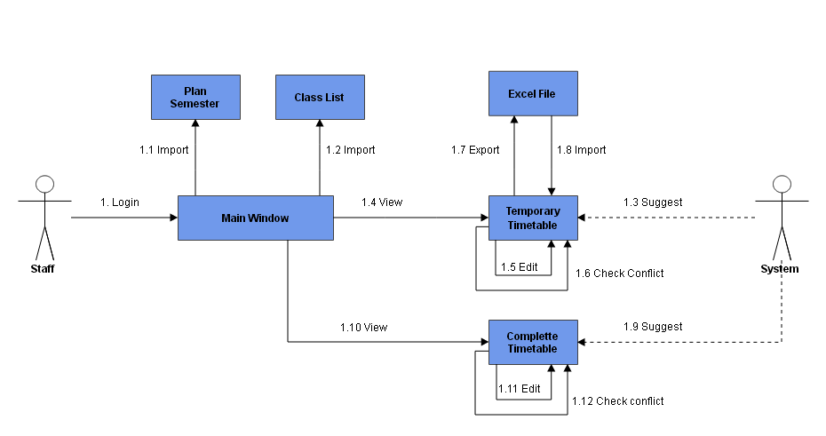

Figure 2: Core Flow 1

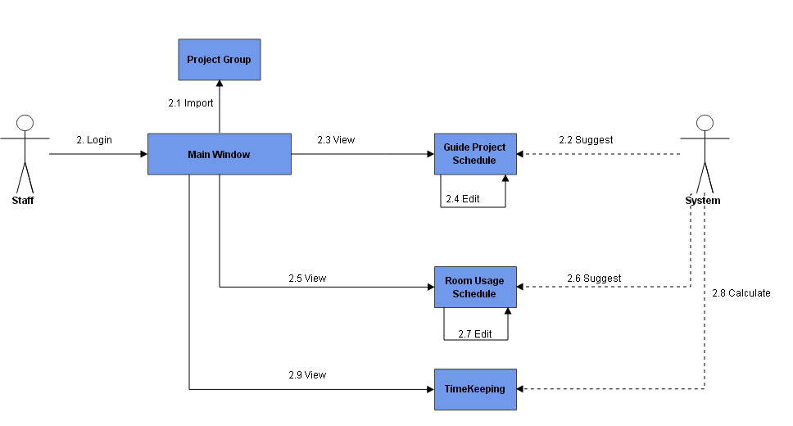

Figure 3: Core Flow 2

### 27.1. Core Flow 1

#### Import Plan Semester.

|  |  |  |  |  |  |  |  |
| --- | --- | --- | --- | --- | --- | --- | --- |
| **ID** | **Test Case Description** | **Test Case Procedure** | **Expected output** | **Inter-test Case Dependence** | **Result** | **Test Date** | **Note** |
| PS01 | Input wrong excel file | 1-On file choose, select non excel file | -Show error message” Invalid extension file. |  | Passed | 17/04/2015 |  |
| PS02 | Not selected before save | 1-Check un to unselect all data  2-Click “Save” button | -Show warning error message “No subject is selected” |  | Passed | 17/04/2015 |  |
| PS03 | Exist error before save | 1-Data exist error, click save | -Show error message “There’s exist error, please check again” |  | Passed |  |  |
| PS04 | Edit Data: null data | 1-Double clicks on a row  2-Delete all data  3-Click “Update” button | -Show error message | PS01 | Passed | 17/04/2015 |  |
| PS05 | Edit Data: wrong data | -Double clicks on a row  2- Input wrong data  3-Click “Update” button | -Show error message | PS01 | Passed | 17/04/2015 |  |
| PS06 | Edit Data: right data | -Double clicks on a row  2- Input right data  3-Click “Update” button | -Close window  -Data updated | PS01 | Passed | 17/04/2015 |  |

Table 3: Import Plan Semester.

#### Import Classes List.

|  |  |  |  |  |  |  |  |
| --- | --- | --- | --- | --- | --- | --- | --- |
| **ID** | **Test Case Description** | **Test Case Procedure** | **Expected output** | **Inter-test Case Dependence** | **Result** | **Test Date** | **Note** |
| CL01 | Input wrong excel file | 1 - On file choose, select non excel file | - Show error message” Invalid extension file. |  | Passed | 17/04/2015 |  |
| CL02 | Not selected before save | 1 - Check un to unselect all data  2 - Click “Save” button | -Show warning error message “No subject is selected” |  | Passed | 17/04/2015 |  |
| CL03 | Exist error before save | 1 - Data exist error, click save | -Show error message “There’s exist error, please check again” |  | Passed |  |  |
| CL04 | Edit Data: null data | 1 - Double clicks on a row  2 - Delete all data  3 - Click “Update” button | -Show error message | CL01 | Passed | 17/04/2015 |  |
| CL05 | Edit Data: wrong data | 1 - Double clicks on a row  2 - Input wrong data  3 - Click “Update” button | -Show error message | CL01 | Passed | 17/04/2015 |  |
| CL06 | Edit Data: right data | 1 - Double clicks on a row  2- Input right data  3 - Click “Update” button | -Close window  -Data updated | CL01 | Passed | 17/04/2015 |  |

Table 4: Import Classes List

#### Suggest Temporary Timetable.

|  |  |  |  |  |  |  |  |  |
| --- | --- | --- | --- | --- | --- | --- | --- | --- |
| **ID** | **Test Case Description** | **Test Case Procedure** | **Expected output** | **Inter-test Case Dependence** |  | **Result** | **Test Date** | **Note** |
| STT01 | Staff request suggest temporary timetable | 1 – At “Main Window”, clicks on “Suggest Temporary Timetable”.  2 – Check classes want to create.  3 – Click “Create” button. | - After step 1, show the “Add Temporary Timetable window”.  - After step 3, show the dialog to notify success or fail. Create temporary timetable for checked classes. |  |  | Passed | 10/4/2015 |  |

Table 5: Suggest Temporary Timetable

#### View Temporary Timetable.

|  |  |  |  |  |  |  |  |
| --- | --- | --- | --- | --- | --- | --- | --- |
| **ID** | **Test Case Description** | **Test Case Procedure** | **Expected output** | **Inter-test Case Dependence** | **Result** | **Test Date** | **Note** |
| VTT01 | Staff view temporary timetable | 1 – At Main Window, clicks on “View Temporary Timetable” | Show “View Temporary Timetable Window” |  | Passed | 10/4/2015 |  |

Table 6: View Temporary Timetable

#### Edit Temporary Timetable.

|  |  |  |  |  |  |  |  |
| --- | --- | --- | --- | --- | --- | --- | --- |
| **ID** | **Test Case Description** | **Test Case Procedure** | **Expected output** | **Inter-test Case Dependence** | **Result** | **Test Date** | **Note** |
| ETT01 | Staff adjust temporary timetable with right input. | 1 – At “View Temporary Timetable” window, double click on a row in view table.  2 – Edit class, time, subject, instructor, priority slot.  3 – Click “Update” button. | - After step 1, show the “Edit Temporary Timetable” window.  - After step 3, Update the table view. |  | Passed | 10/4/2015 |  |
| ETT02 | Priority slot is higher than slot number | 1 – At “View Temporary Timetable” window, double click on a row in view table.  2 – Edit class, time, subject, instructor, priority slot (higher than slot number).  3 – Click “Update” button. | - After step 1, show the “Edit Temporary Timetable” window.  - After step 3, show error message “Priority slot is higher than slot number, please try again”. |  |  |  |  |

Table 7: Edit Temporary Timetable

#### Export Temporary Timetable.

|  |  |  |  |  |  |  |  |
| --- | --- | --- | --- | --- | --- | --- | --- |
| **ID** | **Test Case Description** | **Test Case Procedure** | **Expected output** | **Inter-test Case Dependence** | **Result** | **Test Date** | **Note** |
| EXT01 | Staff export temporary timetable to excel file | 1 – At “View Temporary Timetable” window, click on “Export to Excel file” button.  2 – Select Major, select URL to Export  3 – Click “Export” button. | - After step 1, show the “Export Temporary Timetable” window.  - After step 3, show the dialog to notify success or fail. Export temporary timetable to Excel file. |  | Passed | 10/4/2015 |  |

Table 8: Export Temporary Timetable

#### Import Instructor List.

|  |  |  |  |  |  |  |  |
| --- | --- | --- | --- | --- | --- | --- | --- |
| **ID** | **Test Case Description** | **Test Case Procedure** | **Expected output** | **Inter-test Case Dependence** | **Result** | **Test Date** | **Note** |
| IIL01 | Staff import “Instructor List” Excel file. | 1 – At “View Temporary Timetable” window, click on “Import Instructor List” button.  2 – Select file to import.  3 – Click “Open” button. | - After step 1, show the “Browse file” window.  - After step 3, show the dialog to notify success. Update the table view. |  | Passed | 10/4/2015 |  |
| IIL02 | Staff import “Instructor List” Excel file. A row has invalid Instructor name. | 1 – At “View Temporary Timetable” window, click on “Import Instructor List” button.  2 – Select file to import.  3 – Click “Open” button. | - After step 1, show the “Browse file” window.  - After step 3, show the dialog to notify error. Update the table view. |  | Passed | 10/4/2015 |  |

Table 9: Import Instructor List

#### Check Conflict Temporary Timetable.

|  |  |  |  |  |  |  |  |
| --- | --- | --- | --- | --- | --- | --- | --- |
| **ID** | **Test Case Description** | **Test Case Procedure** | **Expected output** | **Inter-test Case Dependence** | **Result** | **Test Date** | **Note** |
| VCC01 | Class has more than 3 slots one day | 1 – At “View Temporary Timetable” window, click on “Check Conflict” button. | - System show conflict at Conflict List View: “Class (Class ID) has more than 3 slots one day”. |  | Passed | 10/4/2015 |  |
| VCC02 | Class has course both at AM and PM. | 1 – At “View Temporary Timetable” window, click on “Check Conflict” button. | - System show conflict at Conflict List View: “Class (Class ID) has to learn at both AM and PM” |  | Passed | 10/4/2015 |  |
| VCC03 | Instructor has more than 3 slots at AM or PM | 1 – At “View Temporary Timetable” window, click on “Check Conflict” button. | - System show conflict at Conflict List View: “Instructor (Instructor ID) has more than 3 slots at (AM or PM)”. |  | Passed | 10/4/2015 |  |

Table 10: Check Conflict Temporary Timetable

#### Suggest Complete Timetable.

|  |  |  |  |  |  |  |  |
| --- | --- | --- | --- | --- | --- | --- | --- |
| **ID** | **Test Case Description** | **Test Case Procedure** | **Expected output** | **Inter-test Case Dependence** | **Result** | **Test Date** | **Note** |
| CCT01 | Staff create complete timetable base on temporary timetable data | 1 - Click "Create Timetable" on menu bar 2 - Choose the temporary timetable want to create complete timetable  3 - Click "Create" button 4 - Click "OK" button on confirm message | - After step 1, show "Create Complete Timetable" window - After step 3, show confirm message "Are you sure suggest complete timetable for selected courses?" - After step 4, show process dialog. When process dialog close, show confirm message "Create complete timetable successfully. Are you view this?" |  | Passed | 17/04/2015 |  |
| CCT02 | Staff create complete timetable for created courses. | 1 - Click "Create Timetable" on menu bar 2 - Choose the temporary timetable want to create complete timetable  3 - Click "Create" button 4 - Click "Cancel" button on confirm message | 1 - After step 1, show "Create Complete Timetable" window 2 - After step 3, show confirm message "Selected courses were suggested. Are you suggest override for this?" 3- After step 4, close confirm message |  | Passed | 17/04/2015 |  |

Table 11: Suggest Complete Timetable.

#### View Complete Timetable.

|  |  |  |  |  |  |  |  |
| --- | --- | --- | --- | --- | --- | --- | --- |
| **ID** | **Test Case Description** | **Test Case Procedure** | **Expected output** | **Inter-test Case Dependence** | **Result** | **Test Date** | **Note** |
| VCT01 | Staff view complete timetable was suggested | 1 - Click "Manage Timetable" on menu bar 2 - Choose class from "Class" dropdown list 3 - Choose block from "Block" dropdown list 4 - Click "Show" button | - After step 1, show "Complete Timetable" window - After step 4, timetable of this class in selected block was shown at table view. | CCT01 | Passed | 17/04/2015 |  |

Table 12: View Complete Timetable

#### Edit Complete Timetable.

|  |  |  |  |  |  |  |  |
| --- | --- | --- | --- | --- | --- | --- | --- |
| **ID** | **Test Case Description** | **Test Case Procedure** | **Expected output** | **Inter-test Case Dependence** | **Result** | **Test Date** | **Note** |
| ECT01 | Staff edit a lesson's information | 1 - Selected a row in table complete timetable  2 - Change slot, date, and instructor 3 - Click "Update" button 4 - Click "OK" button | 1 - After step 1, show "Update" window 2 - After step 3, show confirm message "Are you sure update?" 3- After step 4, hide "Update" window and show new value in table complete timetable. | VCT01 | Passed | 17/04/2015 |  |
| ECT02 | Staff add new lessons | 1- Click "Add Timetable" button 2 - Input class, subject, slot, instructor, from date, and to date 3- Click "Add" button 4- Click "OK" button | 1 - After step 1, show "Add complete timetable" window 2 - After step 3, show confirm message "Are you sure add?" 3- After step 4, hide "Add complete timetable" window and show all lesson of this class (Number of lesson is increase) |  | Passed | 17/04/2015 |  |
| ECT03 | Staff move date of lessons | 1- Click "Move Date" button 2 - Input from date, to date, class, slot 3- Click "Move" button 4- Click "OK" button | 1 - After step 1, show "Move Day" window 2 - After step 3, show confirm message "Are you sure move?" 3- After step 4, hide "Move Day" window and show all lessons were moved |  | Passed | 17/04/2015 |  |
| ECT04 | Staff change slot of lessons | 1- Click "Change Slot" button 2 - Input class, subject, old slot, new lot, from date and to date 3- Click "Change" button 4- Click "OK" button | 1 - After step 1, show "Change Slot" window 2 - After step 3, show confirm message "Are you sure update?" 3- After step 4, hide "Change Slot" window and show all lessons were changed |  | Passed | 17/04/2015 |  |
| ECT05 | Staff change instructor of lessons | 1- Click "Update Instructor" button 2 - Input class, subject, slot, old instructor, new instructor, from date and to date 3- Click "Change" button 4- Click "OK" button | 1 - After step 1, show "Update Instructor" window 2 - After step 3, show confirm message "Are you sure update?" 3- After step 4, hide "Update Instructor" window and show all lessons were updated |  | Passed | 17/04/2015 |  |
| ECT06 | Staff adjust subject 12 weeks | 1- Click "Adjust 12 Weeks" button 2 - Input class, subject, and type adjust 3- Click "Adjust" button 4- Click "OK" button | 1 - After step 1, show "Adjust 12 Weeks" window 2 - After step 3, show confirm message "Are you sure update?" 3- After step 4, hide "Adjust 12 Weeks" window and show all lessons of subject were adjusted |  | Passed | 17/04/2015 |  |

Table 13: Edit Complete Timetable

#### Check Conflict Complete Timetable.

|  |  |  |  |  |  |  |  |
| --- | --- | --- | --- | --- | --- | --- | --- |
| **ID** | **Test Case Description** | **Test Case Procedure** | **Expected output** | **Inter-test Case Dependence** | **Result** | **Test Date** | **Note** |
| CCC01 | Staff check conflict base on complete timetable data | 1 - Click "Manage Timetable" on menu bar 2 - Click "Check Conflict" button | 1 - After step 1, show "Complete Timetable" window 2 - After step 4, timetable's conflicts were shown at list view | CTT01 | Passed | 17/04/2015 |  |

Table 14: Check Conflict Complete Timetable

### 27.2. Core Flow 2

#### Import Project Group List.

|  |  |  |  |  |  |  |  |
| --- | --- | --- | --- | --- | --- | --- | --- |
| **ID** | **Test Case Description** | **Test Case Procedure** | **Expected output** | **Inter-test Case Dependence** | **Result** | **Test Date** | **Note** |
| IP01 | Staff import project list from excel file | 1 – Login into the system using a staff account.  2 – At Main Window, clicks on “Import Group”  3 – Select file to import.  4 – Click “Open” button.  5 – Check groups without have color to import.  6 – Click “Save” button | - After step 2, show the “Browse file” window.  - After step 4, list groups will be shown on table view.  - After step 6, show success dialog to notify. Data saved into database. |  | Passed | 17/04/2015 |  |
| IP02 | Staff import project list from excel file without select groups. | 1 – Login into the system using a staff account.  2 – At Main Window, clicks on “Import Group”  3 – Select file to import.  4 – Click “Open” button.  5 – Click “Save” button | - After step 2, show the “Browse file” window.  - After step 4, list groups will be shown on table view.  - After step 5, show error dialog “Please select groups to import” to notify. Data will not save into database. |  | Passed | 17/04/2015 |  |
| IP03 | Staff import project list from excel file and select groups filter red color. | 1 – Login into the system using a staff account.  2 – At Main Window, clicks on “Import Group”  3 – Select file to import.  4 – Click “Open” button.  5 – Check groups have red filter.  6 – Click “Save” button | - After step 2, show the “Browse file” window.  - After step 4, list groups will be shown on table view.  - After step 6, show error dialog “Data is exist conflict. Please check again” to notify. Data will not save into database. |  | Passed | 17/04/2015 |  |
| IP04 | Staff import project list from excel file and groups are exist in system. | 1 – Login into the system using a staff account.  2 – At Main Window, clicks on “Import Group”  3 – Select file to import.  4 – Click “Open” button.  5 – Check groups are exist in system to import.  6 – Click “Save” button.  7 – Click “OK” button. | - After step 2, show the “Browse file” window.  - After step 4, list groups will be shown on table view.  - After step 6, show conform dialog “The groups you want to save already exists. Are you sure you want to override it?”  - After step 7, show success dialog to notify. Data saved into database. |  | Passed | 17/04/2015 |  |
| IP05 | Staff import project list from excel file. Staff select a file has extension is *.xls but this file is not excel file. | 1 – Login into the system using a staff account.  2 – At Main Window, clicks on “Import Group”  3 – Select wrong excel file to import.  4 – Click “Open” button. | - After step 2, show the “Browse file” window.  - After step 4, show error dialog “Your file is not Excel file, please choose again” to notify. |  | Passed | 17/04/2015 |  |
| IP06 | Staff import project list from excel file and excel file is wrong format | 1 – Login into the system using a staff account.  2 – At Main Window, clicks on “Import Group”  3 – Select wrong format excel file to import.  4 – Click “Open” button. | - After step 2, show the “Browse file” window.  - After step 4, show error dialog “Your file is wrong format, no data is parsed” to notify. |  | Passed | 17/04/2015 |  |

Table 15: Import Project Group List

#### Suggest Guide Project Schedule.

|  |  |  |  |  |  |  |  |
| --- | --- | --- | --- | --- | --- | --- | --- |
| **ID** | **Test Case Description** | **Test Case Procedure** | **Expected output** | **Inter-test Case Dependence** | **Result** | **Test Date** | **Note** |
| SP01 | Staff create schedule of project group. | 1 – Login into the system using a staff account.  2 – At Main Window, clicks on “Suggest Schedule”  3 – Choose block on combo box.  4 – Check groups to suggest schedule.  5– Click “Suggest Schedule” button.  6 – Click “OK” button. | - After step 2, show the “Project Schedule Create” window.  - After step 5, show process dialog, waiting suggest project finish. Show conform dialog “Create schedule successful. Do you want to view project schedule?”  - After step 6, show “View Project Schedule” |  | Passed | 17/04/2015 |  |
| SP02 | Staff create schedule of project group. Select block started before current day and override old schedule. | 1 – Login into the system using a staff account.  2 – At Main Window, clicks on “Suggest Schedule”  3 – Choose old block on combo box.  4 – Check groups to suggest schedule.  5– Click “Suggest Schedule” button.  6 – Click “Create all” button.  7 – Click “OK” button. | - After step 2, show the “Project Schedule Create” window.  - After step 5, show process dialog, waiting suggest project finish. Show conform dialog “The block you want to create schedule started. Please choose option to create schedule?”  - After step 6, show process dialog, waiting suggest project finish. Show conform dialog “Create schedule successful. Do you want to view project schedule?”  - After step 7, show “View Project Schedule” |  | Passed | 17/04/2015 |  |
| SP03 | Staff create schedule of project group. Select block started before current day and only create schedule from current week to. | 1 – Login into the system using a staff account.  2 – At Main Window, clicks on “Suggest Schedule”  3 – Choose old block on combo box.  4 – Check groups to suggest schedule.  5– Click “Suggest Schedule” button.  6 – Click “Only create new schedule from now” button.  7 – Click “OK” button. | - After step 2, show the “Project Schedule Create” window.  - After step 5, show process dialog, waiting suggest project finish. Show conform dialog “The block you want to create schedule started. Please choose option to create schedule?”  - After step 6, show process dialog, waiting suggest project finish. Show conform dialog “Create schedule successful. Do you want to view project schedule?”  - After step 7, show “View Project Schedule” |  | Passed | 17/04/2015 |  |
| SP04 | Staff create schedule of project group and schedule of groups are exist in system. | 1 – Login into the system using a staff account.  2 – At Main Window, clicks on “Suggest Schedule”  3 – Choose block on combo box.  4 – Check groups have scheduled to suggest schedule.  5– Click “Suggest Schedule” button.  6 – Click “OK” button.  7 – Click “OK” button | - After step 2, show the “Project Schedule Create” window.  - After step 5, show conform dialog “This semester is exist data of group you want to suggest. Are you sure you want to override it?”  - After step 6, show process dialog, waiting suggest project finish. Show conform dialog “Create schedule successful. Do you want to view project schedule?”  - After step 7, show “View Project Schedule” |  | Passed | 17/04/2015 |  |
| SP05 | Staff create schedule of project group and does not select groups to suggest. | 1 – Login into the system using a staff account.  2 – At Main Window, clicks on “Suggest Schedule”  3 – Choose block on combo box.  4 – Uncheck all groups to suggest schedule.  5– Click “Suggest Schedule” button. | - After step 2, show the “Project Schedule Create” window.  - After step 5, show error dialog “No groups is selected, please choose groups to suggest” |  | Passed | 17/04/2015 |  |

Table 16: Suggest Guide Project Schedule

#### View Guide Project Schedule.

|  |  |  |  |  |  |  |  |
| --- | --- | --- | --- | --- | --- | --- | --- |
| **ID** | **Test Case Description** | **Test Case Procedure** | **Expected output** | **Inter-test Case Dependence** | **Result** | **Test Date** | **Note** |
| VP01 | Staff view project schedule and schedule exist. | 1 – Login into the system using a staff account.  2 – At Main Window, clicks on “Manage Schedule”  3 – Choose block on combo box.  4 – Click “View Schedule” button. | - After step 2, show the “View Project Schedule” window.  - After step 4, schedule of groups will be shown on table view. |  | Passed | 17/04/2015 |  |
| VP02 | Staff view project schedule and schedule is not exist. | 1 – Login into the system using a staff account.  2 – At Main Window, clicks on “Manage Schedule”  3 – Choose block is not suggest schedule (Example: block 2) on combo box.  4 – Click “View Schedule” button.  5 – Click “OK” button. | - After step 2, show the “View Project Schedule” window.  - After step 4, show conform dialog “No data in Block 2 Summer 2015 to view. Do you want to create project schedule?”  - After step 5, open “Create Project Schedule”. |  | Passed | 17/04/2015 |  |

Table 17: View Guide Project Schedule

#### Edit Guide Project Schedule

|  |  |  |  |  |  |  |  |
| --- | --- | --- | --- | --- | --- | --- | --- |
| **ID** | **Test Case Description** | **Test Case Procedure** | **Expected output** | **Inter-test Case Dependence** | **Result** | **Test Date** | **Note** |
| EP01 | Staff edit project schedule. Change selected date to new date. | After step 4 in test case VP001.  1 – Double click on a group on table view.  2 – Select a date and click “Change day” button.  3 – Select a date in “New Date” text field.  4 – Click “Update” button. | - After step 1, show the “View Detail” window.  - After step 2, show the “Update Detail” window.  - After step 4, close “Update Detail” window, set new value to “View Detail” window and update new value to database. |  | Passed | 17/04/2015 |  |
| EP02 | Staff edit project schedule. Change selected weekday to new weekday. | After step 4 in test case VP001.  1 – Double click on a group on table view.  2 – Select a date and click “Change weekday” button.  3 – Select a weekday in “New weekday” combo box.  4 – Click “Update” button. | - After step 1, show the “View Detail” window.  - After step 2, show the “Update Detail” window.  - After step 4, close “Update Detail” window, set new value to “View Detail” window and update new value to database. |  | Passed | 17/04/2015 |  |
| EP03 | Staff edit project schedule. Date edit is before current date | After step 4 in test case VP001.  1 – Double click on a group on table view.  2 – Select a date before current and click any button change. | - After step 1, show the “View Detail” window.  - After step 2, show conform dialog “The schedule for the day you selected is started. Are you sure you want to edit this date?” |  | Passed | 17/04/2015 |  |
| EP04 | Staff edit project schedule. Instructor has class in slot staff change. | After step 4 in test case VP001.  1 – Double click on a group on table view.  2 – Select a date and click “Change weekday” button.  3 – Select new Time on “Time” combo box.  4 – Click “Update” button. | - After step 1, show the “View Detail” window.  - After step 2, show the “Update Detail” window.  - After step 4, show error dialog “Instructor [Instructor Name] had class in slot [Slot name] at [Date].” |  | Passed | 17/04/2015 |  |
| EP05 | Staff edit project schedule. Room is used. | After step 4 in test case VP001.  1 – Double click on a group on table view.  2 – Select a date and click “Change weekday” button.  3 – Select new Room on “Room” combo box.  4 – Click “Update” button. | - After step 1, show the “View Detail” window.  - After step 2, show the “Update Detail” window.  - After step 4, show error dialog “Room [Room Name] in slot [Slot Name] at [Date] is used.” |  | Passed | 17/04/2015 |  |

Table 18: Edit Guide Project Schedule

#### View Room Usage Schedule

|  |  |  |  |  |  |  |  |
| --- | --- | --- | --- | --- | --- | --- | --- |
| **ID** | **Test Case Description** | **Test Case Procedure** | **Expected output** | **Inter-test Case Dependence** | **Result** | **Test Date** | **Note** |
| VR01 | Test view room | 1 - Click “Manage Room Usage” button | - Show class and assigned room |  | Passed | 17/04/2015 |  |

Table 19: View Room Usage Schedule

#### Suggest Room Usage Schedule

|  |  |  |  |  |  |  |  |
| --- | --- | --- | --- | --- | --- | --- | --- |
| **ID** | **Test Case Description** | **Test Case Procedure** | **Expected output** | **Inter-test Case Dependence** | **Result** | **Test Date** | **Note** |
| SR01 | Test suggest: right data | 1-Click “Suggest” button | -Show success message “Room Arrange successful” |  | Passed | 17/04/2015 |  |
| SS02 | Test suggest: list room is not enough | 1-Click “Suggest” button | -Show warning message “Classroom is not enough for arranging” |  | Passed | 17/04/2015 |  |

Table 20: Suggest Room Usage Schedule

#### Edit Room Usage Schedule

|  |  |  |  |  |  |  |  |
| --- | --- | --- | --- | --- | --- | --- | --- |
| **ID** | **Test Case Description** | **Test Case Procedure** | **Expected output** | **Inter-test Case Dependence** | **Result** | **Test Date** | **Note** |
| ER01 | Edit data: change room successful | 1 – Select valid room  2 - Click “Change” button | -Window closes  -Data table updated. | VR01 | Passed | 17/04/2015 |  |
| ER02 | Edit data: change room fail | 1 - Double clicks on class has more student than 25 and room has 30 seats  2 – Select room has 25 seats  3 - Click “Change” button | -Show messages: “Student quantity is more than room space, cannot change this room. | ER01 | Passed | 17/04/2015 |  |

Table 21: Edit Room Usage Schedule

#### Calculate and View Timekeeping

|  |  |  |  |  |  |  |  |
| --- | --- | --- | --- | --- | --- | --- | --- |
| **ID** | **Test Case Description** | **Test Case Procedure** | **Expected output** | **Inter-test Case Dependence** | **Result** | **Test Date** | **Note** |
| CT01 | View first timekeeping | 1-Click “Manage Timekeeping” button | -Show timekeeping with default date |  | Passed | 17/04/2015 |  |
| CT02 | Show timekeeping | 1-Select valid from day and end day  2 Click “Show” button | -Show timekeeping by select from date and end date |  | Passed | 17/04/2015 |  |
| CT03 | In valid timekeeping | 1-Select invalid from day and end day  2-Click “Show” button | -No data will be shown |  | Passed | 17/04/2015 |  |

Table 22: Calculate and View Timekeeping

# Software User’s Manual

## Installation Guide

### 28.1. Setting up environment at server side

The web application must be installed into the server side:

#### Hardware requirements

Personal computers for developing with the minimum configuration:

* Processor: CPU Intel Xeon E3 2.0GHz.
* Memory: minimum 2GB of RAM.
* Available Disk Space: minimum 30GB hard disk (10GB install Window server).
* Wi-Fi Internet (> 2Mbps).

#### Software requirements

* Web Server:
* Apache Tomcat 8.0.34: <http://tomcat.apache.org/download-80.cgi>
* Java Runtime Environment 8 update 45 (jre-8u45) or above: <http://www.oracle.com/technetwork/java/javase/downloads/jre8-downloads-2133155.html>
* Microsoft Windows Server 2008: operating system.
* SQL Server 2008 R2: used to create and manage the database for web application.

### 28.2. Deployment at server side

#### Set up system variable.

**Control Panel\All Control Panel Items\System\Advanced system settings**, in “Advanced” tab select **Environment variables**… button.

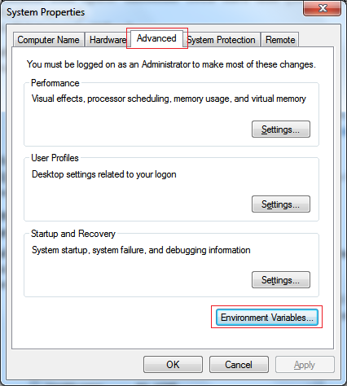

Figure 1: Set up system variable

* Set up JRE_HOME:
  + Click “New…” button in User variables for Admin and fill variable name with JRE_HOME and variable value with your JRE path installed on your computer.

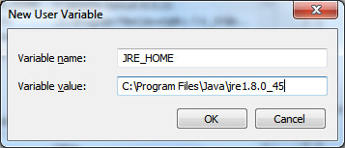

Figure 2: Set up JRE_HOME

* Setup CATALINA_HOME:
  + Click “New…” button in System variables and fill variable name with CATALINA_HOME and variable value with your Tomcat server path on your computer.

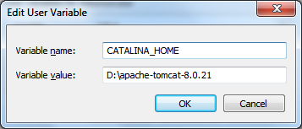

Figure 3: Setup CATALINA_HOME

#### Prepare deployment package

* Copy the deployment package (SyncCalendar.war) to a webapps folder on the Tomcat server.

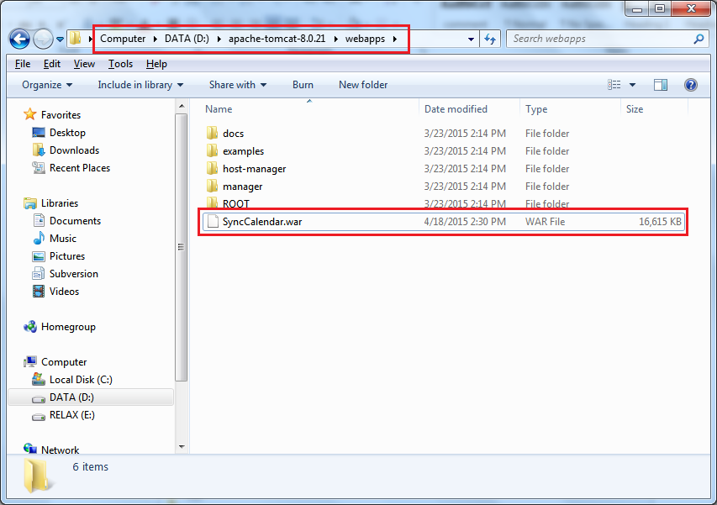

#### Deploy database

Open Microsoft SQL Server Management Studio.

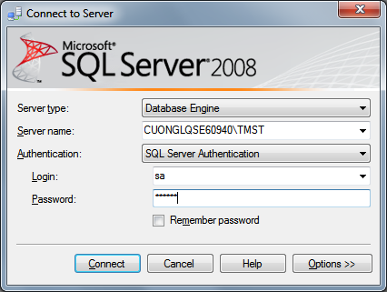

Figure 4: Connect SQL Server

Open and execute the createDB.sql file

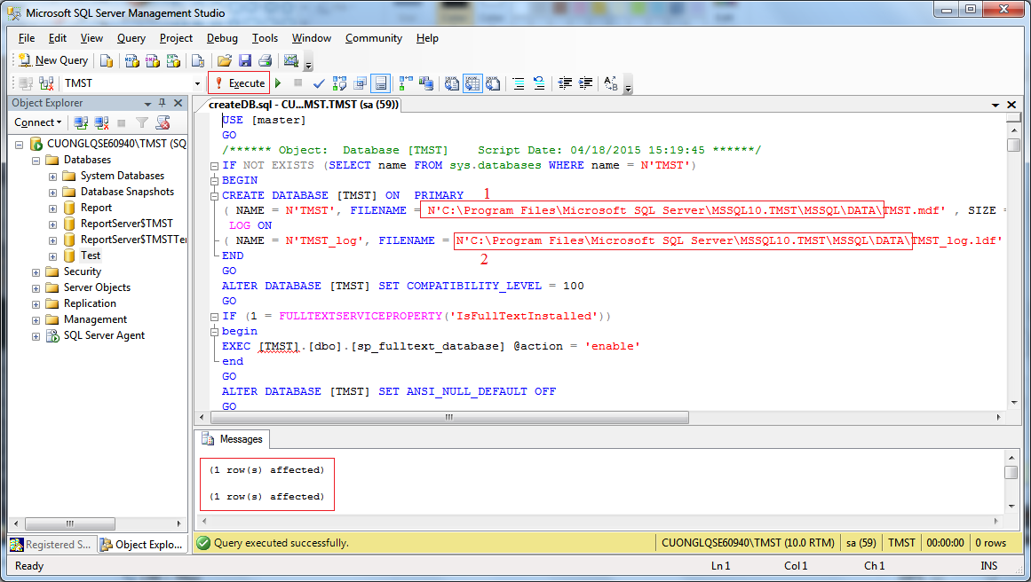

* Replace 1 and 2 with Microsoft SQL Server local installed path

[local_path]/MSSQL\DATA

* Run script file by click Execute
* Program notify (1 row(s) affected) and database TMST will be created.

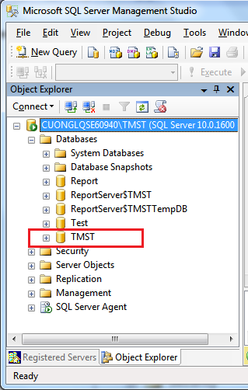

Figure 5: Create Database Success

#### Deploy web application on server

* Start server to unpacked SyncCalendar.war.

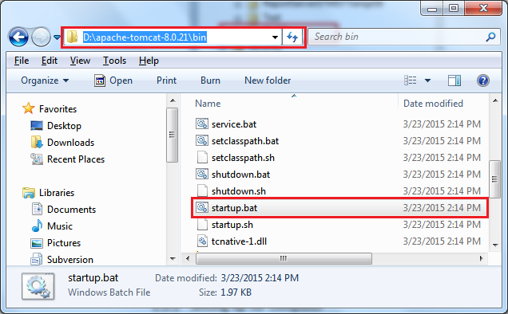

Figure 6: Start server

* Change the connection string in “D:\apache-tomcat-8.0.21\webapps\SyncCalendar\WEB-INF\classes\ DBConfig.properties”

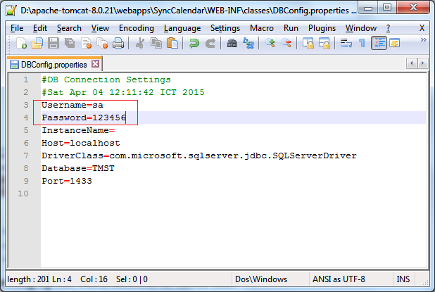

Figure 7: Change the connection string

* Restart server for the changes to take effect.
* Open localhost on server to see if deployment successful or not.
* Ex: http://localhost:8080/SyncCalendar/

### 28.3 Setting up the environment at client side

#### Software requirements

* Java Runtime Environment 8 update 45 (jre-8u45) or above.

<http://www.oracle.com/technetwork/java/javase/downloads/jre8-downloads-2133155.html>

* SQL Server 2008 R2: used to create and manage the database for web application.

#### Deploy database

Reference **1.2.3 - Deploy database**

#### Run application

* Unzip the file TMST.rar
* Run “TMST.exe” file

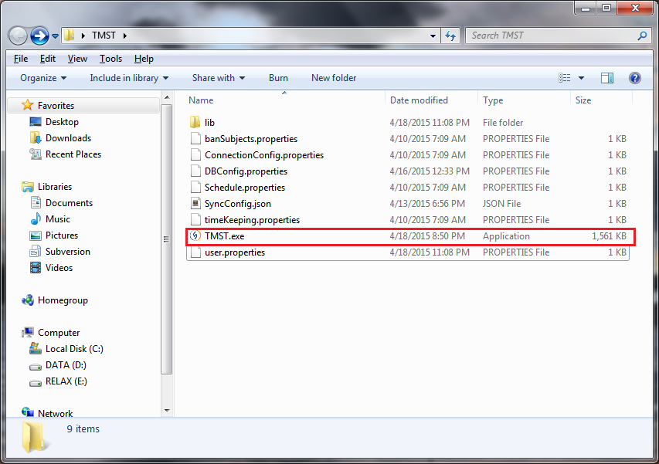

Figure 8: Run application

### 28.4 Synchronize data between local and server

Reference: <http://vn.tips4admin.com/post/2011/04/16/%C4%90ong-bo-hoa-du-lieu-tren-2-Database-Server-dung-SQL-Server-2008.aspx>

## User Guide

### 29.1 Import plan

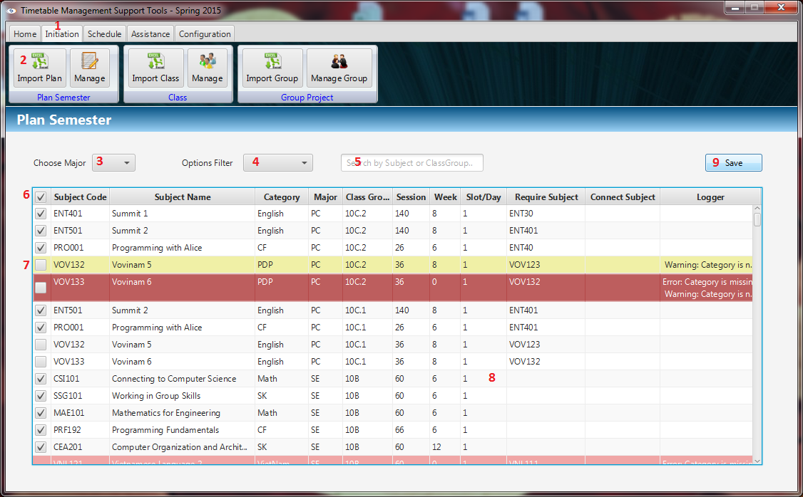

Figure 9: Import plan

|  |  |
| --- | --- |
| **Step** | **Description** |
| 1 | Click “Initiation” Tab |
| 2 | Click “Import Plan” button |
| 3 | Click major combo box to filter by major |
| 4 | Click options combo box to filter by another |
| 5 | Fill the text field to search by subject or class group |
| 6 | Stick the checkbox to select row on table |
| 7 | Stick to top checkbox to check all rows |
| 8 | Double clicks on row to edit information |
| 9 | Click “Save” button to save imported data |

### 29.2 Import class

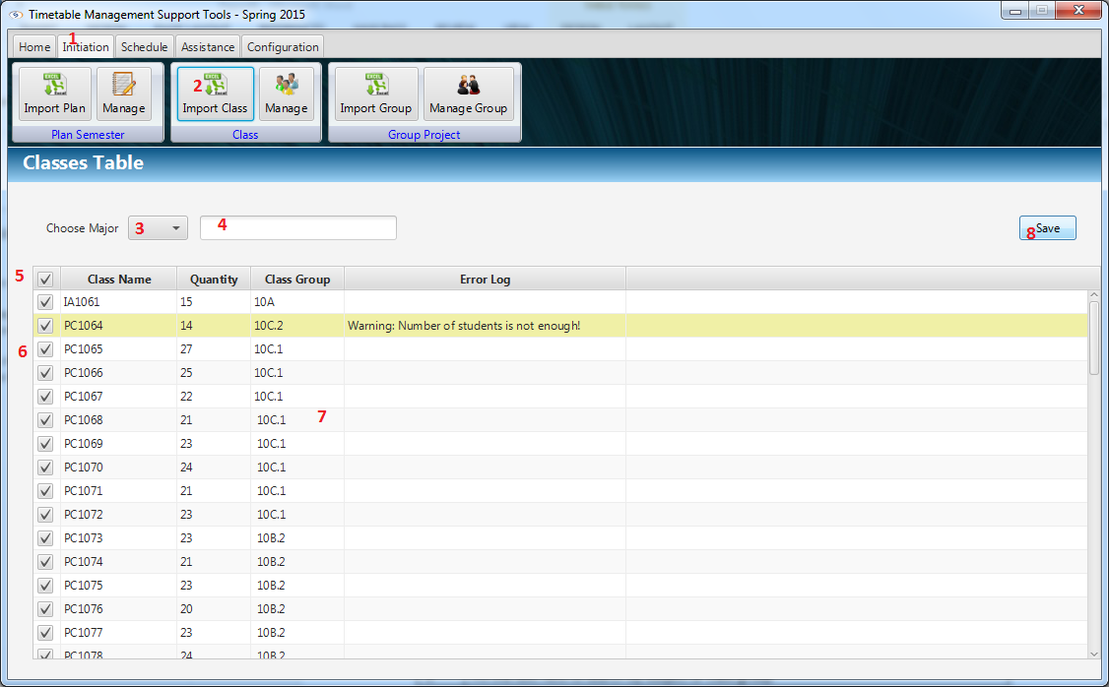

Figure 10: Import class

|  |  |
| --- | --- |
| **Step** | **Description** |
| 1 | Click “Initiation” Tab |
| 2 | Click “Import Class” button |
| 3 | Click major combo box to filter by major |
| 4 | Fill the text field to search by subject or class group |
| 5 | Stick the checkbox to select row on table |
| 6 | Stick to top checkbox to check all rows |
| 7 | Double clicks on row to edit information |
| 8 | Click “Save” button to save imported data |

### 29.3 Import Schedule

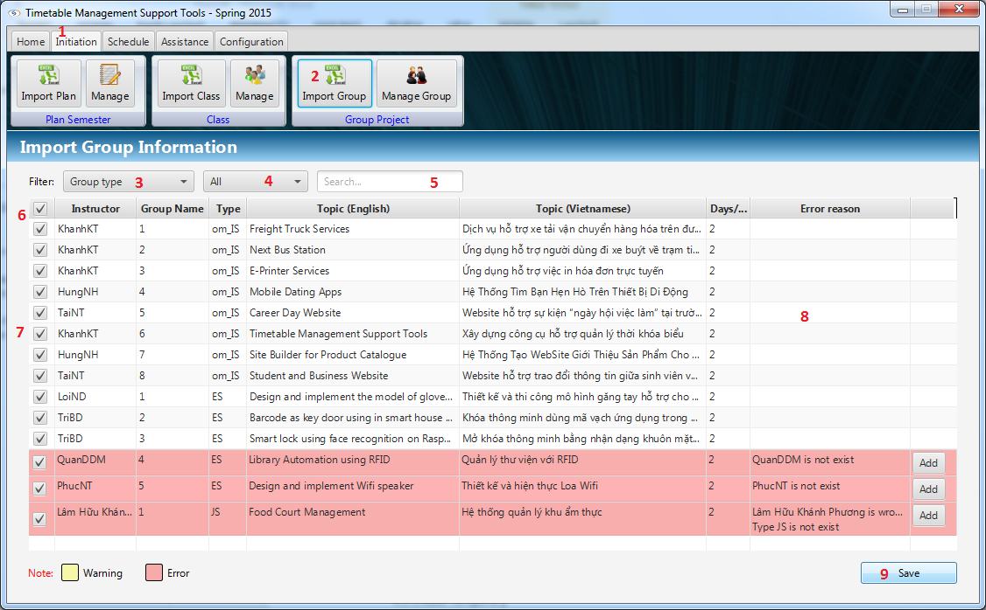

Figure 11: Import Schedule

|  |  |
| --- | --- |
| **Step** | **Description** |
| 1 | Click “Initiation” Tab |
| 2 | Click “Import Schedule” button |
| 3 | Click filter combo box to filter by group type |
| 4 | Click options combo box to filter by another options |
| 5 | Fill the text field to search |
| 5 | Click “Add” button to add instructors |
| 6 | Stick the checkbox to select row on table |
| 7 | Stick to top checkbox to check all rows |
| 8 | Double clicks on row to edit information |
| 9 | Click “Save” button to save imported data |

### 29.4 Suggest Temporary

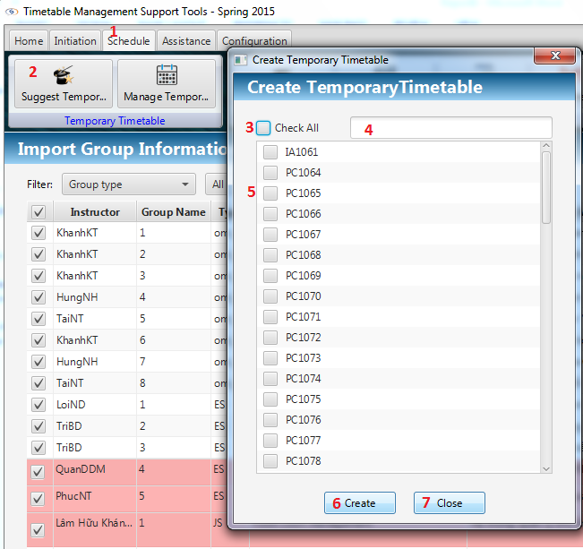

Figure 12: Suggest Temporary

|  |  |
| --- | --- |
| **Step** | **Description** |
| 1 | Click “Schedule” Tab |
| 2 | Click “Suggest Temporary” button |
| 3 | Stick to top checkbox to check all rows |
| 4 | Fill the text field to search |
| 5 | Check to select instructor by check box |
| 5 | Fill the text field to search |
| 6 | Click “Create” button to create temporary timetable |
| 7 | Click “Close” button to close the window |

### 29.5 Edit Temporary Data

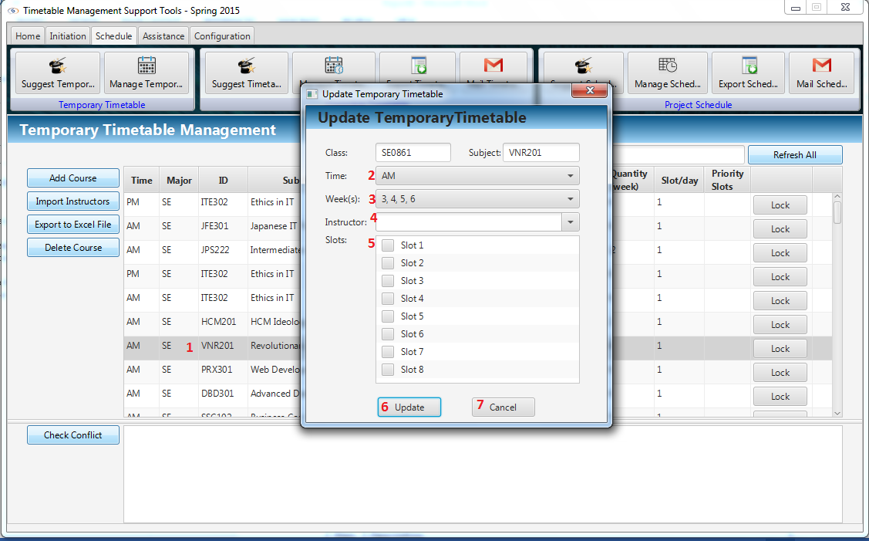

Figure 13: Edit Temporary Data

|  |  |
| --- | --- |
| **Step** | **Description** |
| 1 | Double clicks on a non-clock row of table |
| 2 | Select Time by Combo box |
| 3 | Select Week by Combo box |
| 4 | Select Instructor by Combo box |
| 5 | Check slots that course will study |
| 6 | Click “Update” button to update changed information |
| 7 | Click “Close” button to close window |

### 29.6 View Temporary Data

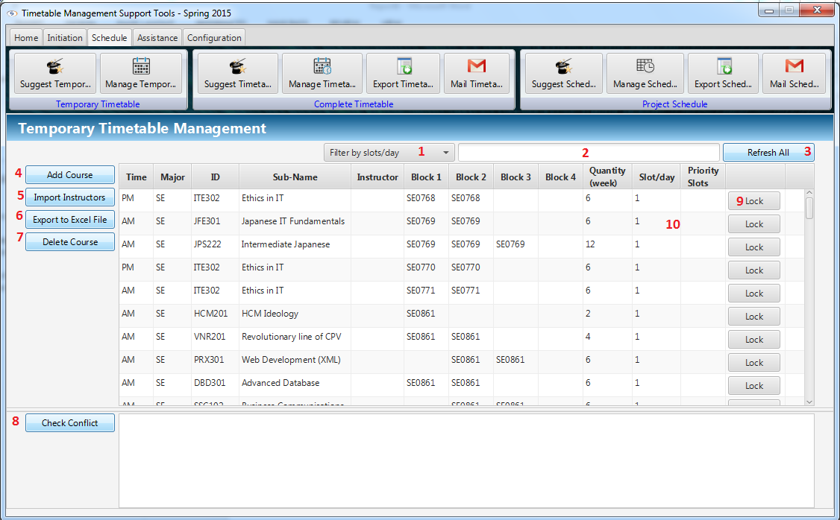

Figure 14: View Temporary Data

|  |  |
| --- | --- |
| **Step** | **Description** |
| 1 | Filter slot/day by combo box |
| 2 | Filter by attributes |
| 3 | Click “Refresh” button to reshow data |
| 4 | Click “Add Course” to add new course |
| 5 | Click “Import Instructors” to import instructor file |
| 6 | Click “Export to excel file” to export temporary timetable |
| 7 | Delete course |
| 8 | Check “Check Conflict” button to check conflict |
| 9 | Click “Clock” button to lock the row |
| 10 | Double clicks to row to edit data |

### 29.7 Add Course

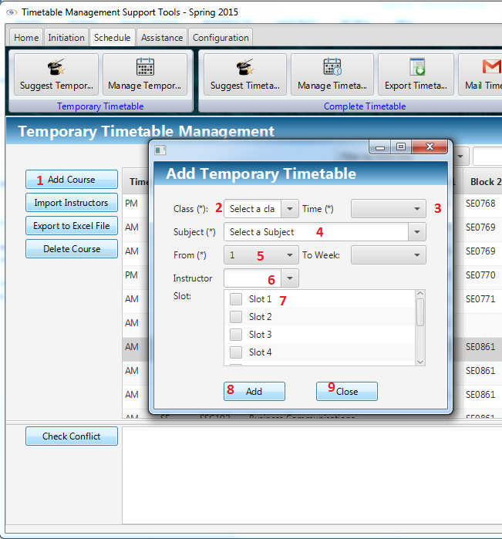

Figure 15: Add Course

|  |  |
| --- | --- |
| **Step** | **Description** |
| 1 | Click “Add Course” button |
| 2 | Select Class by combo box |
| 3 | Select time AM/PM by combo box |
| 4 | Select Subject by combo box |
| 5 | Select From week number by combo box, To week number will suggest automatically |
| 6 | Select Instructors by combo box |
| 7 | Check what slots that new course will study in |
| 8 | Click “Add” to add new course |
| 9 | Click “Close” to close window |

### 29.8. Export to Excel

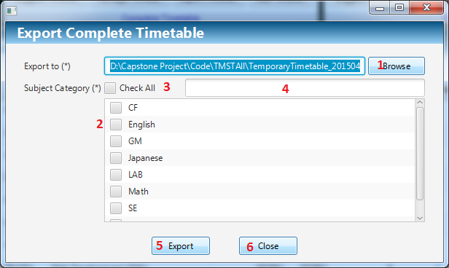

Figure 16: Export to Excel

|  |  |
| --- | --- |
| **Step** | **Description** |
| 1 | Click “Browse” button to select path to export |
| 2 | Check category checkboxes need to export |
| 3 | Check “Check All” button to check all category |
| 4 | Search category |
| 5 | Click “Export” button to export to selected location |
| 6 | Click “Close” button to close window |

### 29.9. Create Complete

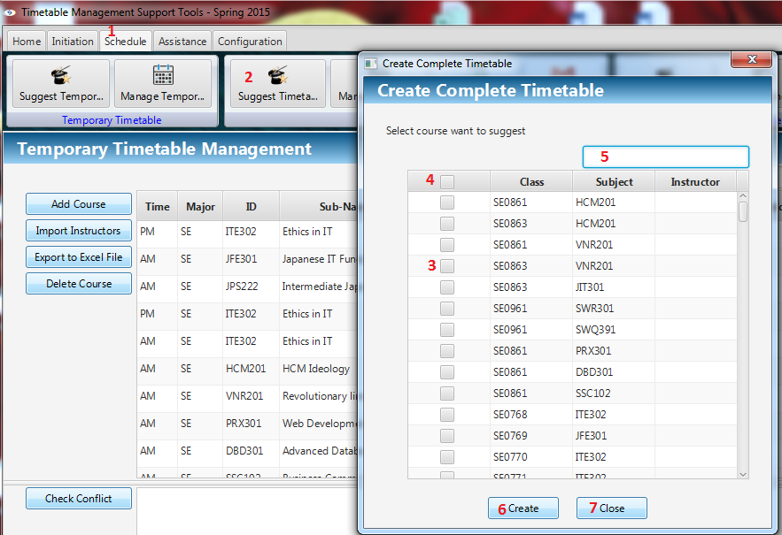

Figure 17: Create Complete

|  |  |
| --- | --- |
| **Step** | **Description** |
| 1 | Click “Schedule” Tab |
| 2 | Click “Suggest Timetable” button |
| 3 | Select classes will be suggested |
| 4 | Click top checkbox to check all classes |
| 5 | Filter data by Class, Subject, Instructor |
| 6 | Click “Create” button to create Complete timetable |
| 7 | Click “Close” button to close window |

### 29.10. Show Complete

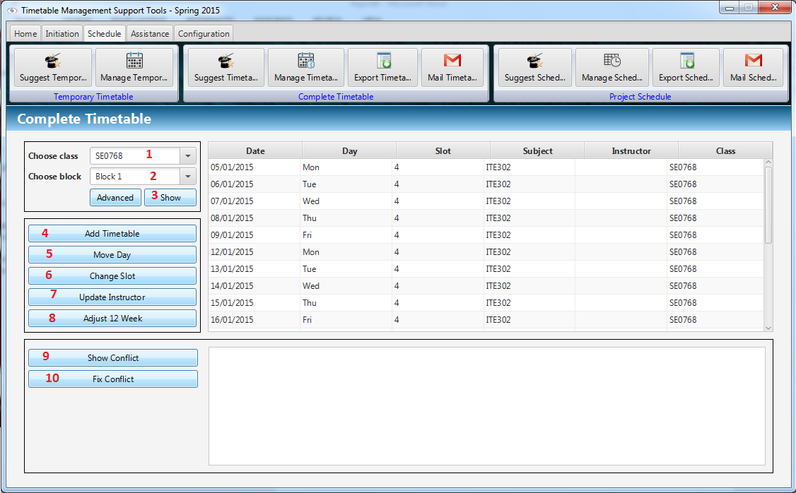

Figure 18: Show Complete

|  |  |
| --- | --- |
| **Step** | **Description** |
| 1 | Select Class by combo box |
| 2 | Select Block by combo box |
| 3 | Click “Show” button |
| 4 | Click “Add Timetable” button to add more timetable |
| 5 | Click “Move Day” button to move day |
| 6 | Click “Change Slot” button to change slot |
| 7 | Click “Update Instructor” to update instructor for a timetable |
| 9 | Click “Show conflict” to show conflict in time table |
| 10 | Click “Fix conflict” to fix conflict in timetable |

### 29.11 Edit Complete

#### Add Time Table

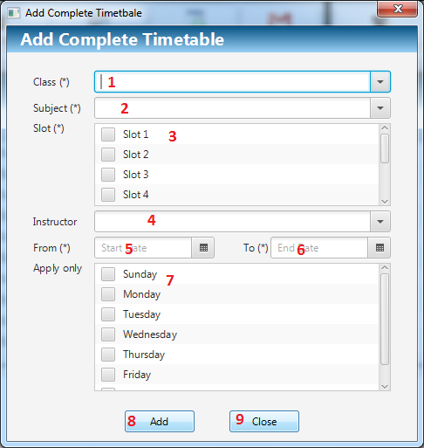

Figure 19: Add Time Table

|  |  |
| --- | --- |
| **Step** | **Description** |
| 1 | Select Class by combo box |
| 2 | Select Subject by combo box |
| 3 | Check what slots that new course will be studied in |
| 4 | Select Instructors by combo box |
| 5 | Select From day by Date picker |
| 6 | Select End day by Date picker |
| 7 | Check days in week will be studied on |
| 8 | Click “Add” to change information |
| 9 | Click “Close” to close the window |

#### Move Day

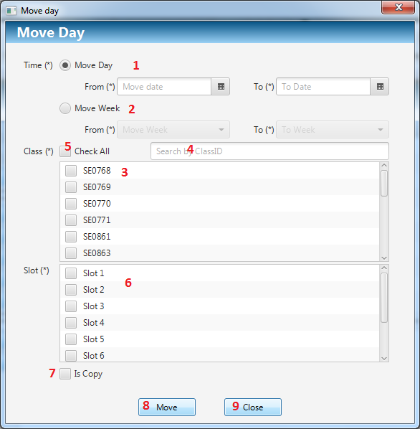

Figure 20: Move Day

|  |  |
| --- | --- |
| **Step** | **Description** |
| 1 | Select “Move day” to move day of course by radio button |
| 2 | Select “Move week” to move week of course by radio button |
| 3 | Select classes by checkbox |
| 4 | Filter class by text field |
| 5 | Select all Class by check All checkbox |
| 6 | Select slots by checkbox |
| 7 | Check “isCopy” to move to another day but not removing current day |
| 8 | Click “Move” button to move day |
| 9 | Click “Close” to close the window |

#### Change Slot

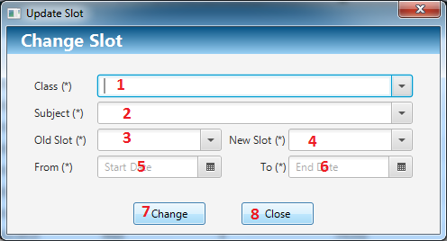

Figure 21: Change Slot

|  |  |
| --- | --- |
| **Step** | **Description** |
| 1 | Select Class by combo box |
| 2 | Select Subject by combo box |
| 3 | Select new slot by combo box |
| 4 | Select old slot by combo box |
| 5 | Select From day by Date picker |
| 6 | Select End day by Date picker |
| 7 | Click “Change” button to move day |
| 8 | Click “Close” to close the window |

#### Update Instructor

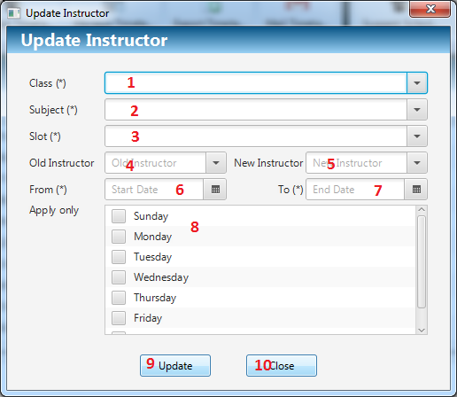

Figure 22: Update Instructor

|  |  |
| --- | --- |
| **Step** | **Description** |
| 1 | Select Class by combo box |
| 2 | Select Subject by combo box |
| 3 | Select Slot by combo box |
| 4 | Select old Instructor by combo box |
| 5 | Select new Instructor by combo box |
| 6 | Select From day that instructor will teach by Date picker |
| 7 | Select End day that instructor will teach by Date picker |
| 8 | Select Day in week by checkbox |
| 9 | Click “Update” button to move day |
| 10 | Click “Close” to close the window |

#### Adjust 12 week

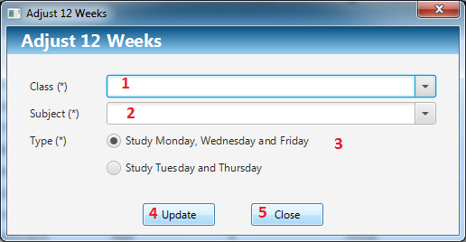

Figure 23: Adjust 12 week

|  |  |
| --- | --- |
| **Step** | **Description** |
| 1 | Select Class by combo box |
| 2 | Select Subject by combo box |
| 3 | Select types of days that will teach by radio button group |
| 4 | Click “Update” button to move day |
| 5 | Click “Close” to close the window |

### 29.12 Export Timetable

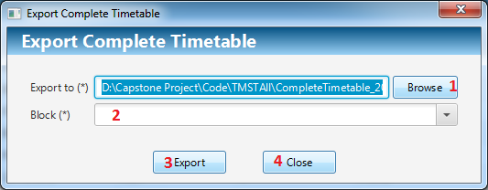

Figure 24: Export Timetable

|  |  |
| --- | --- |
| **Step** | **Description** |
| 1 | Click “Browse” button to select path to export |
| 2 | Select Block by Combo box |
| 3 | Click “Export” button to export to selected location |
| 4 | Click “Close” button to close window |

### 29.13 Mail Timetable

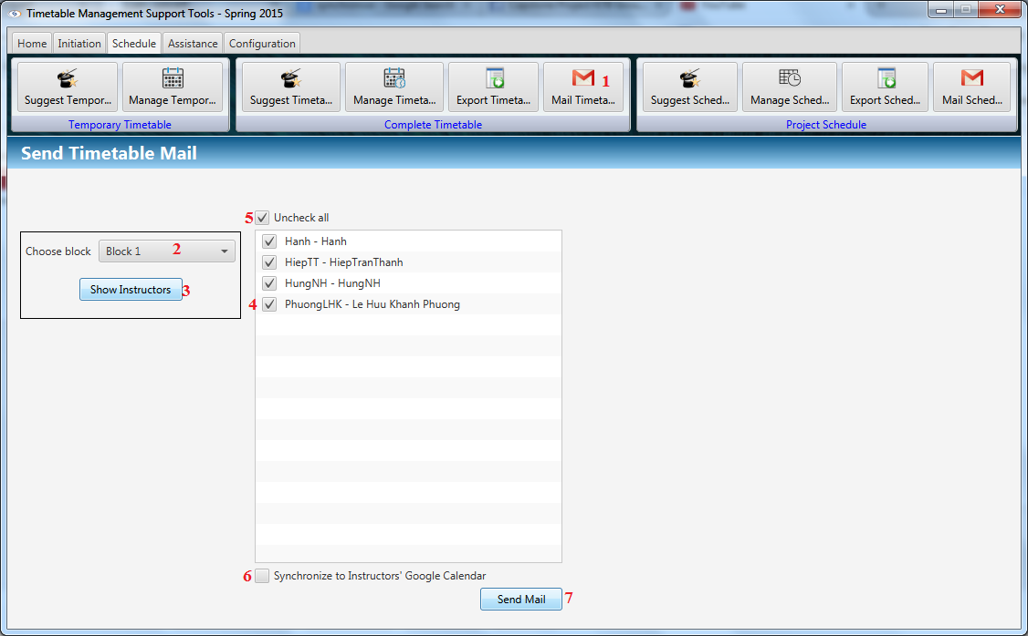

Figure 25: Mail Timetable

|  |  |
| --- | --- |
| **Step** | **Description** |
| 1 | Click “Mail timetable” button on Schedule |
| 2 | Select Block by Combo box |
| 3 | Click “Show Instructor” Button |
| 4 | Check instructor by checkbox |
| 5 | Check “Check all” button to check all instructors |
| 6 | Check “Synchronize to Instructor’s to Calendar” to synchronize with Google calendar |
| 7 | Click “Send Mail” button to send for selected instructors |

### 29.14 Suggest Guide Project Schedule

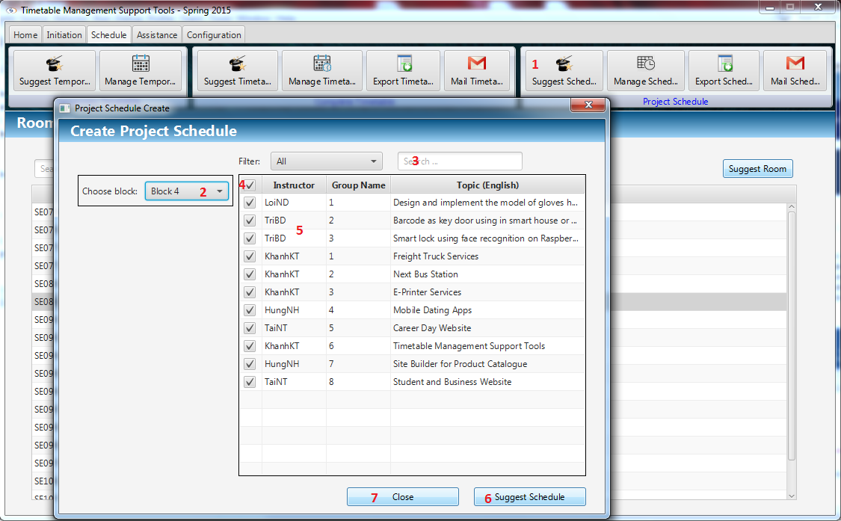

Figure 26: Suggest Guide Project Schedule

|  |  |
| --- | --- |
| **Step** | **Description** |
| 1 | Click “Suggest Schedule” button on Schedule Project |
| 2 | Select Block by Combo box |
| 3 | Search data by filter field |
| 4 | Check “Check all” button to check all instructors |
| 5 | Select Project by checkbox |
| 6 | Click “Suggest Schedule” button to suggest project schedule |
| 7 | Click “Close” to close the window |

### Manage Schedule

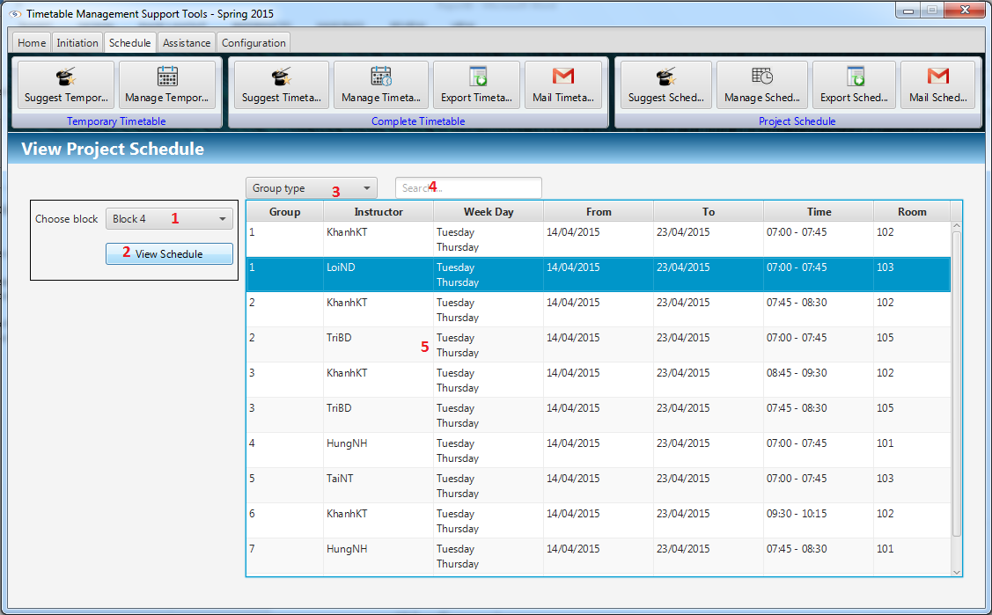

Figure 27: Manage Schedule

|  |  |
| --- | --- |
| **Step** | **Description** |
| 1 | Select Block by Combo box |
| 2 | Click “View Schedule” button to view |
| 3 | Schedule Selected Group Type by Combo box |
| 4 | Search data by filter field |
| 5 | Double clicks to edit data field |

### Edit Guide Project Schedule

#### Change Day

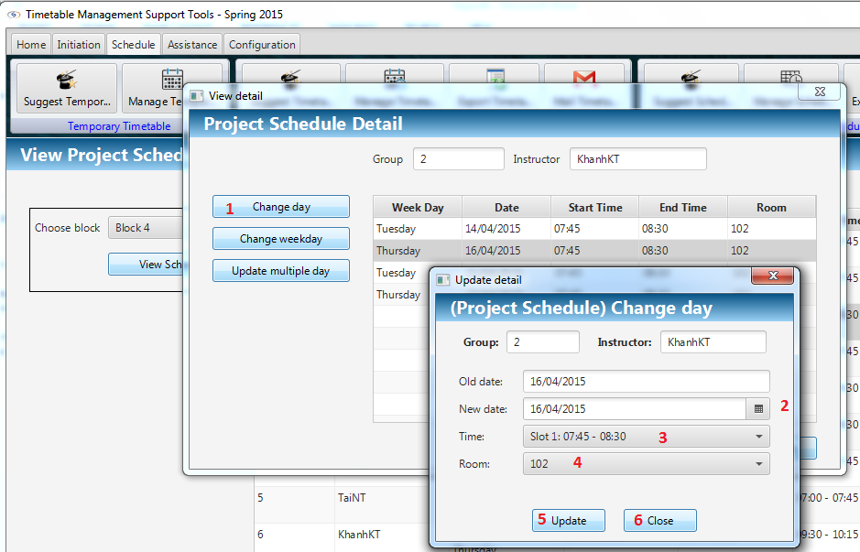

Figure 28: Change Day

|  |  |
| --- | --- |
| **Step** | **Description** |
| 1 | Click on “Change day” |
| 2 | Select date by day picker |
| 4 | Select time by combo box |
| 5 | Select room by combo box |
| 6 | Click “Update” button to update information |
| 7 | Click “Close” button to close window |

#### Change Week

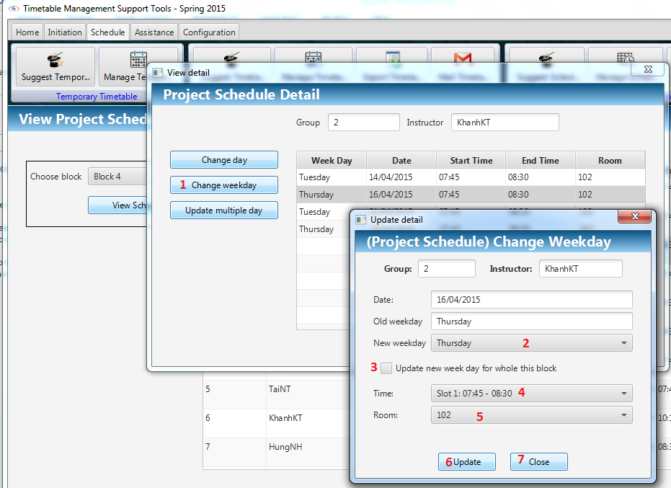

Figure 29: Change Week

|  |  |
| --- | --- |
| **Step** | **Description** |
| 1 | Click on “Change weekday” |
| 2 | Select new weekday by combo box |
| 3 | Stick checkbox to update week day for whole block |
| 4 | Select time by combo box |
| 5 | Select room by combo box |
| 6 | Click “Update” button to update information |
| 7 | Click “Close” button to close window |

#### Update Multiple Day

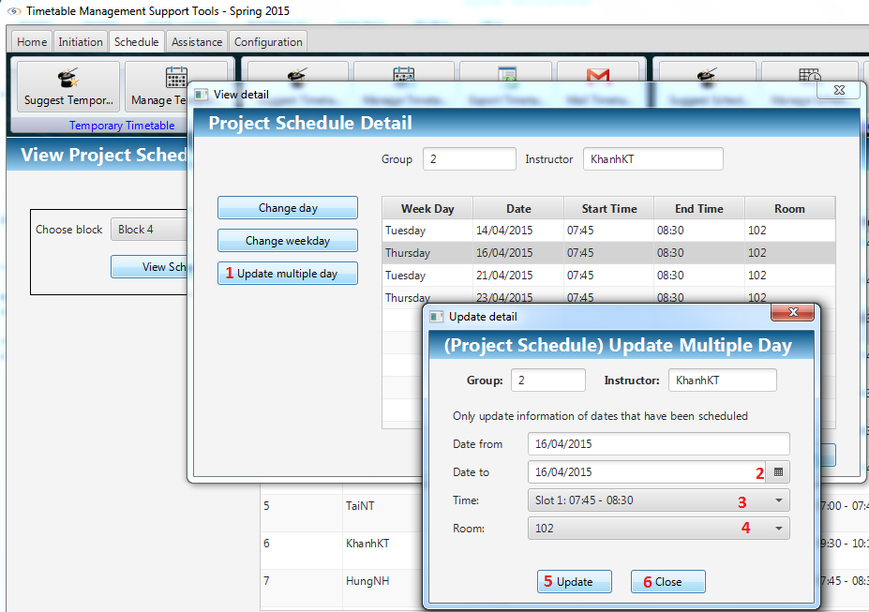

Figure 30: Update Multiple Day

|  |  |
| --- | --- |
| **Step** | **Description** |
| 1 | Click on “Change weekday” |
| 2 | Select new weekday by combo box |
| 3 | Stick checkbox to update week day for whole block |
| 4 | Select room by combo box |
| 5 | Click “Update” button to update information |
| 6 | Click “Close” button to close window |

### Export Guide Project Schedule

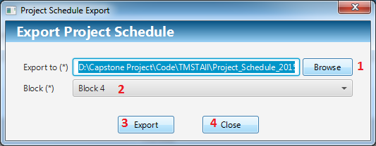

Figure 31: Export Guide Project Schedule

|  |  |
| --- | --- |
| **Step** | **Description** |
| 1 | Click “Browse” button to select path to export |
| 2 | Select Block by Combo box |
| 3 | Click “Export” button to export to selected location |
| 4 | Click “Close” button to close window |

### Mail Guide Project Schedule

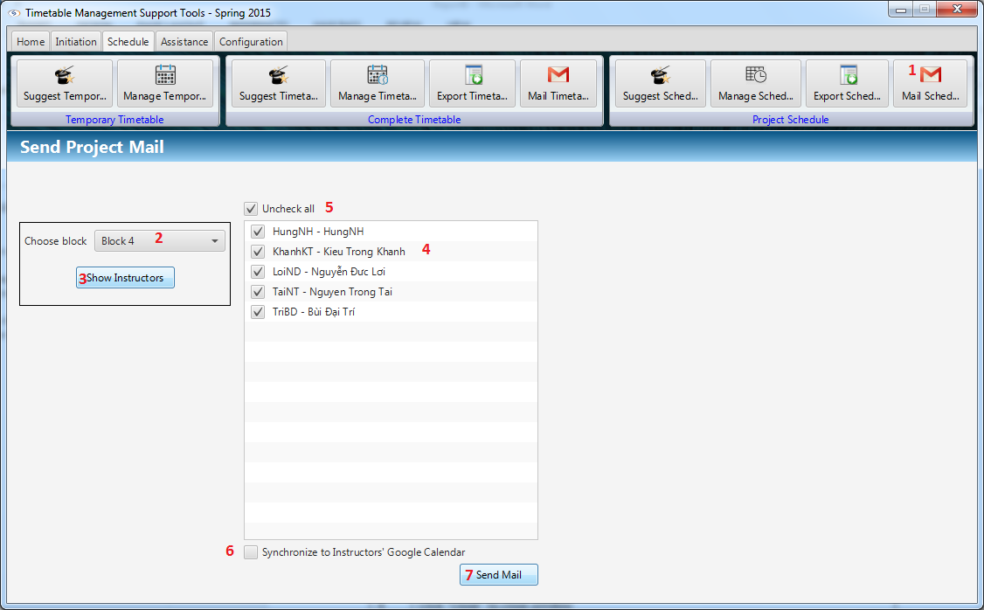

Figure 32: Mail Guide Project Schedule

|  |  |
| --- | --- |
| **Step** | **Description** |
| 1 | Click “Mail timetable” button on Schedule |
| 2 | Select Block by Combo box |
| 3 | Click “Show Instructor” Button |
| 4 | Check instructor by checkbox |
| 5 | Check “Check all” button to check all instructors |
| 6 | Check “Synchronize to Instructor’s to Calendar” to synchronize with Google calendar |
| 7 | Click “Send Mail” button to send for selected instructors |

### Manage Room Usage

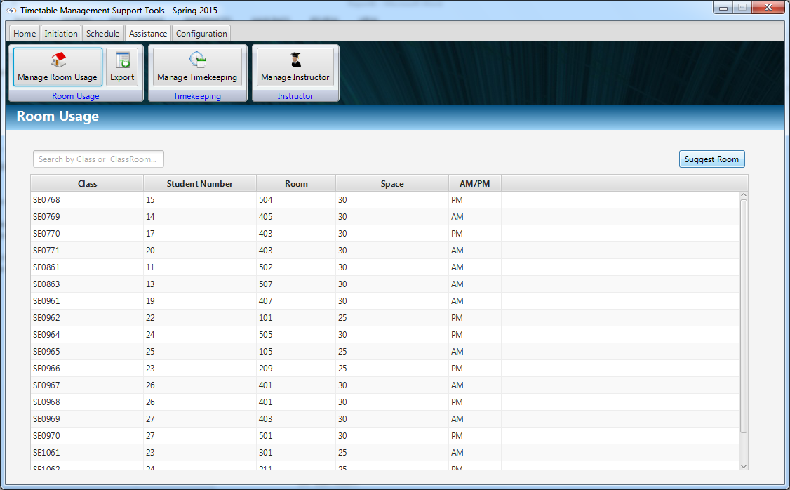

Figure 33: Manage Room Usage

|  |  |
| --- | --- |
| **Step** | **Description** |
| 1 | Click “Manage Room Usage” |
| 2 | Click “Suggest Room” to suggest rooms for classes |
| 3 | Search data by Class or Classroom by filter field |

### Edit Room Usage

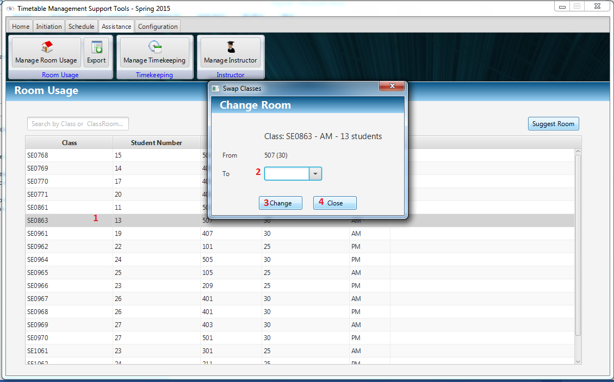

Figure 34: Edit Room Usage

|  |  |
| --- | --- |
| **Step** | **Description** |
| 1 | Double clicks on row on data to choose class for changing room |
| 2 | Select room by Combo box |
| 3 | Click “Change” to change room |
| 4 | Click “Close” to close window |

### Export Room Usage

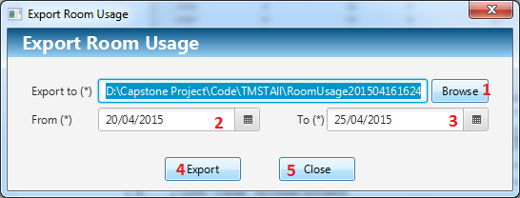

Figure 35: Export Room Usage

|  |  |
| --- | --- |
| **Step** | **Description** |
| 1 | Click “Browse” button to select path to export |
| 2 | Select From day by date picker |
| 3 | Select End day by date picker |
| 4 | Click “Export” button to export to selected location |
| 5 | Click “Close” button to close window |

### Calculate Timekeeping

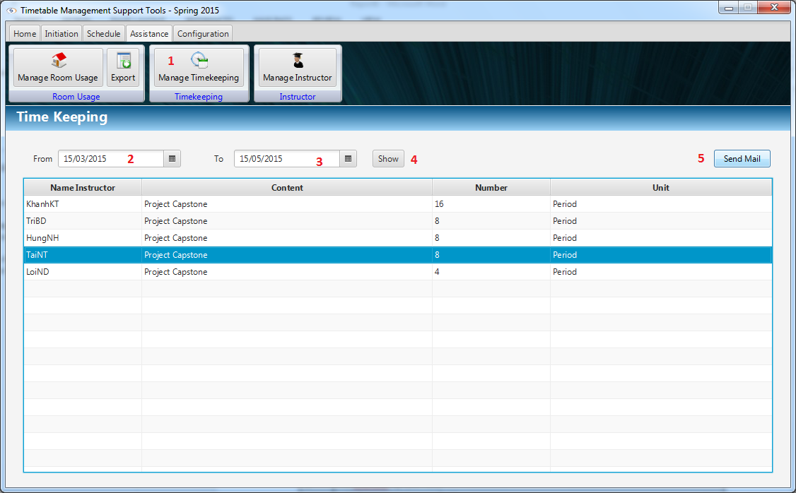

Figure 36: Calculate Timekeeping

|  |  |
| --- | --- |
| **Step** | **Description** |
| 1 | Click “Manage Timekeeping” button |
| 2 | Select From day by date picker |
| 3 | Select End day by date picker |
| 4 | Click “Show” button to show data filter by From day and End day |
| 5 | Click “Send Mail” button to send timekeeping |

### Email Configuration

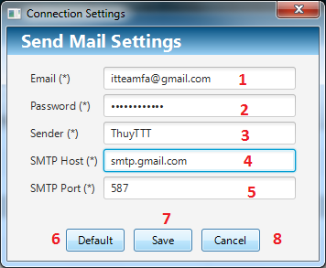

Figure 37: Email Configuration

|  |  |
| --- | --- |
| **Step** | **Description** |
| 1 | Fill Email by text field |
| 2 | Fill Password by text field |
| 3 | Fill Sender Name by text field |
| 4 | Fill SMTP Host by text field |
| 5 | Fill SMTP Port by text field |
| 6 | Click “Default” button to reset default values |
| 7 | Click “Save” button to save values |
| 8 | Click “Close” button to close window |

### Synchronize Configuration

#### Get JSON file

Reference: [https://developers.google.com/.../#creatingdeletingprojects](https://developers.google.com/console/help/#creatingdeletingprojects)

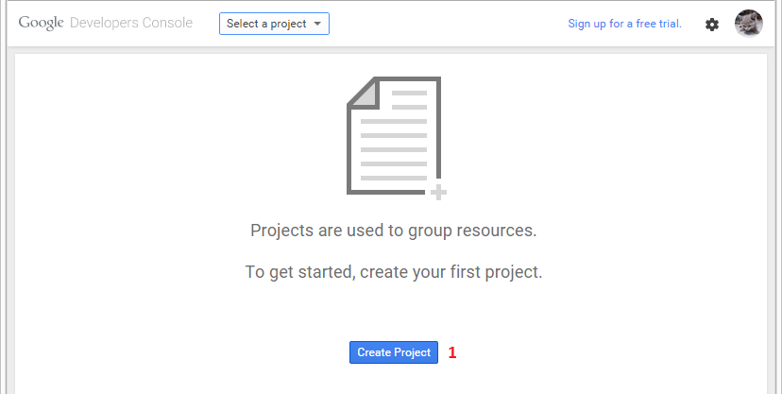

Figure 38: Get JSON setting - Step 1 – Create Project

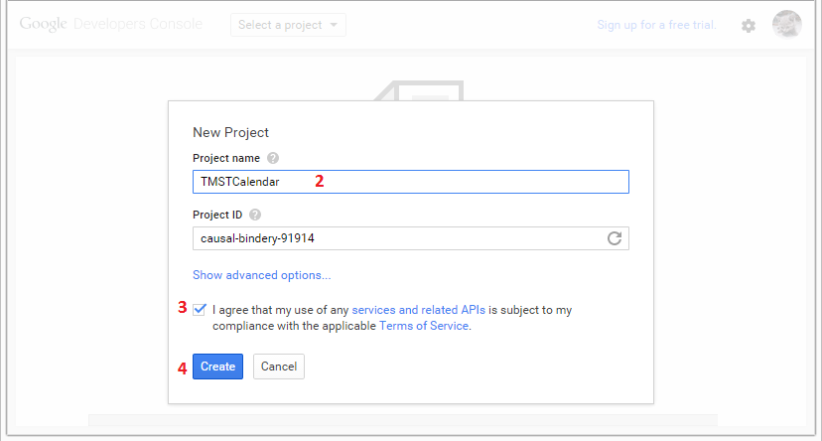

Figure 39: Get JSON setting - Step 2, 3, 4 – Setting name of project

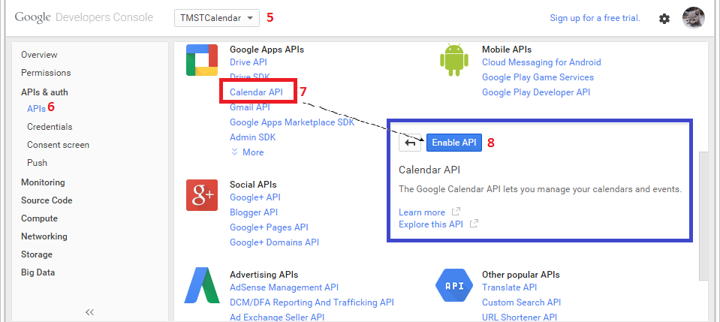

Figure 40: Get JSON setting – Step 5, 6, 7, 8 – Enable Calendar API

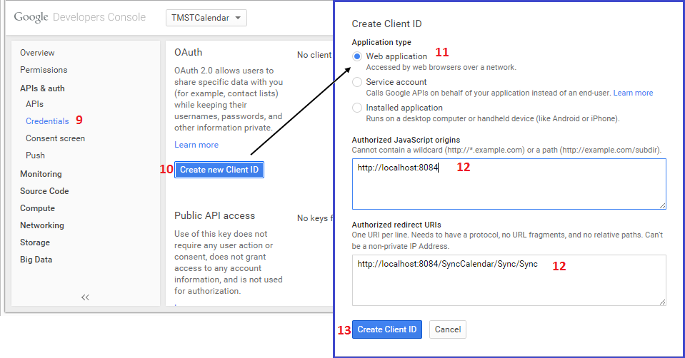

Figure 41: Get JSON setting – Step 9, 10, 11, 12, 13 – Create Client ID

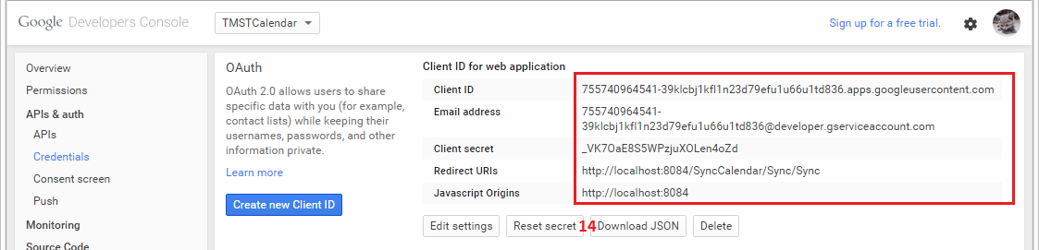

Figure 42: Get JSON setting – Step 14 – Download JSON file

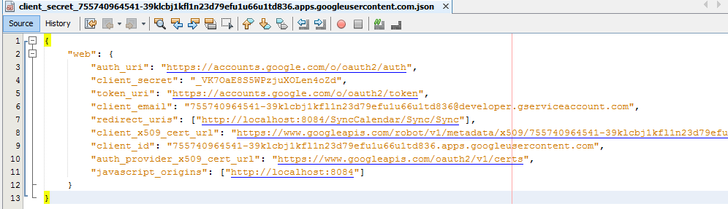

Figure 43: Get JSON setting – Content of JSON file

|  |  |
| --- | --- |
| **Step** | **Description** |
| 1 | Staff go <https://console.developers.google.com/project> to creating a project. |
| 2 | Fill name of project |
| 3 | Check to agree Terms of Service |
| 4 | Click “Create” button to finish create. |
| 5 | Choose project on combo box. |
| 6 | Click “APIs” in “APIs & auth” link |
| 7 | Click “Calendar API” link |
| 8 | Click “Enable API” to enable calendar API. |
| 9 | Click “Credentials” on left panel link |
| 10 | Click “Create new Client ID” to open window create |
| 11 | Select “Web application” |
| 12 | Enter link JavaScript origins (Optional) and Enter “Authorized redirect URIs” link |
| 13 | Click “Create Client ID” button. |
| 14 | Click “Download JSON” button. |

#### Synchronize Configuration

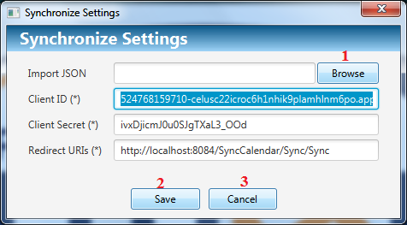

Figure 44: Synchronize Configuration

|  |  |
| --- | --- |
| **Step** | **Description** |
| 1 | Click “Browse” button to select JSON file created in 2.24.1. |
| 2 | Click “Save” button to save settings |
| 3 | Click “Cancel” button to close window |

# Appendix

1. Google API:

* <http://kieutrongkhanh.net/index.php/google-api/102-google-calendar-part-1>
* <http://kieutrongkhanh.net/index.php/google-api/106-google-calendar-part-2>
* <http://kieutrongkhanh.net/index.php/google-api/108-google-calendar-part-3>
* <https://developers.google.com/maps/documentation/javascript/tutorial>

1. Ribbon menu

* <https://introjava.wordpress.com/2012/04/08/java-fx-2-ribbon-menu/>

1. JavaFX 8 Tutorial

* <http://code.makery.ch/library/javafx-8-tutorial/>